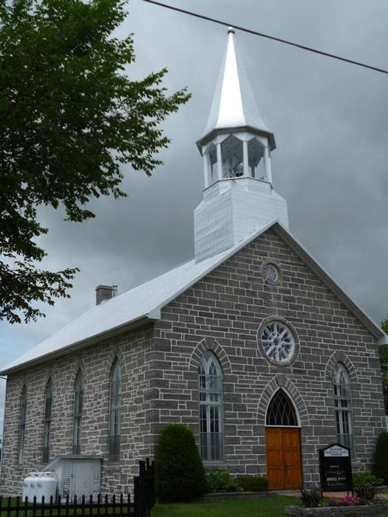
2016

Kenyon Presbyterian Church
Annual Report

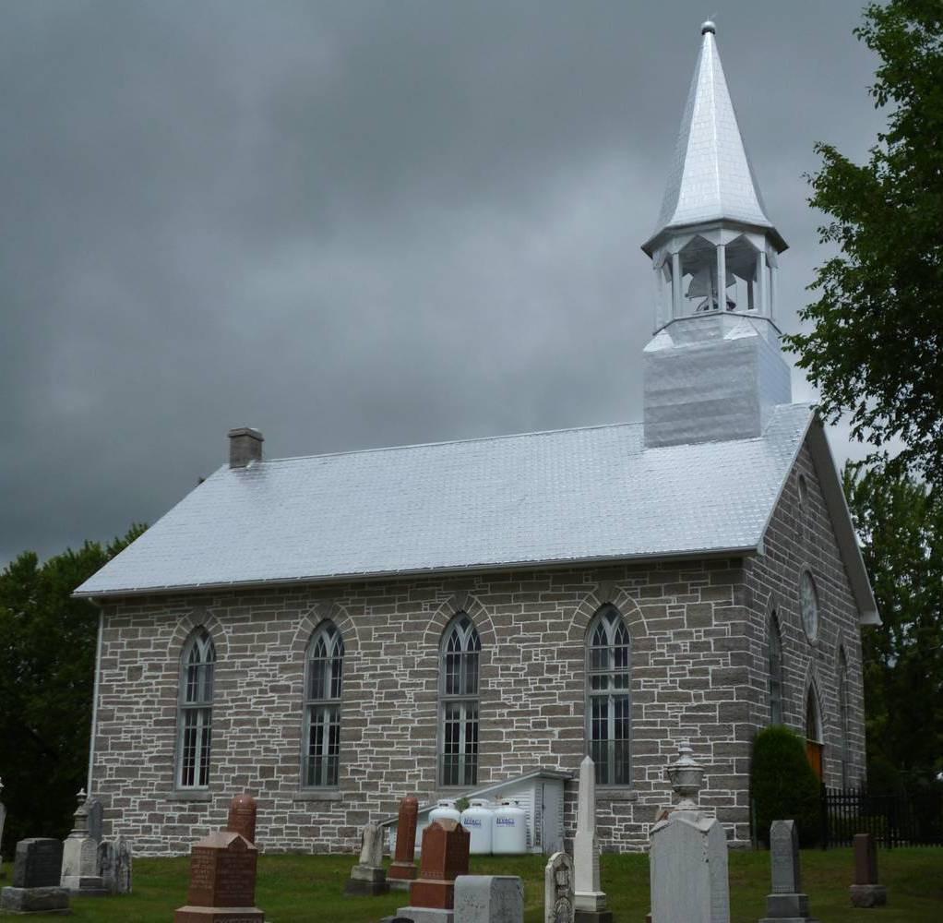

Table of Contents

From your Minister… 2
Committees and General Notices 3
Minutes of the Annual Meeting held February 21, 2016 4
Kirk Session Report 2016 7
Membership 8
Baptisms 8
In Memoriam 8
Weddings 8
Cradle Roll 2016 9
Choir Report 2016 9
Board of Manager’s Report 2016 10
Sunday School Report 2016 11
Maxville Manor Report 11
Kenyon W.M.S. Report 2016 12
Kenyon Women’s Association Report 2016 13
Trustee Investment Committee Report 2016 15
Cemetery Board Report 2016 16
Memorial Donations – Kenyon Presbyterian Church – 2016 17
Memorial Donations – Kenyon Presbyterian Church Cemetery – 2016 18
Thank you to our Donors – 2016 19

From your Minister…

To the Congregation of Kenyon

The important part of an annual meeting is to look back, to the year that has passed, to give thanks to God for the joys, the sorrows and the events where we brought people together.
We tend to get caught up in numbers, but it is good to look at those times of celebration, hospitality and most importantly worship.

We are a reformed tradition and teaching is the cornerstone of this. Our Sunday school is important to Kenyon as this is the place where the promises of the people are learned.
My appreciation to Dona Addison, Heather MacIntosh, Bobbie Jo MacLeod, Ashley MacLeod-McRae, and Jade Fraser for their time and their work to teach our children about who created them and walks with them.
Praising God, is why we come together on Sunday morning, we give praise to the Living God.

Music is important to worship, and this past year we have been blessed, with Kim Little, Rosemary Chatterson, Tracy Young and on occasion Eileen Campbell. I wish to express my appreciation for these ladies who share their gifts and bring joy to our worship.

My thanks and appreciation to Ashley MacLeod-McRae who has brought young musicians to Kenyon, has organized the music for our ‘Social’ and also for her knowledge regarding our sound system.

My thanks to the ‘The Women’s Missionary Society’, who gathers to learn more about the needs of this world we live in. The future is yet to be decided for our group, but we can be pleased for the work that has been done in our Lord’s name.

To the Ladies of Kenyon, who have put on lunches for funerals, who have been behind the ham suppers and breakfasts; I thank you.

To the Board of Managers, you have looked after the temporal and financial matters of Kenyon and I thank you.

I want to thank the Session for their care of Kenyon congregation. I also want to thank them for their concern for the education of our children and the worship at Kenyon. I appreciate the work of Kenyon’s Clerk Dona Addison who keeps our Session working well.

There is much to be thankful for, and much work to do in our Lord’s name. The Presbytery of Seaway Glengarry has taken on supporting Syrian Refugees. Ironically we in Glengarry are in an area with history of people leaving everything behind to come to a new world. In the next few months we will be welcoming these new families.

May we in this new year be the hands, the feet and voice of Jesus Christ to our neighbours both near and far.

God Bless
Rev Julia Apps Douglas
January 28, 2017

Committees and General Notices

Sabbath Services in 2017: |  |  |  | January to April – 09:30 a.m.
 |  |  |  | May to August – 11:00 a.m.
 |  |  |  | September to December – 09:30 a.m.
Kenyon W.M.S. Meetings: |  |  |  | 2nd Tuesday Apr/May/June/Sept/Oct/Nov/Dec – 12 noon
Women’s Association Meetings: |  |  |  | Third Wednesday in Apr/May/Jun/Sep/Oct/Nov – 1:30 pm
Board of Managers Meetings: |  |  |  | Third Sunday of each month – before/after worship
The Kirk Session
Jack Fraser |  | Dona Addison(Clerk) |  |  | Donald MacLean |  |  |  | Ashley MacLeod-McRae (2021)
Bobbi Jo MacLeod (2021) |  | Heather McIntosh (2017) |  |  | Sandra MacPherson (2017)
The Deacon’s Court
Donald MacLean |  | Jack Fraser |  |  | Leslie McKinnon |  |  |  | Ian Hartrick
Board of Managers
Until Mar 2017 |  | Until Mar 2018 |  |  | Until Mar 2019 |  |  |  | Until Mar 2020
Jack Fraser |  | James Prevost |  |  | Audrey MacQueen |  |  |  | Jack Fraser
Jean MacLeod |  | Jean-Guy Goudreau |  |  | Elizabeth Stewart |  |  |  | Evan McIntosh
Catherine Gauthier |  | Doris MacIntosh |  |  | Betty Bracken |  |  |  | Shawn MacLeod
Nominating Committee
Until Mar 2017 |  | Until Mar 2018 |  |  | Until Mar 2019 |  |  |  | Until Mar 2020
Martha MacLean |  | Audrey MacQueen |  |  | Gwen Arkinstall |  |  |  | Jean MacLeod
Board of Trustees
Donald MacLean |  | Ian Hartrick |  |  | Heather McIntosh
Auditors for 2017 |  | Gwen Arkinstall |  |  | James Prevost
Cemetery Committee
Gordon Bracken |  | Steven MacIntosh |  |  | Donald MacLean |  |  |  | Robert Campbell
Wendy MacLeod |  | Isabelle Johnston
Church Treasurer: |  |  |  |  |  | Cemetery Caretaker:
Laurie Arkinstall |  |  |  |  |  | Margaret MacLeod
Kenyon Presbyterian Church |  |  |  |  |  | 19045 County Rd. 24
1630 County Rd. 30 |  |  |  |  |  | Dunvegan, ON K0C 1J0
Dunvegan, ON K0C 1J0 |  |  |  |  |  | 613-527-2739
Organist |  | Custodian |  |  |  |  |  |  | Proof Readers
 |  | Allison MacLeod |  |  |  |  |  |  | Jade Fraser
 |  |  |  |  |  |  |  |  | Wendy MacLeod
Ushers
Heather McIntosh |  | Jack Fraser |  |  | Doris MacIntosh |  |  |  | Jean MacLeod
Linda Fraser
Maxville Manor Representatives
Linda Fraser |  | Gerhard Schmidt |  |  | Gwen Arkinstall
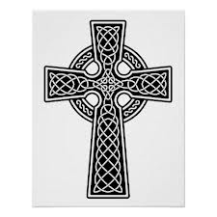
Minutes of the Annual Meeting held February 21, 2016
The annual congregational meeting of Kenyon Presbyterian Church was held on Sunday, February 21, 2016, following morning worship and a delicious potluck luncheon.
Reverend Julia Apps Douglas was unable to be present; James Prevost agreed to act as Moderator.
Devotions: James Prevost called the meeting to order, welcomed 19 members and adherents, and constituted the meeting with prayer.
Election of Secretary: Moved by Catherine Gauthier and seconded by Laurie Arkinstall that Gwen Arkinstall acts as Secretary for the meeting. No other nominations forthcoming, Gwen accepted.
Motion to receive the Minutes for 2015 was moved by Martha MacLean, seconded by Heather McIntosh. No errors or omissions were found. Carried.
Motion to adopt the Minutes as printed was moved by Laurie Arkinstall, seconded by Linda Fraser. Carried.
Motion to receive the written Annual Reports for 2015 for review was moved by Dona Addison, seconded by Heather McIntosh. Carried. All in favour.
Kirk Session Report:
Laurie Arkinstall reported a correction in the “In Memoriam” section of the report; Eric John Moore’s date of death should read August 4, 2014 instead of 2015. Mr. Moore was buried in 2014.
Cemetery Report:
Laurie Arkinstall reported a correction; we had 4 burials with coffins and 2 burials with urns at Kenyon Presbyterian Cemetery.
No more information has been received on the skull found in the river north west of the cemetery.
Motion to adopt the written reports as amended was moved by Catherine Gauthier, seconded by Dona Addison.
Motion to receive all Financial Reports for 2015 for review was moved by Myrna Ladouceur and seconded by Heather McIntosh.
Treasurer Laurie Arkinstall explained the Cemetery, Church Investments and General Fund’s receipts, disbursements and budget for 2016.
Cemetery:
Jack Fraser asked the cost of buying a grave; a single grave is $500 and $700 for a plot of 4 graves. These prices are for church members.
There was discussion regarding the repair of the gravestones done this year and the responsibility of the Cemetery in the repair.
Jack Fraser reported that a settlement regarding the Pioneer Cemetery expenses has been made with Markus Haerle and that Mr. Haerle made a donation to the church.

Investments:
James Prevost thanked the Church Investment Committee for a job well done
General Church Account:
Laurie Arkinstall explained that the Special Receipts section in the General account will now show when money is received for the Capital Projects.
Included with the income tax receipts was a letter from the Board of Managers asking for funds for the painting and repair of the church. Laurie Arkinstall reported that we have received some donations due to the letter.
Motion was made to give $4000 to Presbytery Sharing, moved by Dona Addison and seconded by Donald MacLean.
Auditor Linda Fraser thanked Laurie for all her time and work as Treasurer.
Catherine Gauthier thanked the congregation for all their support.
Elizabeth Stewart commented about our well-kept church and cemetery.
Motion to adopt all Financial Reports was made by Martha MacLean and seconded by Doris MacIntosh. Carried.
The Nominating Committee Reports were reviewed:
The Kirk Session will welcome Bobbi Jo MacLeod and Ashley MacLeod-McRae as new elders. Bobbi Jo MacLeod’s name is not shown in the report. They will be ordained March 6, 2016.
The names of the retiring elders were incorrectly omitted from the report; Elizabeth Stewart, Shawn MacLeod and Katie Jean-Louis.
Nominating Committee report should read Elizabeth Stewart until March 2016 not Catherine Gauthier.
Motion to adopt the Nominating Committee reports as amended was moved by Laurie Arkinstall and seconded by Catherine Gauthier. Carried.
New Business:
Linda Fraser asked for permission on behalf of the Maxville Manor, that a link to the Church’s website be allowed from the Manor’s website. Permission was given. It was decided that our website would create links to the charities that we support as well. James Prevost will do this.
Dona Addison asked that our Church clean- up day, which in the past has been done by the Board of Managers, be called a Congregational Clean Up. Possible dates were discussed.
Dona Addison suggested that we have a congregational cemetery tour, and we would be aware of the cemetery boundaries.
Dona Addison reported the dates for the Breakfast April 16, 2016; Ham Supper May 14, 2016 and the Church Social July 5, 2016. She asked that a Social Committee be formed. All agreed.
The Presbyterian College in Montreal has made a request for a donation to help with extensive renovations at the College. This was discussed and Catherine Gauthier made a motion to give the College $200 yearly for five years for a total of $1000, seconded by Donald MacLean. Carried.
Laurie Arkinstall asked for an update on the Presbytery sponsoring a Syrian family, Heather McIntosh will look into this.
Martha MacLean asked that the print be larger in a few of the 2016 Annual Reports to be given to the Manor residents and those visually impaired.
Dona Addison thanked Laurie Arkinstall for her work as Treasurer, James Prevost for preparing the Annual Report and an excellent website, Sandra MacPherson for her photography on the cover of the Annual Report, Margaret MacLeod for Cemetery care, and Eileen Campbell for her years as organist and wished her a long and healthy retirement. She also thanked all the committees for their help.
Myrna Ladouceur thanked Dona for her work as Clerk of Session and her years of being Caretaker.
Elizabeth Stewart thanked Myrna Ladouceur and Margaret MacLeod for their help in setting up for communion.
James Prevost closed with prayer.
Laurie Arkinstall Adjourned the meeting.
Respectfully Submitted,
Gwen Arkinstall

Kirk Session Report 2016
Kirk Session had a total of 7 active members. Six regular meetings were held and several short meetings were held after the church service. We welcome our new elders, Bobbi Jo MacLeod and Ashley MacLeod-McRae.

We thank Rev Julia for her leadership. We thank all the ministers who conducted our services throughout the year. Thank you to Heather McIntosh who attends Presbytery and Senate meetings. Sylvia Fraser is the alternate attendee.

There are 7 children on the Sunday school role. Thank you to our teachers, Heather McIntosh, Ashley MacLeod-McRae and Bobbi Jo MacLeod and Jade Fraser. With the help of the congregation, we filled 46 “Good Samaritan” boxes.

The third church social was held on July 5. Thank you to everyone for your assistance, with special thanks going to the organizer, Ashley MacLeod-McRae and her helpers.

White Gift Sundays were held on November 27 and December 4. We thank the congregation for their generous gifts. All items were donated to St. Vincent de Paul Society in Alexandria.

The music leaders were Ashley MacLeod-McRae, Rosemary Chatterson, Tracy Young, and Kim Little. Bobbi Jo MacLeod was able to purchase music CDs that can be used, if necessary, for worship in the New Year. Thank you to the choir and to our church musicians for enriching our worship services with music.

Special services that were held included the Pioneer Service, an Ecumenical service at the Maxville Fair, Memorial Day, Anniversary and St. Andrew’s Day services. We thank the Kenyon Youth Choir, Paul and Brenna Villeneuve, Grace Morris Armstrong, for their gifts of music.

Communion was observed on February 14, March 20, May 15, October 2, and November 27.

The wedding policy was revamped and approved by session.

As some have difficulty hearing the minister, Ashley MacLeod-McRae bought 2 new speakers and supervised their placement.

After 140 years, the Presbyterian Record will cease publication as of December 2016.

We thank the Board of Managers for supervising the many jobs, including, plastering and painting of the church interior, reinforcing and painting the steeple and church roof, for purchasing a new clock, 2 flag stands and for replacing light fixtures in the choir room and vestry.

We thank the cemetery caretaker, the cemetery board, and all volunteers for maintaining the beautiful grounds throughout the year. We thank the Woman’s Association for hosting the various luncheons.

We thank Jean MacLeod, Elizabeth Stewart, Doris MacIntosh, and Betty Bracken who so beautifully decorated the sanctuary for special occasions. Thank you to Doris MacIntosh who tends to the Pioneer Cemetery and for looking after flowers placed around the church.

We thank the Trustees Investment Committee for looking after the investments. Special thanks to Laurie Arkinstall for faithfully maintaining the financial books of the church.

We ask the blessings of God as we move forward into 2017.

Respectively submitted, Dona Addison, Clerk of Session.

Membership

On Roll as of January 1, 2016 |  | 94
Added by Profession of Faith |  | 0
Added by Session |  | 0
Removed by Certificate |  | 4
Removed by Death |  | 1
On Roll as of December 31st, 2016 |  | 92

Baptisms
Name | Date of Birth | Date of Baptism
Olivia Mary Fraser | August 3, 2015 | May 22, 2016
Chancey Alexander Chad McRae | March 23, 2016 | June 19, 2016

In Memoriam

Date | Name | Age | Urn/ Coffin
June 13, 2016 | Douglas Grant Stewart | 99 | Urn
June 25, 2016 | Robert MacLeod Kelly | 56 | Urn
August 6, 2016 | Raymond William Beaumont | 73 | Urn
October 21, 2016 | Catherine Mary MacRae | 98 | Coffin

Weddings

April 23, 2016 | Dona Catherine Fraser Addison | William Keith Urquhart
July 20, 2016 | Allison Elizabeth MacLeod | Jason Luke Leroux

Cradle Roll 2016
Children on Cradle Roll in 2015: |  |  | 9
Graduated from Cradle Roll in 2016:
 | Brennan Lucas Russett  Owen Danny Joseph Hartrick  Braeden John Ogilvie |  | -3
Added by Baptism in 2016: |  |  | 6
Olivia Mary Fraser
Chancey Alexander Chad McRae
Children on Cradle Roll as of December 31st, 2016: |  |  | 8
Birthday Cards sent in 2016: |  |  | 10
A heart that is open to Christ will be open to those He loves.

Respectfully Submitted,
Margaret MacLeod – Sunday School Cradle Roll

Choir Report 2016

At the end of 2015, after many years of faithful service to the congregation of Kenyon Church, Eileen Campbell retired as the organist. We wish to thank her for guidance and for her gift of music that has been enjoyed over the years. We are so fortunate to have other gifted musicians in the area and though out the year, Kim Little, Rosemary Chatterton, Tracy Young and Ashley MacLeod-McRae have supplied music for our worship services. We also want to recognize and thank our few, but very faithful choir members for their contribution to the worship time. Our thank you is extended to everyone, whom in the past year has helped in the choir when called upon.

For our St Andrew’s service we were delighted to have Grace (Morris) Armstrong provide us with her harp music. For our children’s Christmas service Ashley MacLeod-McRae, the Mini Music Makers, Ashley’s fiddle students and Ian and Karen MacLeod gifted the congregation with their talent. At the Christmas eve service, which was conducted by Rev. Julia Apps-Douglas, we had music and carols provided by Kim and Eric Little and Brenna and Paul Villeneuve
Rev. Julia Apps-Douglas and Eileen Campbell have conducted and provided the music for the worship service at the Maxville Manor throughout the year.

President: Catherine Gauthier
Secretary: Eileen Campbell

Board of Manager’s Report 2016
The Board of Managers held 9 meetings throughout the 2016 year plus 1 special Board of Managers meeting on July 17. Thank you to outgoing Board of Manager’s members Brian Campbell, Myrna Ladouceur and Andre Jean-Louis. In March, Audrey MacQueen, Elizabeth Stewart and Betty Bracken began their 3 year terms of service on the board. Betty Bracken volunteered to be the BOM secretary.
The Board of Managers assumed responsibility for the 2016 summer social. Thanks to Ashley and Chad McRae, the organizing committee and the volunteers for a successful event.
2016 was one of the busiest years for the committee as two major Capital Projects were completed in addition to the regular care and maintenance. A few of the maintenance tasks completed included:
- Successful congregational spring cleanup day. Thanks to all that participated.
- Water samples were taken quarterly for testing and all passed the testing process. Thanks to Heather MacIntosh for taking them into Ottawa.
- Electrical outlets were verified for capacity and safety – a faulty breaker was fixed.
- Issues with the plumbing and septic were resolved. Thanks to Brian Campbell for his work. Thanks to Jack Fraser and Andrew Arkinstall for the many long hours of work to help fix this.
- Repairs to the weather-stripping on the back basement doors completed – resolved wind noise.
- Window glass in Choir room was replaced and weather-stripping on Front church window repaired.
- Two Church ceiling fans were replaced.
- 5 new smoke detectors were installed by Gordon Bracken.
- Church attic and window exteriors were sprayed for bugs and wasps in the fall.
- Critters in the hall roof were removed.
- A new clock and a new Canadian Flag were donated for the church.

The committee made a special request for additional donations this year to help pay the cost for the 2 major capital projects. We were very pleased with the response by the congregation and the many Church donors for their support.
The first capital project was the extensive repair to the sanctuary ceiling and the interior plasterwork. To finish the job, the interior was brightened up with a fresh coat of paint. This project was completed by Plantagenet Workshop, Adrian Karaguesian and his wife Ingrid Silver. The second project completed was to repair the Church Bell tower and paint the Church roof. This project was completed by Dan Long Painting. Thank you to all our very talented trade and craftsmen who helped to repair our beautiful place of worship.
Shawn MacLeod continued to attend meetings as a representative of the Cemetery Committee. This has improved communication between the two committees.
Thanks to our Board of Managers, who continue to donate their time, talents and resources towards keeping this Church, the hall and the surrounding grounds a beautiful and intricate part of this community.
Respectfully submitted by,
James Prevost, Chairperson / Betty Bracken, Secretary

Sunday School Report 2016

We have 10 children on the Sunday school roll with Heather McIntosh, Ashley MacLeod-McRae, Bobbi Jo MacLeod and Jade Fraser as teachers. Dona Addison prepares the lesson framework.

With the help from members of the congregation, 46 boxes were filled for the Christmas Child project. We also filled boxes of White Gift food which were donated to the St. Vincent de Paul Society in Alexandria. We thank all those who generously donated.

We are proud of our Kenyon Youth choir who are under the leadership of Ashley MacLeod-McRae. The choir participated in various church services and also in the social program.

On December 11, we held our Christmas program in the church. The children performed their musical selections, recited their recitations, and participated in the Youth Choir.

Thank you to Rev Julia for her leadership and children’s time stories.

We gratefully acknowledge the assistance of all parents and friends for their help and support.

Respectively submitted,
Dona Addison

Maxville Manor Report

The Board of Directors of the Maxville Manor met 8 times during the year. Ivan Coleman was re-elected as Chairman and Gord White filled the position of Vice-Chairman.
The two wells drilled on the Kenyon, Roxborough Boundary Road west of Maxville are meeting the needs of the Manor. This has eliminated the expense of buying water which the Manor has been forced to do over the last number of years.
Executive Director Bernard Bouchard is directing the redevelopment project at the Manor. Applications for funding have been submitted to build two new dementia units plus renovate the older sections of the Manor.
The front doors at the entrance have been replaced with two sliding doors with a glass atrium. This will make access to the building easier for residents in wheelchairs.
All units in the Glen Garden Village are occupied and there is a waiting list of people interested in this type of accommodation.
Respectfully submitted,
Linda Fraser

Kenyon W.M.S. Report 2016
Each of our meetings started with a luncheon. We held our annual meeting in November as it was found that December was too busy and we weren’t meeting in the winter months. At this meeting it was decided to have meetings from April – June and from September – December, as well as participating in the World Day of Prayer service in March. For our Christmas meeting we met in Maxville at the Country Girls restaurant and had a lovely Christmas meal. We had Elizabeth Chisholm join us for that meeting. We had the special services at Easter and Thanksgiving, using the ones set out in the Glad Tidings. Members led in devotions and a variety of readings. We were glad to have Eileen accompany us with the hymns. Our studies covered violence and abuse against women. In June we talked about some of the missionaries we support and what they are doing in their respective jobs.
The Roll Call was answered with verses from scripture using special words which we are given beforehand. There were 783 visits to the sick. Average attendance was 10 members per meeting. We had 10 subscriptions for Glad Tidings; this is looked after by Gwen Arkinstall. Evelyn MacQueen ordered calendars for 2016 from the Presbyterian Church for several members. Special donations were made to the Red Cross for the Fort McMurray fires and to the Kenyon Church Capital Projects.
Catherine (Dan) MacRae, one of our devoted members passed away in October. Annabelle Hartrick sent out 55 cards and letters for birthdays, sympathy and get well.
Thank you all for participating in the meetings in our service to God and mission. Thanks to Gwen for taking up these responsibilities when I’m not able to be at the meetings.
Respectfully submitted,
Lynda Heinsma
2017 W.M.S. Officers
Past President | Annabelle Hartrick
President | Sheila Paterson
Vice President
Secretaries | Gwen Arkinstall, Dona Addison
Treasurer | Gwen Arkinstall
Expense Fund Treasurer | Evelyn MacQueen
Friendship & Service | Annabelle Hartrick
Pianist | Eileen Campbell
Glad Tidings | Gwen Arkinstall
Auditors | Evelyn MacQueen, Elizabeth Stewart
Nominating Committee | Eunice Nixon, Dona Addison
Glad Tidings Report
There were 10 subscriptions to Glad Tidings this year.
Your Glad Tidings Secretary,
Gwen Arkinstall

Kenyon Women’s Association Report 2016

The Kenyon Women’s Association held six regular and five special meetings during the year.
Luncheons were catered for the following:

- Annual General Meeting on February 21st
- Church Breakfast on April 16th
- Church Ham Supper on May 14th
- Pioneer Service on June 12th
- Church Social bake table on July 5th
- Memorial Sunday Service on September 4^{h}
- Anniversary Service on October 16th
- St. Andrew’s Service and White Gift Sunday on November 27th
- Sunday School Christmas Program on December 11th
- Three Funerals

Several members took part in the annual Church clean-up on April 30th.
On June 5th, members were invited to the Dunvegan Recreation Association Park for a time of fellowship, refreshments and children’s activities.
Flowers were placed in the Sanctuary for the Easter and Anniversary Services.

Donations:

- Five thousand dollars was presented to the Kenyon Church General Fund
- Two hundred dollars was presented to the Kenyon Sunday School
- Women’s Association paid for the insurance on the hall contents and for all of the cost of the 2015 Annual Reports
- Church Hall was rented twice – November 17th and December 25th

The Christmas list was brought up to date, gifts purchased and delivered.
The Convenors List was updated.
Special thanks to the members of the Decorating Committee, Doris MacIntosh, Jean MacLeod and Elizabeth Stewart, who decorated the church for various seasons and events.
Thanks also to Gwen Arkinstall, Doris MacIntosh and Wendy MacLeod for the care and upkeep of the flower beds.
The Women’s Association acknowledges the generous donations of Betty Bracken to the Church Décor and for the towels and wash cloths for the Hall.
The Women’s Association wishes to express their sincere appreciation to all members and friends who supported our endeavours during the past year, and especially to Dona Addison for her leadership.

Respectfully submitted,
Catherine Gauthier, Secretary

W.A. Slate of Officers for 2017
President: |  | Dona Addison
Secretary: |  | Catherine Gauthier
Treasurer: |  | Margaret MacLeod
Food Committee: |  | Jean MacLeod | Betty Bracken
Auditors: |  | Audrey MacQueen | Gwen Arkinstall
Nominating Committee: |  | Catherine Gauthier | Martha MacLean
Convenors
Dunvegan East: |  | Jean MacLeod
Dunvegan North: |  | Elizabeth Stewart
Dunvegan West: |  | Eileen Campbell
Baltics Corners: |  | Linda Fraser
Maxville: |  | Martha MacLean
Skye: |  | Penny Nixon
Ireland & Cotton Beaver: |  | Myrna Ladouceur

Trustee Investment Committee Report 2016
The Trustee Investment Committee met two times during 2016. The committee conducted an annual review meeting with our Church’s financial advisor Randy Douglas in February and June. These meetings focused on the comprehensive review of the status and holdings of our financial investments and maintaining a balanced investment portfolio. We utilized the Statement of Investment Philosophy, Policy and Guidelines that were developed by the Committee and accepted by the Board of Managers, to guide the required decision making throughout this year.
During 2016, our investment advisor, Randy Douglas, changed investment firms. After being with BMO Nesbitt Burns for more than 25 years, Randy Douglas joined Echelon Wealth Partners. The Trustee Investment Committee was very pleased with Randy Douglas’s previous performance and advice and chose to follow him to make the move to Echelon Wealth Partners in July of this year.
2016 saw the improvement and recovery in the financial markets and this was reflected greatly in our Church holdings at Echelon Wealth Partners. The portfolio growth in 2016 was 10.9%, with 4% earnings from securities. A well balanced portfolio has been achieved with high quality fixed income, common stocks, and Government Investment Certificates [GIC’s]. A higher quantity (%) of GIC’s was maintained this year to anchor the portfolio and a slight increase in common stock to improve portfolio growth.
The Church Scotiabank portfolio contains GIC’s which earned 2.1-2.4% interest. Two GIC’s came due in 2016 and one was renewed in an Equity Powered GIC with a varying rate (0% to 8%). Two GIC’s are due for renewal in the summer of 2017. The Margaret U. Stewart Memorial Trust earned $215 this year. The money was put toward the Sunday school for children’s ministry.
The Cemetery portfolio is held at Scotiabank and contains GIC’s with interest rates of 2% and 2.7% and one Equity Powered GIC with a varying rate (0.2% to 3.35%). No GIC’s came due in 2016.

Respectfully submitted
Heather McIntosh &
Laurie Arkinstall

Cemetery Board Report 2016

The Cemetery Board responsibilities include looking after the affairs and care of the Kenyon Presbyterian Cemetery.

In 2016 the Cemetery Board met twice and wishes to thank those who attended.

The board would like to send a special thank you to Sandbanks Lawn Care (Sandra and Norman Bankley). Their care and attention to detail made the cemetery grounds look beautiful despite the difficult weather this year. It was also stated by families and visitors when they came to pay their respects to their loved ones.

There were a total of 4 burials; one burial with coffin and 3 burials with urns.

Projects Completed:
- 2 workdays to gather litter, tree limbs, place and store benches on the grounds
- Soil leveling in sunken areas throughout the year
- Updating of the cemetery map and replacement in the display case on the grounds for the summer months
- Storing of the cemetery map display case for the winter months

Repairs:
- One new stone was placed in the cemetery this year
- 20 older stones were repaired in the cemetery. The majority of the work on the stones was base repair at a cost of $6000.00.

The Cemetery Board wishes to thank the families who generously donated to help fund the repair of their family’s stones.

Memorial Sunday:

Flowers were placed in the church for Memorial Day by the Cemetery Board.
The Cemetery Board would like to thank the Women’s Association who made the delicious lunch after the service. It was enjoyed by many members of the congregation and visitors.

The Cemetery Board would like to thank everyone who made generous donations and assisted this year with the maintenance and care of the cemetery as well as the Memorial Sunday weekend.

Hold fast to your memories for comfort, lean on your friends for strength and always remember how much you are cared about.

Respectfully submitted,

Shawn MacLeod

Memorial Donations – Kenyon Presbyterian Church – 2016

Allister Campbell | Catherine MacRae
Myrna Ladouceur | Eileen Campbell (capital project)
 | Don & Pauline Cherry
Freda Campbell | Richard & Eileen Cherry
Canada Border Services Agency | Ryan & Gianna Cherry
 | Donald Clark & Helene Bellafeuilli
Isabel Crawford | Gordon Dewar
Angus Grant & Heather Buchan | Annabelle Hartrick
(Capital Project) | Pam Jamison
 | Laura Jelley
Catherine Hartrick | Ron & Wilma Jelley
Keith Urquhart (Church Social) | Isabelle Johnston
 | Myrna Ladouceur
Lloyd MacCrimmon | Leslie & Joyce MacKinnon
Myrna Ladouceur | Margaret MacLeod
 | Evelyn MacQueen
Weldon MacIntosh | Joanne McMahon
Myrna Ladouceur | Eunice Nixon
 | Susan Perry
Murray MacQueen | Eric & Janice Sloan
Allan & Sandy Blaney | Elizabeth Stewart
Thelma MacQueen
 | Ivy Scott & Mr.&Mrs. Alex D. Stewart
 | Donald J. Stewart

Romans 14:8 - For whether we live, we live unto the Lord; and whether we die, we die unto the Lord: whether we live therefore, or die, we are the Lord's.

John 11:25-26 - Jesus said unto her, I am the resurrection, and the life: he that believeth in me, though he were dead, yet shall he live:

1 Thessalonians 4:14 - For if we believe that Jesus died and rose again, even so them also which sleep in Jesus will God bring with him.

Memorial Donations – Kenyon Presbyterian Church Cemetery – 2016

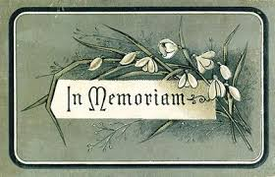

In Memory of Family | Margery McCaskill | Sander Stewart
Elizabeth & Gordon Bracken | Heather McCaskill | Elizabeth Stewart
 | Munroe McCaskill
Mr&Mrs Leonard McPhee-Hutton |  | Ivy Scott & Mr. & Mrs. Alex D. Stewart
Dr. Linda Grace Hutton |  | Donald J Stewart
John W. & Kathy Hutton

Thank you to our Donors – 2016
Addison, Dona | Hartrick, Ian & Michelle | MacQueen, Evelyn
Apps-Douglas, Julia | Hartrick, Neil R. | MacQueen, Thelma
Arkinstall, Andrew & Laurie | Heinsma, Lynda & Jerry | MacRae, Catherine
Arkinstall, Doug | Hollis, Moira & Murray | Massia, Lorna
Arkinstall, Gwenneth | Hutton, John W. & Kathy | McCaskill, Heather
Arthurs, Robert & Heather | Hutton- Grace, Dr. Linda | McCaskill, Munroe
Barret, Darlene M. & James | Jamison, Pam | McCormick, Ron & Barbara
Beales, Florence | Jean-Louis, Andre & Grace | McDonald's Electric
Beaumont, Verna | Jean-Louis, Ian & Kathryn | McEwen, Kenneth & Christina
Bickerstaff, Janet | Jean-Louis, Katie | McIntosh, Evan & Heather
Blaney, Allan & Sandy | Jeaurond, Roger & Cynthia | McLean, Alastair
Bracken, Gordon & Elizabeth | Jelley, Laura | McMahon, Joanne
Buchan, Heather & Angus Grant | Jelley, Ron & Wilma | McRae, Chad & Ashley
Cameron, Francine | Johnston, Isabelle | McRae, Doris & David Proudfoot
Campbell, Betty | Kanai, Sachiko | McRae, Glen & Mary-Anne
Campbell, Brian & Karen | Kelly, Marjorie & Donald | Mesman, Andrew & Norma
Campbell, Bruce & Louise | Ladouceur, Myrna | Munroe, Ruth & Dean
Campbell, Eileen | Lang, Wendy & Roy | Nixon, Donna J.
Campbell, Nancy | Little, Grant | Nixon, Donna M. & Stuart
Campbell, Richard & Pat | Loewen, John & Donna | Nixon, Eunice
Cdn. Border Services Gift Fund | MacCrimmon, Harold & Janet | Nixon, Glen & Penny
Chatterson, Rosemary | MacCrimmon, Margaret | Nixon-Crawford, Audrey
Cherry, Don & Pauline | MacDonell, Bernard & Mona | O'Donohue, Dwaine & Florence
Cherry, Richard & Eileen | MacEwen Petroleum Inc. | Paterson, Sheila
Cherry, Ryan & Gianna | MacEwen, Allan | Peckett, Heather
Chisholm, Elizabeth | MacGillivray, Bruce & Lynn | Perry, Susan
Clark, Donald | MacGillivray, Emerson | Pollock, James & Gwen
Clark, Donalda | MacInnes, Glenda & Doug Sutherland | Prevost, James & Sandra MacPherson
Clark, Douglas A. | MacInnes, Brent | Reid, Wendy
Clark, Murdie & Louise | MacIntosh, Doris | Rupp, Margarita
Conners, William | MacIntosh, Steve & Julia | Russett, Brian & Serena
Corkal, Janice M. & J. Thomas | MacKinnon, Leslie & Joyce | Silmser, Donald & Catherine
Cousineau, Marilyn | MacLean, Donald & Martha | Sloan, Eric & Janice
Cunning, Mora | MacLean, Sterling | St Columba Presbyterian Church
Dewar, Gordon | MacLeod, Adele | Stevens, Percy
Draffin, Ruth | MacLeod, Donald Ian & Jean | Stewart, Andrew
Fletcher, James | MacLeod, Gladys | Stewart, Archie & Catherine
Forrester, Dorthy | MacLeod, Allison & Jason Leroux | Stewart, Debra
Fraser, Jack & Linda | MacLeod, Kenneth & Annette | Stewart, Donald J.
Fraser, Jean & Malcolm | MacLeod, Kenzie & Elsie | Stewart, Elizabeth
Fraser, Mark & Jade | MacLeod, Kevin | Stewart, Tyler
Fraser, Rae | MacLeod, Margaret | Urquhart, Eileen
Fraser, Sandra & Gordon | MacLeod, Marvel | Urquhart, Evelyn
Fresque, Dorothy | MacLeod, Roberta J. | Urquhart, Keith
Gaudreau, Jean Guy | MacLeod, Shawn & Annik | Walker, Allan
Gauthier, Gerard & Catherine | MacLeod, Wendy | Williams, Janet (Jean)
Glengarry Highland Lodge | MacMaster, Brenda | Zsadany, Ron & Faye
Hartrick, Annabelle | MacMillan, Lorna
Hartrick, Ewan & Donna | MacQueen, Audrey

