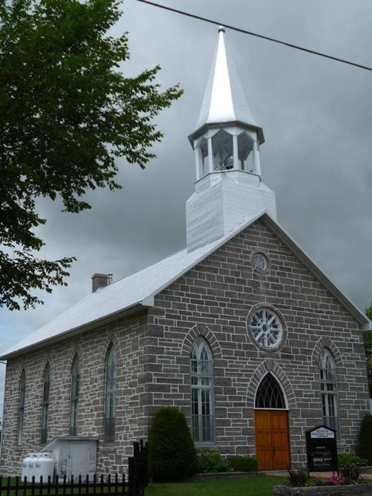

Kenyon Presbyterian Church
Annual Report 2021

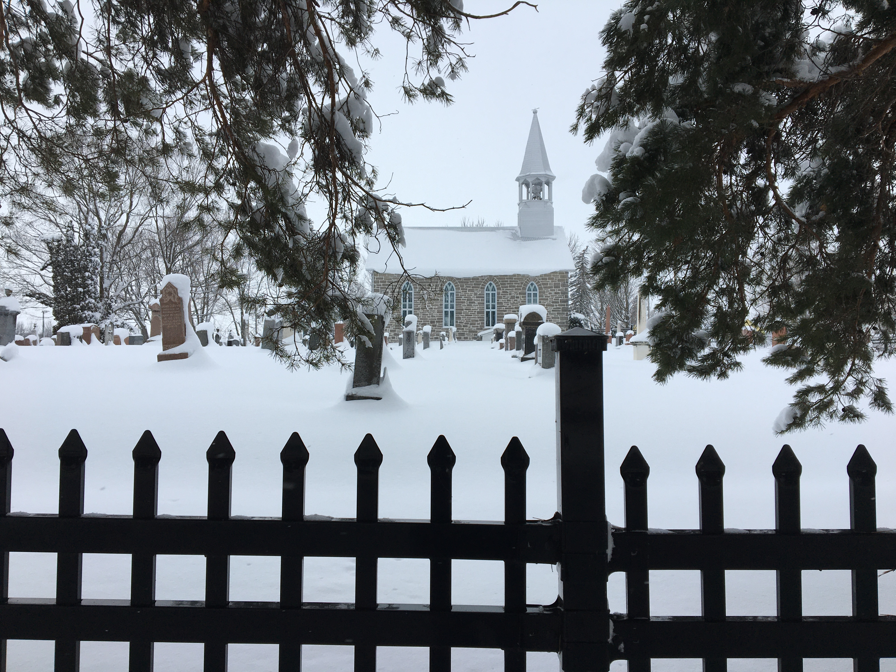

Table of Contents

From your Interim Moderator… 2
Committees and General Notices for 2022 3
Minutes of the 2020 Annual Meeting held February 28, 2021 4
Mission, Vision, Values and Motto 7
Kirk Session Report 2021 8
Membership 9
Baptisms 9
In Memoriam 9
Search Committee Report 2021 10
Cradle Roll 2021 11
Maxville Manor Report 2021 11
Board of Manager’s Report 2021 12
Kenyon Women’s Association Report 2021 14
Sunday School Report 2021 15
Cemetery Committee Report 2021 16
Investment Committee Report 2021 17
Memorial Donations – Kenyon Presbyterian Church – 2021 18
Memorial Donations – Kenyon Presbyterian Church Cemetery – 2021 19
Thank you to our Donors – 2021 20

From your Interim Moderator…

Last year in my message, I had made reference to 2020 being “...a year like none other in recent memory”. Most of that observation was informed by the onset of the Covid-19 corona virus. There was hope that 2021 would be a time when life would be restored to normal. It hasn’t turned out that way. As Yogi Berra quipped, “It’s Deja Vu all over again”.
Over the course of this past year we have had challenges - some of them brought on by Covid-19 and its variants. In so many ways you - as a congregation and followers of Christ, have met them, whether the challenges are the shifting protocols and requirements to deal with the spread of the virus...through to your support of Kenyon Church - not only financially, also with your time and talents. To offer some examples, your Memorial Sunday and the Church School Christmas Program were held again, despite restrictions, and each was truly memorable. Thank you to everyone involved conducting each of them.
Here are some thoughts on last year. There are several ways to describe your congregation. For me, the word Resilience comes to mind: resilience and a deep and abiding faith in God and that we are always in God’s hands.
As I look back over last year, I am reminded of the Gospel narrative of Jesus stilling the storm (Mark 4: 35 - 41). He and his disciples are crossing the Sea of Galilee. On their way across, a vicious squall comes up - nearly swamping their boat. It is tossed to and fro in the water as the squall strengthens in its fury. All the while Jesus is in the stern of the boat - sleeping. His frantic disciples waken him, and when he “..rebukes the wind and the waves”, everything settles down and is calm.
In the course of the past two years especially, more than likely there have been times we’ve felt “tossed and turned all over the place” as well; perhaps not to the same extent as in the Gospel narrative. Yet, there have been challenges to how we have carried out the basics of our congregational life: regular worship, visiting, special events. And more deeply, our spirits, our mental and emotional health have been affected. The late William Barclay describes it as, “..when life’s problems involve us in a tempest of doubt and tension and uncertainty..”.
In face of these times, I’d say that’s where the intersection of our faith and resilience is found. With the faith that is first given to us by our God and when we seek God’s guidance and discernment, out of this seeking comes the resilience to move forward and to step out in faith. What this year and the years to come will bring cannot be fully revealed. In the meantime, we continue to seek God’s guidance and discernment... we continue to live out our faith.
On a concluding note, I want to thank you for your support that’s been shown in so many ways: for our congregation and members and for me as your Interim Moderator. May God’s every blessing be with each of you this year and beyond.
Rev. Jim Ferrier, Interim Moderator

Committees and General Notices for 2022
Website: kenyondunvegan.ca Facebook: Kenyon Presbyterian Church
Worship Service Times: |  |  | January to April – 11:00 a.m.  May to August – 09:30 a.m.
 |  |  | September to December – 11:00 a.m.
Kenyon Session Meetings: |  |  | Every other month except June and July
Board of Managers Meetings: |  |  | Third Sunday of each month except July and August
The Kirk Session
Jack Fraser (2023) | Gwen Arkinstall (2022) |  |  | Wendy MacLeod (2022) |  | Ashley MacLeod-McRae (2021)
Bobbi Jo MacLeod (2021) | James Prevost (2022) |  |  | Heather McIntosh (2023) Clerk
The Deacon’s Court
Donald MacLean | Jack Fraser |  |  | Leslie McKinnon |  | Ian Hartrick
Board of Managers
Until Mar 2022 | Until Mar 2023 |  |  | Until Mar 2024 |  | Until Mar 2025
Betty Bracken | Evan McIntosh |  |  | Janet MacCrimmon |  | Laurie Arkinstall
Laurie Arkinstall | Jack Fraser |  |  | Elizabeth Anne Nutt |  | Lynn MacGillivray
Doris MacIntosh | Eric Nixon |  |  | James Prevost
Nominating Committee
Until Mar 2022 | Until Mar 2023 |  |  | Until Mar 2024 |  | Until Mar 2025
Dona Addison | Doris MacIntosh |  |  | Gwen Arkinstall |  | Audrey MacQueen
Board of Trustees
Laurie Arkinstall (2025) | Heather McIntosh (2024) |  |  | James Prevost (2023)
Investment Committee
Evan McIntosh (Treasurer) | Jack Fraser (Church Member)
Laurie Arkinstall (Trustee) | Heather McIntosh (Trustee) |  |  | James Prevost (Trustee)
Auditors for 2021-2024 | Myrna Ladouceur |  |  | James Prevost
Cemetery Committee
Gordon Bracken (2024) | Myrna Ladouceur (2024) |  |  | Eric Nixon (2024) |  | Audrey MacQueen (2024)
Wendy MacLeod (2024) | Janet MacCrimmon (2024)
Church Treasurer: |  |  |  |  | Cemetery Supervisor:
Evan McIntosh  Kenyon Presbyterian Church |  |  |  |  | Audrey MacQueen Email: audreymacqueen@gmail.com  Kenyon Presbyterian Church
1630 County Rd. 30 |  |  |  |  | 1630 County Road 30
Dunvegan, ON K0C 1J0 |  |  |  |  | Dunvegan, ON K0C 1J0
613-322-9404 Email: treasurerKPC@gmail.com |  |  |  |  | 613-527-1655 Email: cemeteryKPC@gmail.com
Hall Rental | Custodian |  |  | Proof Readers
James Prevost (2022) | Annette MacLeod |  |  | Laurie Arkinstall
 |  |  |  | Wendy MacLeod
Ushers
Heather McIntosh | Jack Fraser |  |  | Doris MacIntosh |  | Jean MacLeod
Linda Fraser
Minutes of the 2020 Annual Meeting held February 28, 2021
Agenda Item #1 The annual meeting of Kenyon Presbyterian Church, Dunvegan was held on Sunday February 28, 2021 at 1 pm. It was conducted over a conference call format organized by Evan McIntosh through Bell services. The instructions for participation were included in the printed copy of the 2020 Annual Reports along with an agenda and service content, which had been delivered door to door by volunteers. Rev. Jim Ferrier, Interim Moderator, called the meeting to order, quoted Scripture from Matthew 6: 25, 33, 34, and welcomed 13 members. Members identified were James Prevost, Jack Fraser, Janet MacCrimmon, Doris MacIntosh, Audrey MacQueen, Gwen Arkinstall, Jean MacLeod, Myrna Ladouceur, Elizabeth Nutt, Bobbi-Jo MacLeod, Heather and Evan McIntosh. In the following minutes, first names will be used to identify the comments of individuals. Three members, Laurie and Andrew Arkinstall and Wendy MacLeod, sent regrets of not being able to participate.
Agenda Item #2 Gwen nominated Rev. Jim to serve as chairperson, seconded by Jack. All in favor.
Agenda Item #3 Several nominations did not provide a secretary so Janet volunteered. Gwen moved to accept Janet as secretary, seconded by Evan. All in favor. A transcript and audio copy are now available, thanks to Evan. However, voice recognition and the resulting audio and transcribed copy demonstrate the shortcomings of this technology. Anyone reading the transcribed copy should be aware that corrections cannot be made and the raw language did not occur. It is merely a machine trying to rapidly translate from other technologies. The role of secretary will not soon be obsolete.
Agenda Item #4 It was moved by Myrna and seconded by Doris to receive the minutes from 2019. All in favor. No errors or omissions were contained in the minutes. Myrna asked if the recorded length of term for the auditors was correct. Evan clarified with reference to page 3 details. Heather thanked Wendy for including such meticulous details in the minutes. All in favor.
Agenda Item #5 It was moved by Heather and seconded by Jack to receive and adopt the written Committee and Financial Reports for 2020, contained on pages 8 to 15. All in favor. Heather asked for a correction in the recording of the In Memoriam report on page 10. In last year’s minutes a request was recorded to include spousal names to more accurately identify the deceased. James confirmed that it would only be a matter of adding and adjusting columns for the information. The extra information will be added for 7 of the 9 individuals listed. Audrey MacQueen stated she would search for the lesser known information.
This discussion led to a mention of the Crypt Keeper software, currently being updated by Katie Arkinstall. Evan and James confirmed that the software had the capacity to store obituaries and details of relatives. Rev. Jim noted this job of keeping a detailed record of family connections, lies in the hands of the Cemetery Committee. Each successive year, the preparations for Memorial Sunday and all burials, highlight the need to know the ancestry of congregational members. Audrey, current Cemetery Supervisor, explained that she was maintaining the habit of Margaret MacLeod, former Cemetery Supervisor, who kept a scrapbook style collection of obituaries, in a dual role as historian.
The Kirk Session report submitted by Heather, page 8, was without errors or omissions. Heather stated that during the Pandemic so many members contributed to keeping the Church business alive and well. Rev. Jim was a large part of the leadership effort to engage all efforts, ruled by restrictions.
The Search Committee Report, page 10, submitted by Laurie, was without errors or omissions. Jack thanked Laurie for her hard work and leadership, which resulted in progress within the Covid-19 restrictions. Janet was hopeful that the statistical detail in the congregation narrative would be acceptable for an extended period of time, to allow for the Search to come to an end, after restrictions. Rev. Jim was sure that the Presbytery was aware of the steady progress made by the Search committee.
The Cradle Roll submitted by Margaret MacLeod, page 11, was without errors or omissions.
The Maxville Manor Report submitted by Linda Fraser, page 11, was without errors or omissions.
The Board of Manager’s Report submitted by James, page 12 – 13, was without errors or omissions. An impressive list of projects was completed throughout the year, as Audrey commented, because members had time on their hands. It was possible to do extensive indoor and outdoor renovations without interruption or regular traffic on the property. A positive financial situation made the improvements possible. Jack reminded us that the necessary repairs were carried out with prior planning, budgeting and purpose, not hasty decisions for cosmetic reasons. Generous donors have initiated the major capital projects as noted in reports. Rev. Jim added that he constantly hears comments that the Church property and grounds show how much its members care.
The Kenyon Women’s Association Report, page 14, was without errors or omissions. Evan took on the role of treasurer. The report, submitted by the executive of Dona Addison, Catherine Gauthier and Margaret MacLeod, who were not part of the call, noted a change or reorganization will be needed in the future. This committee will soon be without leadership and has lost its ability to function due in part to restrictions. Without potential new members, how will the catering, fundraising, gardening and decorating be organized and completed? These activities of care and hospitality are very necessary and appreciated by the congregation, visitors, and benefactors. Further discussion was deferred to new business.
The Sunday School Report submitted by Bobbi-Jo, page 15, was without errors or omissions. Heather thanked Bobbi-Jo who persevered to create and distribute packages of children’s material for faith education and worship at home. Families appreciated the materials and agreed that monthly deliveries filled the void just right. Rev. Jim called Bobbi-Jo’s efforts, “remarkable work”.
Agenda Item # 6 Financial Reports for 2020, pages 16 to 22, were submitted by Evan. Evan moved that the 2020 Financial Reports be received and adopted, seconded by Audrey. All in favor. Evan clearly and concisely explained the receipts and disbursements as well as investments, identifying annual differences. In summary, receipts from donations were increased substantially, so that allowed the church to be generous with the Mission Initiatives in the community. Some capital projects, such as the window upgrades and cemetery ramp, will be completed in 2021. A large decrease in expenses for the cost of weekly ministers has stopped the practice of drawing from investments. Generous estate bequests have allowed more money to be moved to investments. Overall, the church’s finances are in very good shape.
Agenda Item #7 No comments were made for old business.
Agenda Item # 8 New business dealt first with Presbyterian Sharing. Evan explained that the usual assessment is 10% of the 2019 dollar amount of the end of year statistical report. $2000.00 was the rounded up amount. It was moved by Jack and seconded by Gwen that the sharing be increased to $2000.00. All in favor.
Members of the congregation may read the report compiled by the Search Committee that describes the people and our community for prospective ministers.
The issue of the possible demise of the Women’s Association was treated seriously by the members on the conference call. It was noted that WA contributions have been a key part of the heart and soul of Kenyon Church. Gwen stated that members were always very compliant to requests for help or food items, but the problem was a lack of interest in being part of the association. Leadership is needed to make events successful. Rev. Jim believes that a solution will be more evident as the pandemic restrictions are relaxed. He added that many more members and their families should be invited to contribute specialized skills. This topic will continue to be discussed at every opportunity.
A Memorial service, dedicated to our members and adherents who passed away in 2020, included scripture, prayers and personal reflection. Names of the deceased listed on pages 10, as well as donors pages 24 and 25 indicate a common pattern of generosity within the congregation. Such traditions support Kenyon Church emotionally and financially.
Adjournment was agreeable to all at 2:35pm.
Thanks to “tech savvy” Evan for all he did to organize a successful conference call.
Agenda Item # 9 Rev. Jim finished with a prayer.

Mission, Vision, Values and Motto

MISSION STATEMENT
Provide a safe space where the community can freely gather to worship and praise God to grow in Christian faith.

VISION STATEMENT
On our journey forward we will:
- Live as a caring congregation seeking to share, show and speak about the love and joy of knowing God
- Adapt to changes and take risks to live by our values by hearing and teaching His word through the gospel of Jesus Christ
- Promote stewardship of accumulated resources
- Foster communication between session, committees and the congregation
- Invite the participation of all in our church programs and activities
- Support the world-wide mission of The Presbyterian Church in Canada

VALUE STATEMENT
We value:
- The involvement of members, adherents and children
- Interdependency and caring for one another
- Trust and integrity
- The power of prayer
- The use of our spiritual gifts in Christ’s service

MOTTO
With God we find a way

Kirk Session Report 2021

We have emerged from 2021, a very stressful year, full of pandemic anxiety related to outbreaks, vaccination, COVID testing and numerous protocols, health, food and financial insecurities. As well the world threats of climate change with numerous climate disasters, economic disparities between countries, rampant racism, and the tragic legacy of residential schools have left us unsettled and unsure. The theme of the 146th General Assembly of the Presbyterian Church in Canada which happened in June 2021 was “Fear Not, I am with you”. We have to remember this in our hearts and minds, to keep moving forward in a positive manner.
We started the year in lockdown where we decided to move forward with online services in mid-January which continued until the end of June when restrictions were eased. However, we did decide to cancel services for Christmas Eve and December 26th, as case numbers of the omicron variant increased in our community. Session members, while being unable to meet in person, communicated via many, circular emails and telephone calls to make certain decisions as circumstances changed. We did get to hold 3 in person meetings in July, September and November where we homologated our email decisions. In person worship resumed in July where there was great joy in being with our church family once again. We were able to celebrate World Communion on October 3rd and the first Sunday of Advent on November 28th, following Public Health protocols and using the Fellowship cups.
We did get to hold various special services with 3 infant baptisms being enjoyed by the congregation. Emily Margaret Mesman, infant daughter of Kelsie Mesman and John Davidson was welcomed on September 26th, Sophia Melody Blanchette, infant daughter of Ashley Nixon and Stephane Blanchette welcomed on November 17th and Nathaniel Bennett Lowe, son of Rebecca and Alex Lowe welcomed on November 31st. Our Memorial Sunday service on September 5th was well attended with many musical selections presented and appreciated. We are thankful to have the musical talent of Ashley MacLeod-MacRae and her Kenyon Youth Strings group, composed of Brenna Villeneuve, Kenzie and Shelby MacRae and Cadence MacIntosh. Their poignant memorial video is also posted on our church website. Allan Walker with his bagpipes was a much appreciated treat.
Our Remembrance Sunday service on November 7th was well attended with congregation members giving readings like the History of the Poppy, the WWI and WW2 Honor Rolls, In Flanders Fields poem and laying of the Wreaths. We are thankful for Kim Little and Rosemary Chatterson for their piano playing and vocal musical selections which accompanied this service.
Thanks also to the bagpiping musical talent of Lynn MacGillivray, during, before and after the service.
Our last special service of the year was on December 12th- the Sunday School Christmas Program, under the capable direction of Bobbi MacLeod and Kathryn Levesque. We were treated to the wonderful voices of the Glengarry Girls Choir, directed by Kim Little and musical selections and Christmas readings by Vivica, Zoe, Addison and Ellie Matar. We feel truly blessed to be surrounded by so much musical and leadership talent.
The joint online services for the first half of the year were done with the dedication of Reverend Jim Ferrier and the Little family of Kim, Eric, Issac and Tori. These valuable worship services were enjoyed by our congregations and their families and friends far and near. We enjoyed seeing and hearing Merle Marjerrison in the pulpit supply role too. We appreciate the pulpit supply of Guy Laberge during regular in person services too as a familiar face and voice. A big vote of appreciation is given to James Prevost for taking care of our church website and Facebook site, which gets used regularly.
We are again very appreciative for the dedication and hard work of our Board of Managers including the Cemetery Committee, the Investment Committee, the Treasurer, the Church and Hall Caretakers, Church Decorating Committee and Sunday School. We have so many members working behind the scenes to keep our church buildings and grounds so well-groomed and beautiful. We acknowledge, with thanks, the faithful support of members and their families, adherents and many friends for their financial support and generosity to our financial needs. We consider ourselves very fortunate to have Reverend Jim Ferrier provide the spiritual leadership and support as our Interim Moderator to help us navigate through, again, another pandemic year. We pray that he and his wife Olga stay safe and healthy as we all proceed together to face the joys and challenges of this next year. We pray for God’s grace and guidance too as the Joint Ministry Search Committee completes their work with both congregations to ready the Call for a Minister proposal to Presbytery.
We are God’s people, called to serve God with our many gifts. When we work together, we can accomplish so much more than we ever could on our own.
Respectfully submitted
Heather McIntosh, Clerk of Session

Membership
On Roll as of January 1, 2021 |  | 86
Added by Profession of Faith |  | 0
Added by Session - Transfer |  | 0
Removed by Certificate |  | 0
Removed by Death |  | 1
On Roll as of December 31st, 2021 |  | 85

Baptisms

Name | Date of Birth | Date of Baptism
Emily Margaret Mesman  Sophia Melody Blanchette  Nathaniel Bennett Lowe | April 19, 2021  February 3, 2021  September 14, 2021 | September 26, 2021  October 17, 2021  October 31, 2021

In Memoriam

Name |  |  | Date of Death | Date of Burial | Age | Urn /Coffin
Florence O’Donohue | neé MacIntosh |  | January 8, 2021 | May 1, 2021 | 84 | Urn
Dorothy E. Fresque | neé Fretwell |  | February 7, 2021 | September 18, 2021 | 93 | Urn
Muriel N. English |  |  | September 13, 2021 | September 25, 2021 | 91 | Urn
Kenzie D. MacLeod |  |  | October 9, 2021 | October 16, 2021 | 87 | Urn

Search Committee Report 2021

The Search Committee to find a new Minister for Kenyon Presbyterian Church and St Columba Presbyterian Church continued to forge ahead in 2021. Kenyon Members are: Laurie Arkinstall, Jack Fraser, Lynn MacGillivray and Janet MacCrimmon. St Columba members are: Doreen Howes, Rowan MacPherson, Ralph MacGillivray and Pauline Hambleton. The committee has been diligently guided by Reverend Jim Ferrer.
The Search committee held a total of five in-person meetings this year. The committee continued our work on the Congregational Profile and added the Mission Statements we received from our respective Sessions. The committee looked at in depth, what the congregations wanted and needed from a Minister. Along with these discussions, the committee reviewed what the joint churches could financially afford.
Along with the Congregational Profiles, the committee wrote a detailed cover letter to the Sessions of Kenyon and St Columba recommending the hiring of a three-quarter-time Minister. In this letter, it was outlined what a three-quarter-time Minister’s role and responsibilities would entail. As well, the committee recommended the details they would like to see in a Call to a Minister; such as stipend and employee benefits among other things. The committee awaits a response from the Sessions before we can proceed with the next steps in 2022.
I would like to thank all the committee members for their time, energy and thoughtfulness in working through the process of finding a new Minister for our congregations. A special thank you to Reverend Jim for his guidance, knowledge and patience through this search process.
Respectfully submitted,
Laurie Arkinstall
Committee Chair

Cradle Roll 2021

Children on Cradle Roll in 2021: |  |  | 8
Graduated from Cradle Roll in 2021: |  |  | -2
William James Ogilvie
Olivia Mary Fraser

Added by Baptism in 2021: |  |  | 3
Sophia Melody Blanchette
Emily Margaret Mesman
Nathaniel Bennett Lowe

Children on Cradle Roll as of December 31st, 2021: |  |  | 9
Birthday Cards sent in 2021: |  |  | 9
Babies are nature’s way of showing people what the world looks like at 2am

Respectfully Submitted,
Margaret MacLeod – Cradle Roll Superintendent

Maxville Manor Report 2021
Unfortunately, 2021 saw the continuation of the Covid-19 pandemic through the entire year. The pandemic continued to cause a great deal of stress for the residents, family members and staff. During the outbreak in January, all residents were confined to their rooms and visiting of residents was severely restricted. During the year, a hiring blitz was held to hire more PSWs (Personal Support Workers). New protocols were adopted such as rapid testing, new hygiene procedures, use of PPE (personal protection equipment) and vaccination of all the residents.
The redevelopment project is moving slowly forward. Maxville Manor has been approved to add 38 new beds for a total of 160 beds. G Architects have been hired to produce preliminary plans. A building committee has been formed and meets regularly. The financing of this project is complicated by Covid-19 related increased costs.
In 2021, The Board decided to change the governance model of the Manor. In the past, the Board of Directors has been comprised of individuals from founding organizations in the community. Starting in 2021, Board members will apply to sit on the Board and will be selected according to their skills and personal qualities. People who have the interest and compassion to serve the seniors of this area will be welcome to apply to sit on the Board. Since these changes were adopted in October, this will be the last report that will be submitted to the Kenyon Presbyterian Church annual report. The church will no longer send a representative to the Maxville Manor Board of Directors.
Respectfully submitted, Linda Fraser

Board of Manager’s Report 2021

The Board of Managers held 3 regular meetings in 2021. Betty Bracken volunteered to be the BOM secretary. BOM members Jean MacLeod, Jean-Guy Gaudreau and James Prevost completed their 3 year terms on the Board. Elizabeth Ann Nutt, James Prevost and Janet MacCrimmon were welcomed as Board members for 3 year terms.
Cemetery Committee members continued their active participation in all Board of Manager’s meetings. This enables the committee to work closely with the Board of Managers to review/discuss/resolve cemetery tasks and issues.
The Annual General Meeting was completed successfully using the Bell Conference Centre application. This worked well as we could not meet in person due to COVID-19 restrictions. Thanks to Evan McIntosh for investigating and testing this option to make sure it could be used for our meeting.
Kenyon Church is privileged to have Rev Dr. MacMillan’s collection of books and sermons. The congregation can continue to reference or read these books if they wish.
The board welcomed Annette MacLeod as the Church/Hall caretaker. She was given a job description and has agreed to a commitment of 2 hours work per week for $200 per month compensation.
There were no private church hall rentals in 2021.
In 2021, there was a major capital project completed to improve the accessibility and usage of the area surrounding the west side of the Church and the patio area between the Church hall and the Church building. The cemetery map was re-installed where it is easily accessible and readable. This project was completed by Andy Scherer Landscaping and was jointly funded through donations to the cemetery and the church. The total cost of the project was $26,546.46.
This major landscaping improvement will not only provide better and safer access to the cemetery from the church and the hall, but it will provide a meeting and gathering area for families to visit during the Memorial Sunday event and for other family gatherings like baptisms, weddings and funerals.
There was a 2nd major capital project that was budgeted and approved for 2021 but it was not completed due to the Covid-19 pandemic. This capital project was the replacement of the 2 West Plexiglas coverings over the stained glass windows. This project is scheduled for completion in 2022.
A few other maintenance tasks completed include:
- Removal of overgrown dying shrubs. Thanks to Gordon (Corky) Bracken for doing most of the work.
- Water samples taken quarterly for testing. Thanks to Heather McIntosh for taking them into Ottawa
- Church attic and window/eaves exteriors were sprayed for bugs and wasps in the hall
- Furnace cleaning and repair
- Water system and snow blower maintenance
Eileen Campbell’s family purchased a bench in memory of her to be placed in the walkway / patio area. In recognition of Eileen’s many dedicated years as church organist, the BOM chose to donate towards this purchase.
The board thanks the volunteers from the congregation and their families for the inventory and cleanup of the hall basement and removal of the unused 2 stoves and refrigerator.
The board recognizes Doris MacIntosh for her work on the garden at the Church sign and for maintaining the Pioneer Cemetery site on Skye Road.
The board thanks Jean MacLeod for organizing and compiling the lists for the welcoming committees, the collection bearers and the tithe counters each year.
The board thanks Wendy MacLeod for providing the health and safety signage for the Covid-19 pandemic restrictions and guidelines which were posted in the Church and the Church hall.
Christmas gifts were purchased and delivered.
Thanks to our Board of Managers and Cemetery Committee members, who continue to donate their time, talents and resources towards keeping the Church, the hall and the cemetery a beautiful and intricate part of this community.

Respectfully submitted by,
James Prevost, Chairperson
Betty Bracken, Secretary

For we are God's handiwork, created in Christ Jesus to do good works, which God prepared in advance for us to do. — Ephesians 2:10

Kenyon Women’s Association Report 2021

Due to the length of the COVID-19 pandemic, only one meeting was held in 2021. It took place in the month of November with 6 members present.

A long discussion was held regarding the viability of the Women’s Association. The pros and cons were taken into consideration. It was with heavy hearts that the vote was taken to disband the Kenyon Women’s Association effective November 20, 2021. Carried

The W.A. bank account as of October 26, 2021, contained $6,463.18 including two G.I.C’s due in 2022 and 2023. The chequing account portion is to be left as is for now. In the event that going forward a committee may wish to organize planned events for the Church, these funds would be available for their use.

A list of Christmas gifts were delivered by Dona Addison and the bill was given to the Church Treasurer. No more gifts will be accepted by the W.A.

In regards to the Stirling silver cutlery, Betty Bracken is to approach the Board of Managers for ideas.

Special thanks are extended to:
- Dona Addison for her leadership
- Jean MacLeod and Betty Bracken for the catering committee
- Doris MacIntosh, Jean MacLeod and Betty Bracken for the decorating committee
- Wendy MacLeod for the Reverend Dr. MacMillan Library

On behalf of the ladies of the W.A., we wish to thank all who have supported our organization over the years.

Respectfully submitted,
Dona Addison [President]
Catherine Gauthier [Secretary]
Margaret MacLeod [Treasurer]

When Jesus spoke again to the people, he said, "I am the light of the world. Whoever follows me will never walk in darkness, but will have the light of life." — John 8:12

Sunday School Report 2021

We have 15 children on the Sunday School Roll with Kathryn Levesque and Bobbi Jo MacLeod as teachers. The Lesson framework from January untill June 2021 was prepared by Bobbi Jo MacLeod. The Sunday School was closed to in-person learning from January to June 2021 due to the Covid 19 Pandemic. The lessons were sent out by email once per month as was agreed upon by the parents. The children of the Sunday School did participate in Easter, Mother’s Day, & Father’s Day Online Church Services through gifts of music, recitations, and pictures. A Memorial Video was made under the direction of Ashley MacLeod McRae for Memorial Sunday.

In September the Sunday School was back to in-person learning. The average number of students attending Sunday School for September – December 2021 was 2. The lessons were taught by Kathryn Levesque. The lesson framework was prepared by Kathryn Levesque.

The Sunday School decided this year to donate to Operation Christmas Child. The Sunday School with the help of the congregation brought in donations of items needed and the Sunday School children filled a total of 28 boxes. The congregation also donated food and hygiene care items for White Gift Sunday, collection and pick up was organized by Dona Addison and Gwen Arkinstall. The items were donated to the St. Vincent de Paul Society in Alexandria. Again, this year we had a good response from the members of the congregation. We thank all those who generously donated.

This year for the Sunday School Christmas gifts, we decided to donate $170 to PWS&D Gifts of Change on behalf of the Sunday School students. A certificate was made for each child and there were also small gifts purchased for the children.

Our Sunday School along with the teens in our congregation participated in St. Andrew’s Day and the Christmas Pageant, the children shared their musical talents much to the delight of the congregation. We were very pleased to also have the musical talents of the Glengarry Girls Choir, under the leadership of Kim Little join us for the Christmas Pageant. Thank you to Kim Little and Kathryn Levesque for their leadership and direction during these special services.

Unfortunately, due to the restrictions in place with COVID 19 the Summer Social was cancelled again this past year.

Thank you to Rev. Jim Ferrier for his leadership and support. We gratefully acknowledge the assistance of all parents and friends for their help and support.

Respectfully Submitted
Bobbi Jo MacLeod

Cemetery Committee Report 2021

Our cemetery committee has worked diligently this year to finish the new wheel-chair ramp between the church and hall including a viewing patio at the back of the church.
Improvements were made to the stairs in that area and the cemetery map base was installed at the edge of the new patio allowing for improved access for locating a grave. Our mission is complete as it is now safe and accessible to all. We are grateful to the late Connie MacLeod and the late Marjorie Kelly (nee MacKinnon) for providing the funding for this project.
This past year we had four private funerals. It has been a challenge for us but everyone stepped up to help. We now have protocols and equipment in place, updated as need be to address changing traditions.
For Memorial Day weekend we asked Ashley MacLeod-McRae to make a video highlighting the Cairn to help promote our weekend. What a gem she created! Please check it out on this link from the Church web site: https://youtu.be/kYG-W2j4RWk. Shelley MacPhee also played the bagpipes for us on Saturday. Thank you to both these Dunvegan ladies and the Kenyon Youth Strings for the great music.
A few additional examples of maintenance performed include:
- New benches were purchased.
- Overall cleanliness of the grounds.
- Topsoil dressing and grass seeding.
- Tree and shrub removal.
- Additional landscaping at the creek.
Our goal is to continue the care and maintenance of our cemetery.
Thanks to our committee and the continued support of family and friends of Kenyon Presbyterian Church
Respectfully submitted and God Bless,
Audrey MacQueen, Cemetery Supervisor

“For if we believe that Jesus died and rose again, even so them also which sleep in Jesus will God bring with him”. 1 Thessalonians 4:14

Investment Committee Report 2021
The Trustee Investment Committee was unable to conduct an in-person annual review meeting with our Church’s financial advisor, Randy Douglas of Echelon Wealth Partners, in 2021. Instead, through frequent telephone conversations and emails, Randy Douglas continued to communicate with us, update us and keep us fully informed throughout the year. Our conversations allowed for the overall review of our financial investments and to maintain a balanced investment portfolio. We utilized the Statement of Investment Philosophy, Policy and Guidelines in making decisions throughout the year.
The Church’s investment portfolio with Echelon Wealth Partners earned 3.4% in interest and dividends and had a steady increase in Market Value of 15.4% in 2021. The earnings on investments in the Canadian account were deposited into the Church bank account monthly to help cover operational costs. Randy Douglas continued to do a great job and give us sound advice to keep our investments safe and earning some income. There was a continued focus on purchasing quality investments with some earning potential. The portfolio includes high quality GIC’s, Fixed Income, Preferred Shared, Common Stocks, Bonds, Exchange Traded Funds and Income Trusts.
The Margaret U. Stewart Memorial Trust continues to be invested in the Church’s Canadian account with Echelon Wealth Partners. The original portion of the trust, $10,000.00 was designated to go towards Youth and Sunday School programs, the interest on this amount was calculated from interest and dividends earned in the Church’s Canadian Cash Account in the amount of $367.43 for the year 2021. The remainder of the Margaret U. Stewart Memorial Trust earnings go towards the general operation of the Church.
A bequest of $10,000 was made to Kenyon Presbyterian Church by the Estate of Dorothy Fresque in 2021. This generous donation was invested in the Church Canadian Investment account for future use.
The Cemetery portfolio with Echelon Wealth Partners earned 3% in interest and dividends this year and saw an increase of 5% in Market Value.
Through thoughtful consideration and prayerful management of these investments and with Donors continued support, Kenyon Presbyterian Church and Cemetery will be able to continue Gods work. Thank you to all our generous donors.

Respectfully submitted
Laurie Arkinstall

Memorial Donations – Kenyon Presbyterian Church – 2021

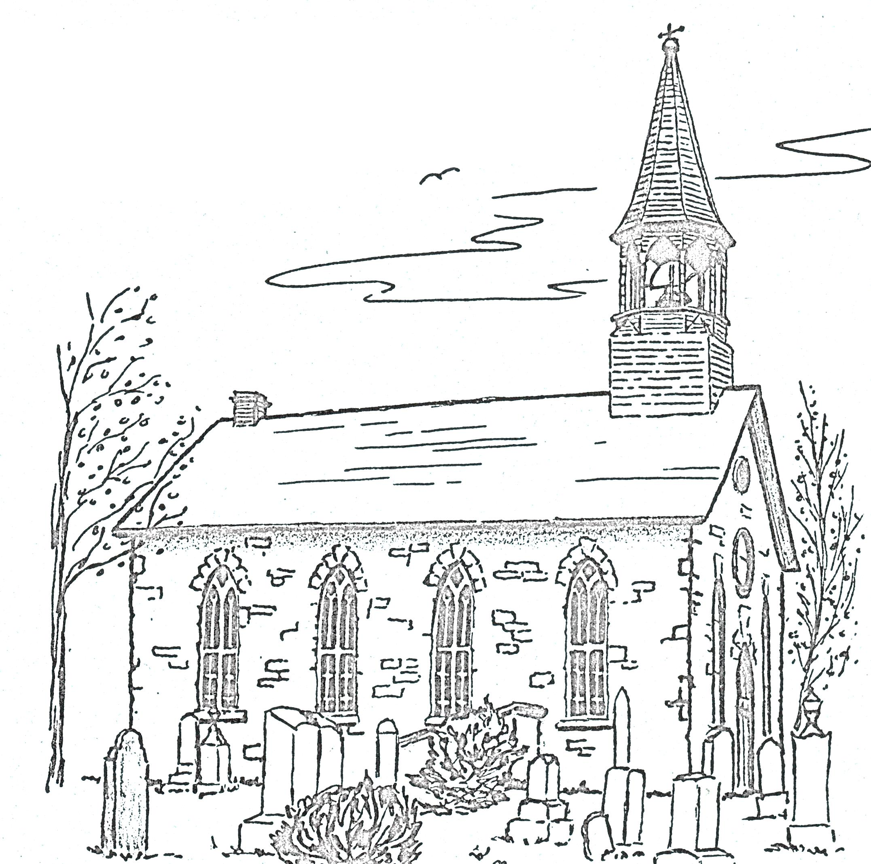
Weldon MacIntosh | Rev & Mrs. William J. Baxter
Myrna Ladouceur | Shirley Smith
Chris Nutt  Wendy MacLeod  Donald Ian & Jean MacLeod  Christina Mae MacEwen  Donald Ian & Jean MacLeod  Donna M & Stuart Nixon | Eileen & Allistair Campbell  Richard Campbell  Myrna Ladouceur  Lorna Massia  Brian & Karen Campbell
Stirling & Daryl Lang  Gary Hewston | Clifford & Christina Hewston  Gary Hewston
Lloyd MacCrimmon  Myrna Ladouceur | Mr. & Mrs. Leonard McPhee Hutton  Dr. Linda Hutton

And God shall wipe away all tears from their eyes; and there shall be no more death, neither sorrow, nor crying, neither shall there be any more pain: for the former things are passed away.- Revelation 21:4

Memorial Donations – Kenyon Presbyterian Church Cemetery – 2021

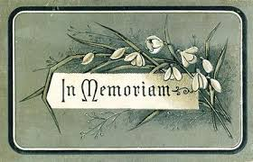

Danny John & Annabelle Hartrick  Ewan Hartrick | Frank & Mara MacDonell  Marlene MacQuaig
Kenzie MacLeod  Wendy MacLeod  Donald Ian & Jean MacLeod  Heather McCaskill | Spurgeon & Dora Golden  Greta & Charlie Golden  Elizabeth MacLeod  Brenda MacMaster
Donald & Freda Campbell & Lillian Campbell | Mr. & Mrs. L.M. Hutton
Leona Campbell & family | John & Kathy Hutton
Margery & Munroe McCaskill  Heather McCaskill | John Keith MacLeod  Marvel MacLeod
Sander Stewart  Elizabeth Stewart | Murray & Thelma MacQueen  Sandy & Allan Blaney
Douglas Sutherland  Glenda MacInnes  Lloyd & Eunice Nixon  Lois MacNaughton  Donna Nixon | Christina MacEwen  Wendy MacLeod  Chris Nutt  Doris MacIntosh  Marvel MacLeod

Then shall the dust return to the earth as it was: and the spirit shall return unto God who gave it. – Ecclesiates 12:7

Thank you to our Donors – 2021

Addison, Dona | Johnston, Isabelle | Munroe, Ruth & Dean
Arkinstall, Andrew & Laurie | Kennedy, Janet | Prevost, Sandra MacPherson & James
Arkinstall, Doug | Ladouceur, Ann & Roger | Rupp, Margarita
Arkinstall, Gwenneth | Ladouceur, Myrna | Nixon, Donna Jean
Barret, Darlene M. & James | Loewen, John & Donna | Nixon, Donna M. & Stuart
Barton, Ken | MacCrimmon, Janet | Nixon, Glen & Penny
Beales, Florence | MacCrimmon, Margaret | Nutt, Elizabeth
Beaumont, Verna | MacEwen, Allan | Peckett, Heather
Bickerstaff, Janet | MacGillivary, Royce | Shields, Helen
Bishop, Ronald & Sharon | MacGillivray, Emerson | Silmser, Donald & Catherine
Blaney, Allan & Sandy | MacGillivray, Lynn | Smith, Shirley
Blaney, Bruce | MacInnes, Glenda | Stewart, Elizabeth
Bracken, Gordon & Elizabeth | MacInnes, Rhonda | Stewart, Margaret
Buchan, Angus Grant & Heather | MacIntosh, Doris | United Way East Ontario
Cameron, Francine | MacKinnon, Leslie & Joyce | Urquhart, Eileen
Campbell, Betty | MacLean, Donald & Martha | Urquhart, Evelyn
Campbell, Brian & Karen | MacLeod Cameron, Bonnie | Urquhart, Keith
Campbell, Elizabeth | MacLeod, Brian | Walker, Allan
Campbell, Richard & Pat | MacLeod, Donald Ian & Jean | Waugh, Audrey
Chatterson, Rosemary | MacLeod, Gladys | Wilson, Isabel
Cherry, Richard & Eileen | MacLeod, Isabel Clark & Donaldson | Zsadany, Ron & Faye
Clark, Donald | MacLeod, Keith
Clark, Donalda | MacLeod, Kenzie & Elsie
Clark, Douglas A. | MacLeod, Kevin
Corkal, Janice M. & J. Thomas | MacLeod, Margaret
English, Muriel | MacLeod, Marvel
Ferrier, Jim & Olga | MacLeod, Roberta J.
Fraser, Alastair | MacLeod, Wendy
Fraser, Jack & Linda | MacMaster, Brenda
Fraser, Sandra & Gordon | MacMillan, Kyle & Carol
Fresque, Dorothy | MacMillan, Lorna
Gauthier, Gerard & Catherine | MacNaughton, Lois
Gibson, Katherine | MacCuaig, Marlene
Hartrick, Ewan & Donna | MacQueen, Audrey
Hartrick, Ian & Michelle | MacQueen, Evelyn
Hartrick, Ken | MacRae, Queenie
Hewston, Garry | Martin, Rev. Robert & Ruth
Hollis, Moira & Murray | Massia, Lorna
Hutton, Dr. Linda | McCaskill, Heather
Hutton, John W. & Kathy | McCormick, Ron & Barbara
Jean-Louis, Andre & Grace | McIntosh, Evan & Heather
Jean-Louis, Ian & Kathryn | McLean, Alastair
Jean-Louis, Katie | McRae, David Proudfoot & Doris
Jeaurond, Cynthia & Roger | McRae, Glen & Mary-Anne

