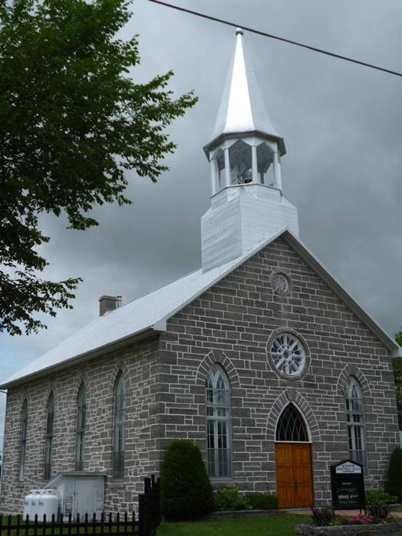
Kenyon Presbyterian Church
Annual Report 2023

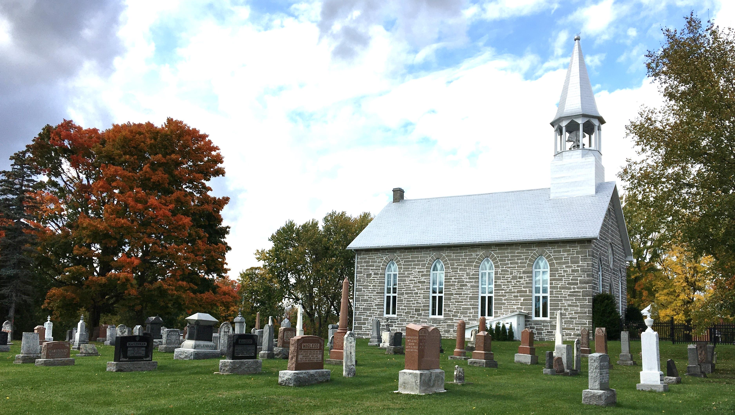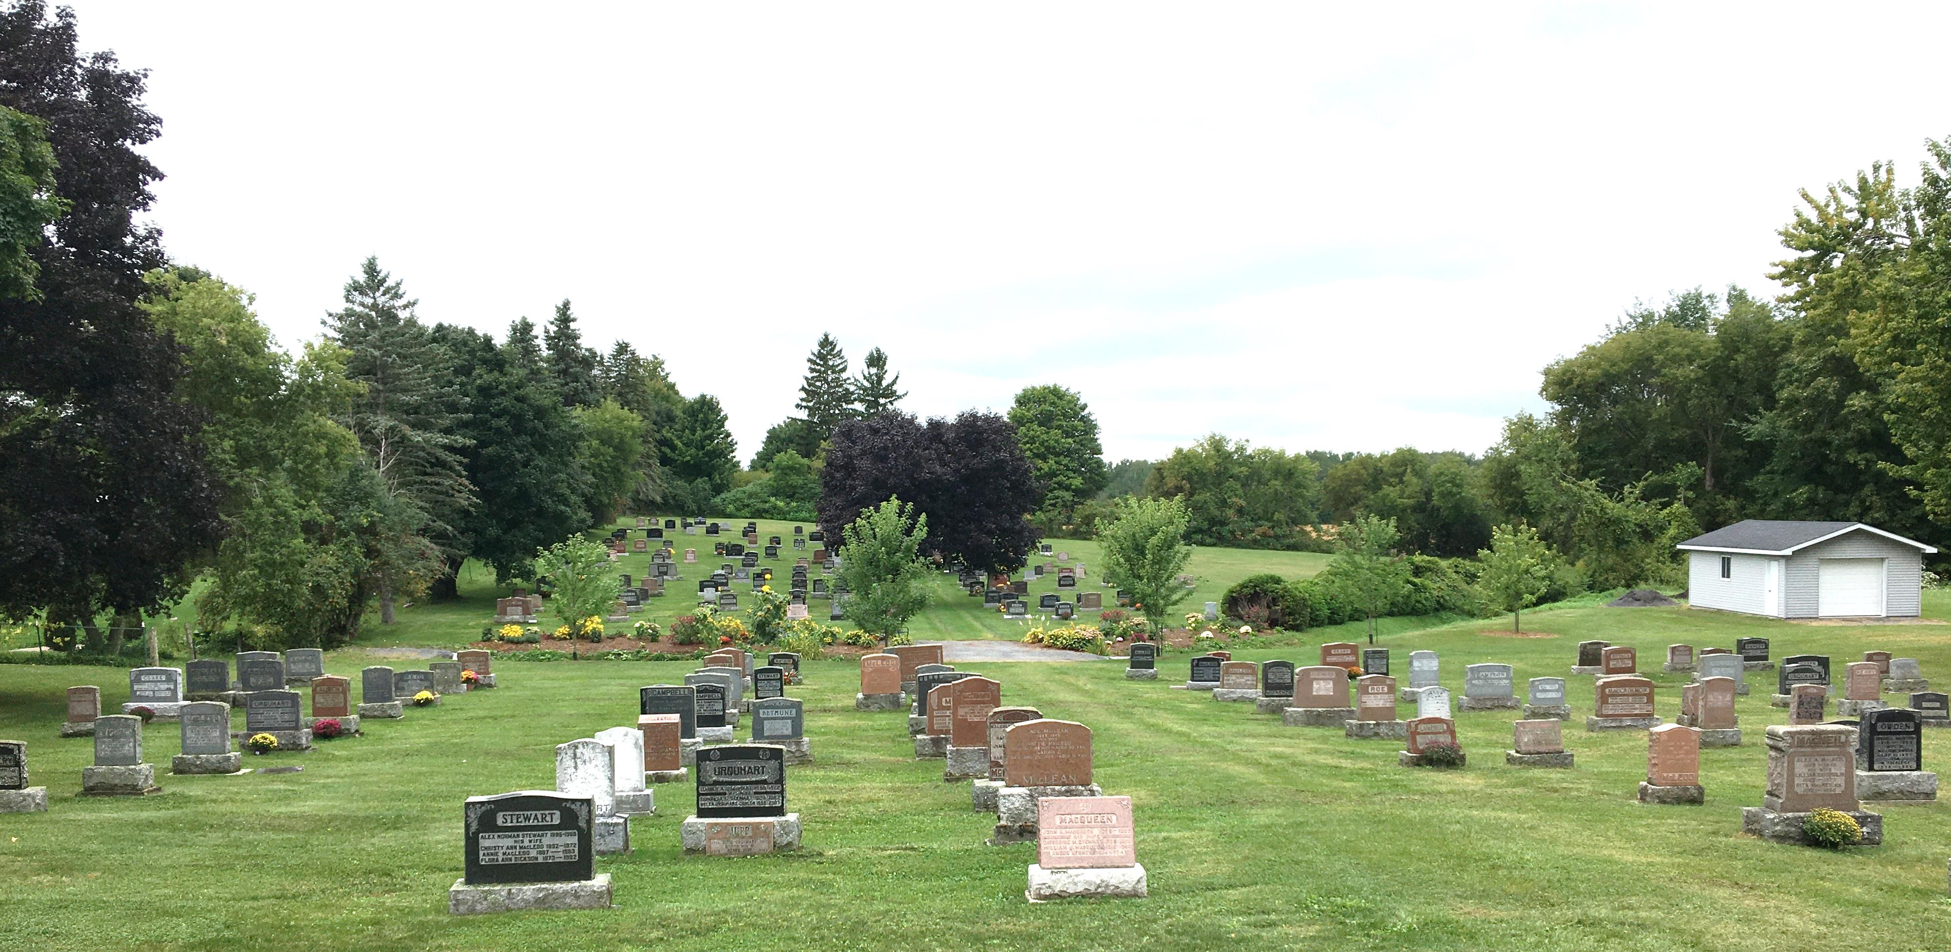

Table of Contents

Mission, Vision, Values and Motto 2
Interim-Moderator’s Message 3
Committees and General Notices for 2024 4
Minutes of the 2022 Annual Meeting held March 5, 2023 5
Kirk Session Report 2023 7
Membership 8
Weddings 8
In Memorium 9
Cradle Roll 2023 9
Search Committee Report 2023 10
Cemetery Committee Report 2023 11
Board of Manager’s Report 2023 12
Trustee Investment Committee Report 2023 14
Memorial Donations – Kenyon Presbyterian Church – 2023 15
Memorial Donations – Kenyon Presbyterian Church Cemetery – 2023 16
Thank you to our Donors – 2023 17

Mission, Vision, Values and Motto

MISSION STATEMENT
Provide a safe space where the community can freely gather to worship and praise God to grow in Christian faith.

VISION STATEMENT
On our journey forward we will:
- Live as a caring congregation seeking to share, show and speak about the love and joy of knowing God
- Adapt to changes and take risks to live by our values by hearing and teaching His word through the gospel of Jesus Christ
- Promote stewardship of accumulated resources
- Foster communication between session, committees and the congregation
- Invite the participation of all in our church programs and activities
- Support the world-wide mission of The Presbyterian Church in Canada

VALUE STATEMENT
We value:
- The involvement of members, adherents and children
- Interdependency and caring for one another
- Trust and integrity
- The power of prayer
- The use of our spiritual gifts in Christ’s service

MOTTO
With God we find a way

Interim-Moderator’s Message

Periodically, our Presbytery poses a question for its members’ reflection. For some time the question was “What did we do today to accomplish our mission?” It’s a good question to keep in front of us as we have a short review of the year past as well as look to the future for Kenyon Presbyterian Church.
2023 has been a busy year for Kenyon Church. Here’s a quick summary of activities and events from last year:
- The Sacrament of Holy Communion was celebrated during the year at the beginning of Lent, Pentecost and Advent, and on World Communion Sunday;
- Remembrance Sunday was marked on the 5th of November;
- Your “Old Tyme Service” was held on the 24th of September in conjunction with the Glengarry Pioneer Museum’s War of 1812 re-enactment weekend in September;
- In October our Presbytery organized a workshop on the topic of Lay Worship Leadership, and two of your Session members - Heather McIntosh and Jack Fraser attended it, and both were quite engaged in it;
- During the course of the Advent season, you were especially generous in your support of the St. Vincent de Paul Food Bank - both in monetary and non-perishable food donations.
One comment about this listing of special services and events: you’ll notice that quite a few services aren’t included. In her report for the Kirk Session, Heather McIntosh, your Clerk of Session, has listed the worship services that included special music and guest musicians. Inasmuch as Heather was very much involved in their organizing, it seems fitting that they be listed in the Clerk’s report. If you combine the two lists, you’ll notice that almost every month of the year there was a special event or service along with your regular services of worship.
At last year’s Annual Congregational Meeting the Sessions from each congregation brought forward a recommendation from the Search Committee. The recommendation was to put on hold the search for a Part-time (at 3/4 time) minister, so as to consider other options that may be more viable. The recommendation was upheld. Over the course of last year the joint Sessions considered other options. From these discussions the decision was made to reach out to Sessions of congregations in the area that are presently without a “settled” minister. The objective is to gauge their interest in forming an expanded Pastoral Charge. Our Sessions will keep you informed of developments as they come about.
In the meantime, we continue to be faithful to God and our mission, as God continues to be faithful to us. And on a personal note, I want to thank you for your continuing support for Kenyon Church and for me as your Interim Moderator. And much more importantly, that you continue to be Christ’s Church and to go about accomplishing his mission.
Grace and Peace for you in this year and beyond.

Rev. Jim Ferrier, Interim Moderator

Committees and General Notices for 2024
Website: kenyondunvegan.ca Facebook: Kenyon Presbyterian Church
Worship Service Times: |  |  | January to April – 11:00 a.m.  May to August – 09:30 a.m.
 |  |  | September to December – 11:00 a.m.
Kenyon Session Meetings: |  |  | Every other month except June and July
Board of Managers Meetings: |  |  | Third Sunday of every other month except July and August
The Kirk Session
Jack Fraser | Gwen Arkinstall |  | Wendy MacLeod | Ashley MacLeod-McRae
Bobbi Jo MacLeod | James Prevost |  | Heather McIntosh-Clerk
The Deacon’s Court
Donald MacLean | Jack Fraser |  | Leslie McKinnon | Ian Hartrick
Board of Managers
Until Mar 2024 | Until Mar 2025 |  | Until Mar 2026 | Until Mar 2027
Janet MacCrimmon | Laurie Arkinstall |  | Matthew Fraser | Janet MacCrimmon
Elizabeth Anne Nutt | Lynn MacGillivray |  | Chad McRae | Elizabeth Anne Nutt
James Prevost |  |  | Jack Fraser | James Prevost
Nominating Committee
Until Mar 2024 | Until Mar 2025 |  | Until Mar 2026
Gwen Arkinstall | Audrey MacQueen |  | Linda Fraser
Board of Trustees
Laurie Arkinstall (2025) | Heather McIntosh (2027) |  | James Prevost (2026)
Investment Committee
Jack Fraser (Church Member) | Elizabeth-Anne Nutt-Treasurer
Laurie Arkinstall (Trustee) | Heather McIntosh (Trustee) |  | James Prevost (Trustee)
Auditors for 2021-2024 | Myrna Ladouceur |  | James Prevost
Cemetery Committee
Matthew Fraser (2027) | Myrna Ladouceur (2027) |  | Eric Nixon (2027) | Audrey MacQueen (2027)
Wendy MacLeod (2027) | Janet MacCrimmon (2027)
Church Treasurer: |  |  | Cemetery Supervisor:
Elizabeth Anne Nutt  Kenyon Presbyterian Church |  |  | Audrey MacQueen Email: audreymacqueen@gmail.com  Kenyon Presbyterian Church
1630 County Road 30 |  |  | 1630 County Road 30
Dunvegan, ON K0C 1J0 |  |  | Dunvegan, ON K0C 1J0
Email: treasurerKPC@gmail.com |  |  | 613-527-1655 Email: cemeteryKPC@gmail.com
Hall Rental | Custodian |  | Proof Readers
James Prevost (2025) | Annette MacLeod |  | Laurie Arkinstall
 |  |  | Wendy MacLeod
Ushers
Heather McIntosh | Jack Fraser |  | Doris MacIntosh | Jean MacLeod
Linda Fraser

Minutes of the 2022 Annual Meeting held March 5, 2023
The meeting was called to order at 1:10 pm in the church hall following the service and a lunch break. Annual reports had been delivered to everyone earlier in the week. Reverend Jim welcomed everyone and provided the opening prayer. Jack Fraser nominated James Prevost to be chairman, seconded by Heather McIntosh. Accepted. Evan McIntosh nominated Lynn MacGillivray to be secretary, seconded by Linda Fraser. Accepted.
In attendance: Reverend Jim Ferrier, Myrna Ladouceur, Evan McIntosh, Sandra MacPherson, James Prevost, Gwen Arkinstall, Janet MacCrimmon, Heather McIntosh, Linda Fraser, Jack Fraser, Lynn MacGillivray, Laurie Arkinstall, Dona Addison, Janet Bickerstaff, Elizabeth Stewart, Catherine Gauthier.
Laurie Arkinstall moved that the minutes of the 2021 Annual Meeting be received and be accepted as written, seconded by Linda Fraser. All were in favour.
Laurie Arkinstall moved that all of the written annual reports be received as printed, seconded by Gwen Arkinstall. All were in favour.
Discussion of written reports:
Committees and General Notices for 2023: James Prevost noted a correction. His Board of Trustee membership extends until 2026 (not 2023).
Kirk Session report: Heather McIntosh stated that the church had received a thank you from St Vincent de Paul food bank. There was also a thank you from the Seaway Valley Presbytery for the donation toward the Syrian refugees.
Heather McIntosh also stated that the church lost 3 members in 2022. James Prevost asked for clarification of the term “adherents”. Reverend Jim stated that a communicant member has taken confirmation classes and made a profession of faith in the church whereas adherents associate themselves with a congregation through participation or support without making a formal membership commitment.
Cemetery Committee report: Evan McIntosh noted a correction that $11,536.00 was spent on fixing old tombstones throughout the cemetery rather than $5,000.00.
Katie Arkinstall is entering data on the Crypt Keeper software and Lorna Massia has offered to help.
Janet MacCrimmon made a motion to accept and approve all written reports, seconded by Donna Addison. All were in favour.
Evan McIntosh reviewed all of the financial reports. In regard to the money from the Women’s Association (WA), he moved that a $500 donation from the WA funds and $500 from the church funds be given to the Turkey-Syria earthquake relief, seconded by Dona Addison. All were in favour. There was also a discussion that WA funds could be used for a TV screen in the church although all of the pros and cons would have to be considered. James Prevost advised that repair or replacement of the church door would be another expense coming up. Heather McIntosh discussed that some funds could go toward funding children’s’ attendance at Gracefield camp.
Laurie Arkinstall reviewed the Investment Committee report.
Evan McIntosh moved that the financial reports be accepted, seconded by Laurie Arkinstall. All were in favour.
Evan McIntosh moved that the recommended amount of $1,540.00 be accepted for Presbyterian sharing in 2023, seconded by Linda Fraser. All were in favour.
New Business: James Prevost discussed the “Christmas in Dunvegan” event that is held the first Saturday in December. It is a whole village event and he asked if the church would be interested in being a part of it, possibly with Kim Little’s choir in the church and a tea and bake sale in the church hall. There was positive feedback and James will revisit this closer to the event.
Search committee presentation: Jack Fraser summarized the work of the Search committee and the two motions the committee is putting forward. He stressed that both Kenyon and St Columba have a limited amount of financial resources and no one wants to see the churches left with no funds for upkeep of the church buildings and property in a few years. To allow the churches to choose the option for ministry that best serves and positions the churches for the future, there are two motions the committee is putting forward. One is that the committee put a pause on the move to ¾ time ministry to allow more time to consider all possible options in the search process. The other motion is considering other options such as a 4 point charge where a full time minister would be shared among 4 churches. There was discussion whether this would be more costly if some of the churches are not able to continue to pay their portion.
Laurie Arkinstall moved to pause the search for a ¾ time minister, seconded by Catherine Gauthier. All were in favour. Jack Fraser moved to consider other options in the search process (such as a 4 point charge), seconded by Heather McIntosh. All were in favour.
In discussing the status quo, Jack Fraser stated that this was an appropriate time to state how fortunate and grateful the church has been to have Reverend Jim as Interim Moderator. Linda Fraser also expressed a heartfelt thank you to Reverend Jim.
Reverend Jim summarized the current position of the Search Committee. To move forward, Presbytery will be asked to discuss and explore with other local churches (specifically Maxville and Moose Creek) to see if a 4 point charge would be feasible.
James Prevost delivered the Memorial Service for those who had passed away this past year.
Gwen Arkinstall moved to adjourn the meeting. The meeting adjourned at 3:00 pm.
Reverend Jim closed the meeting with prayer.
Submitted by Lynn MacGillivray

Kirk Session Report 2023

Kenyon Church has gradually over the changing months of 2023 returned to provide a place of worship with sanctuary, support, and renewal for our congregation. Our average attendance has remained around 20-25 people but there was a comforting level of friendly chatter before and after services as we gathered together to learn about God’s Word and Direction but also what is happening in each other’s lives. Our church family is a constant source of support and encouragement as we live out our life events.

We worshipped together with our sister church St Columba for January and February with services being held in Kirk Hill in January and Dunvegan in February.

We celebrated the Holy Sacrament of Communion on March 5th, June 4th, October 1st and December 3rd with an average of 22 participants.

As Session we held several Joint Session meetings with St Columba after meeting with the Search Committee. Important decisions about certain dates or changes were easily dealt with by circular emails as it was often difficult to get a time when all of us could meet. Then the results were homologated at the next meeting.

Rev Jim Ferrier as our Interim Moderator has led us in worship for the majority of Sundays in 2023 but did manage to take a few Sundays off for a well-deserved rest. We did appreciate the worship services lead by Guy Laberge, Alastair Fraser and Donna McIlveen who gave us their inspiring messages too.

The Congregation participated in the Samaritan's Purse Operation Christmas Child boxes program. Several boxes were filled, collected and sent a few weeks prior to Christmas.

Our Christmas Eve special service was led by Session and congregation members as Rev Jim was leading worship at St Columba this year.

Remembrance Sunday service featured different congregation members willing to help with readings. Donaldson MacLeod read the Lord’s Prayer in Gaelic for the St Andrew’s service which was much appreciated.

We are truly blessed to have so much musical talent in our congregation and community. Our musical leaders for the year included Kim Little for the first 4 months then Rosemary Chatterson, Ashley MacLeod MacRae, Heather McIntosh and Bettianne Nutt filled in the remaining Sundays. We also got to enjoy the lovely vocals of Rosemary as she led in the hymn singing on the many occasions that she played the piano.

We had special music services on Mother’s Day May 14th, Memorial Sunday September 3rd, Thanksgiving October 8th, Remembrance Sunday November 5th, St Andrew’s Service November 26th and Christmas Eve December 24th. Ashley MacLeod MacRae organized her Kenyon Youth Strings Fiddlers to play on those occasions – Kenzie and Shelby MacRae, Brenna Villeneuve, Abbey MacLeod, Cadence MacIntosh, Lauren and Olivia Fraser and Glen MacRae.

Kenzie and Shelby also have beautiful vocals as they sang several Gaelic songs and Scottish pieces during numerous services. Paul Villeneuve’s mellow tones were appreciated on the Christmas Eve and St Andrews services where he was accompanied by Brenna on her fiddle. Brenna and her fiddle are always welcomed in any of our services.

We have not been able to have the return of Sunday School but we love having the children sing and play their beautiful music. We appreciated the bagpiping talents of Lynn McGillivray as she played for several special services to honour our Kenyon Church Scottish heritage.

As the Presbytery of Seaway Glengarry representative for Kenyon and St Columba, I have attended the in person and virtual meetings which are every 2 months approximately. The January and March meetings were virtual via ZOOM so presbyters do not have to travel in winter weather. I am on the Congregational Life Committee so I will be taking part in different Congregational visitations which will resume in 2024.

Our interim moderator Rev Jim Ferrier has worked tirelessly, as usual, over this past year. He has some assistance as he has a co-moderator, Rev Robert Adams to clarify and help with all the issues that crop up as we proceed toward a formal call for a minister. We consider ourselves very fortunate to have Rev Jim provide us with spiritual leadership and support as we proceed ahead, as well as pastoral care with the congregation.

We are very appreciative of the hard work and dedication of our very active Board of Managers, Cemetery Committee, Investment Committee, our Treasurer, the church and hall caretaker and the church decorating ladies, especially Betty Bracken. We have many hard working members who keep our church buildings and grounds so well-groomed and beautiful. We are thankful to James Prevost for all the time and effort spent to take care of our Church website and Facebook site. We acknowledge, with thanks, the faithful support of members, adherents and their families and many friends of our historical church for their support and generosity to our financial status.

We pray for God’s grace and guidance as the joint Ministry Search Committee progresses on with their difficult task to ready the Call for a Minister proposal to Presbytery.

We are God’s people, called to serve God with our many gifts. When we work together, we can accomplish so much more than we could ever accomplish on our own.

Respectfully submitted
Heather McIntosh, Clerk of Session

Membership
On Roll as of January 1, 2022 |  | 82
Added by Profession of Faith |  | 0
Added by Session - Transfer |  | 0
Removed by Certificate |  | 0
Removed by Death |  | 1
On Roll as of December 31st, 2022 |  | 81

Weddings

June 10, 2023 | Kaitlyn Elizabeth Arkinstall | Zachary Owen Hakvoort

In Memorium
Name | née | Date of Death | Date of Burial |  | Age | Urn /  coffin
Mary Evelyn MacQueen | MacLeod | April 19, 2023 | May 13, 2023 |  | 92 | Urn
Glenn Wallace MacKenzie |  | September 23, 2020 | May 19, 2023 |  | 47 | Urn
Wallace MacLeod MacKenzie |  | October 12, 2022 | May 19, 2023 |  | 79 | Urn
Donald Ian MacLeod |  | January 28, 2023 | June 3, 2023 |  | 86 | Coffin
Christina Mae McEwen | MacLeod | September 20, 2021 | June 10, 2023 |  | 88 | Urn
Roger Rene Jeaurond |  | March 24, 2023 | June 24, 2023 |  | 73 | Urn
Margaret Lillian Hyslop | Campbell | April 19, 2020 | June 20, 2023 |  | 65 | Urn
Percy Stevens  Helmut Friedrich Lorenz  Elsie Lorenz  Mildred Elizabeth Campbell  Gertrude May MacDonald  Hugh MacDonald  Mary Linda Dashney | MacLean  Lasalle | June 24, 2023  February 24, 2016  October 26, 2021  August 18, 2023  April 6, 2019  July 28, 2023  November 23, 2023 | July 5, 2023  August 19, 2023  August 19, 2023  August 30, 2023  September 2, 2023  September 2, 2023  November 30, 2023 |  | 87  92  95  82  80  92  66 | Coffin  Urn  Urn  Urn  Urn  Urn  Urn
Evelyn MacQueen was a past elder from 2000 to 2006 who served the Kenyon congregation faithfully for years, not only as an elder but participated on many committees.

Cradle Roll 2023

Children on Cradle Roll in 2023: |  |  | 7
Graduated from Cradle Roll in 2023: |  |  | 0
Added by Baptism in 2023: |  |  | 0
Children on Cradle Roll as of December 31st, 2023: |  |  | 7
Birthday Cards sent in 2023 |  |  | 7
Loving God, thank you for the gift of your spirit, help me to love you and others more today.

Respectfully Submitted,
Margaret MacLeod – Cradle Roll Superintendent

Search Committee Report 2023

The Joint Search Committee continued meeting in 2023. Members of the Kenyon committee are Laurie Arkinstall, Jack Fraser, Lynn MacGillivray and Janet MacCrimmon. Members of the St. Columba committee are Doreen Howes, Ralph MacGillivray and Pauline Hambleton. Rowan MacPherson is no longer participating due to college attendance. Rev. Jim Ferrier and Rev. Robert Adams are co-moderators.
Based on the observations of the 5 year budget of ministerial affordability and declining size of congregations, data from 2022 survey and projections, the committee decided to change their focus. Much of our time was spent in honest, open discussions to express our desire to develop a plan that worked for our two churches. Rural churches are unique, but little recognized or understood outside of the district. The congregations of Kenyon and St Columba are determined to continue the family legacies and worship.
Jan 11, 2023: The Search Committee met to understand how to approach Presbytery for approval to move from full time to ¾ time ministry. At that same meeting, Laurie advised the committee that she would no longer be Chairperson. Laurie’s leadership and knowledge cannot be replaced; however she will continue to communicate remotely when able. Janet accepted the position of Chairperson.
Jan 15, 2023: A meeting attended by the search committee and the Sessions of both congregations as well as the Clerk, Heather McIntosh, dealt with the reasons for the requested changes. A letter was prepared to send to congregants explaining the issues of costs of hiring a minister, the lack of ministers, and the condition of all churches and their congregations. No move will be made to call a minister, at this time. Worship will continue as usual.
Feb 26, 2023: Jack spoke to Kenyon congregation and March 5, Doreen spoke to St Columba congregation at their Annual Meetings; to present recommendations of the Committee. Both congregations understood the financial restraints and were quite interested in investigating the possibility of a 4 point ministry to include Moose Creek and Maxville.
Presbytery of Seaway-Glengarry replied March 21, 2023 that our requests were accepted. Further work needs to be done to engage the congregations of Moose Creek and Maxville in discussions of these matters.
Our last meeting in June, confirmed that the work of the Search Committee was on hold, at least until Sessions had made decisions. Committee members vowed to keep the church doors open every Sunday and would help in the planning and leadership of the services. To that end, Jack and Heather attended a Lay ministry workshop Saturday, October 7 in Kemptville. It was noted that this initiative was the first of its kind for the Presbyterian Church of Canada. By the end of 2023, Sessions of the 4 churches had not met to discuss interest in joining.

Submitted by Janet MacCrimmon

Cemetery Committee Report 2023

Committee members: Audrey MacQueen (chair), Gordon Bracken, Myrna Ladouceur, Wendy MacLeod, Janet MacCrimmon and Eric Nixon.
Data entry, to identify the owners of all plots, was completed on the Crypt Keeper software. James Prevost continues to update names of new burials. He also has attached photos of the gravestones. Not all burials are named on the gravestones but these also need to be recorded accurately in the software. A precise system of recording, using letters and numbers, will make family burial plans and the excavations much easier.
2023 was a busy year at the Cemetery. Early spring wind and ice storms more than doubled the projected cost for pruning the large trees along the lane. Also, an extraordinary number of burials occurred, with three already booked for 2024. The perennial garden wintered very well and continued to flourish with bright blossoms from spring into the fall.
Logger Head Lumber, owner and arborist Iain MacLellan, was hired to prune the tall trees lining the lane and cleaned up the downed limbs. Wide spread limbs on three of the largest trees have had cables and steel rods installed to prevent them from falling on the gravestones below. Iain is confident that this intervention will last a long time.
Raccoons invaded the cemetery lawn all summer, digging out grubs. Traps had to be placed by Trapper Ken and the lawn reseeded more than once by Gordon Bracken.
Gravestone repairs were extensive, costing $11,000.00. Work was carried out by contractor Fern Viuris and son to straighten and replace slabs, as well as reset taller multi-level monuments.
Fourteen funerals and burials were held in the church and as graveside events. The hall was also used for some catered receptions. Committee members have established a routine of sharing the work and duties for the burials. More men have also volunteered, taking turns to hand dig holes for urn burials.
Memorial Sunday was very well attended. Generous donations were given. The beautiful bench permanently installed in memory of organist Eileen Campbell, graces the South West corner of the Church overlooking the cemetery. The map of the cemetery has been reprinted and was on display on the landing beside the hall. Evan and Audrey created and placed markers identifying the lots and concessions for the west section. The markers were helpful guides and this project will be continued into the next section. The cemetery looked particularly well-manicured and the gardens and plots displayed vibrant blooms and bouquets. Many of the worshippers commented on the scene.
Wet weather in the fall, prevented removal of brush, posts, wire and stones from the west fence line. This project, to open the extension to the cemetery, will continue into 2024.
An appreciation lunch for all the volunteers in the Church will again be hosted by this committee early in 2024. Many hands make light work. The cemetery is a legacy of care taken personally by our congregation.

Submitted by Janet MacCrimmon

Board of Manager’s Report 2023

The Board of Managers held 5 regular meetings in 2023. Board members Evan McIntosh, Jack Fraser and Eric Nixon completed their 3 year terms on the Board. Jack Fraser, Matthew Fraser and Chad McRae were welcomed as Board members for 3 year terms. Lynn MacGillivray continued to take on the role of the BOM secretary in 2023.
Kenyon Church is privileged to have Reverend Dr. MacMillan’s collection of books and sermons. The congregation can continue to reference or read these books and documents if they wish. Reverend Ferrier referenced one of Dr. MacMillan’s sermons for a worship service in 2023.
Cemetery Committee members continued their active participation in all Board of Manager’s meetings to work closely with the Board of Managers to review/discuss/resolve cemetery tasks and issues.
The large screen TV Monitor purchased for the hall has been used frequently for the display of family photos and videos during family gatherings and funerals and for Church business and presentations.
There were 6 private Church hall rentals in 2023. The current rental fee remains at $150 per day. Fifty dollars will be paid to the caretaker, Annette MacLeod if the rental results in a need for a major hall cleaning.
There is an updated process for booking and recording Church Hall Rentals. All bookings are now recorded on the church website under https://kenyondunvegan.ca/church-hall-bookings/ and manually listed in the Board of Manager’s black binder(Section 13) stored in the hall closet. The bookings are also listed on the calendar posted on the fridge in the Church Hall.
The capital project replacement of the two west plexiglass coverings over the stained glass windows was completed by Glengarry Windows and Doors in October 2023 at a cost of $5514.40.
The double front doors of the Church were repaired, refurbished and re-installed in November 2023 by Glenn MacDonald of Bottom to Top Renovations at a cost of $4746.00.
Other maintenance tasks completed include:
- Annual tree and shrub pruning and trimming at the front of the church using the hedge trimmer.
- Re-keying of the Church Hall north door.
- Church and hall exteriors sprayed for bugs and wasps. Church attic also sprayed.
- Furnace cleaning and Water/filter systems maintenance.
- Septic system was pumped.
- Door stop replacement on Church Hall front door.
- Water samples taken quarterly for testing. Thanks to Heather McIntosh for taking them into Ottawa.
- Norman MacLennan was contracted to clear the parking lot of snow.
- Norman Jeaurond cleared the walkways of snow.
The board made the decision to pay the moderator, Rev. Jim Ferrier his full compensation regardless of the amount which is paid to Rev. Adams who is acting as co-moderator.
The board recognizes Doris MacIntosh for her work on the garden at the Church sign and for maintaining the Pioneer Cemetery site on Skye Road.
Thank you to Betty Bracken for her initiative and decorating skills in the Church and the Church hall. Thank you to Bobbi Jo MacLeod for her decorating skills in the church hall.
Thanks to the Nominating Committee for their work in recruiting volunteers to sit on the Board of Managers and other committees.
Christmas gifts were purchased and delivered.
Thanks to our Board of Managers and Cemetery Committee members, who continue to donate their time, talents and resources towards keeping the Church, the hall and the cemetery maintained.

Respectfully submitted by,
James Prevost, Chairperson
Lynn MacGillivray, Secretary

For it is God who works in you both to will and to do for His good pleasure. Phil 2:13

Trustee Investment Committee Report 2023

The Trustee Investment Committee held an in-person annual review in February 2023 with Kenyon Church’s financial advisor, Randy Douglas of Echelon Wealth Partners. Randy has through the year, via telephone and email conversations kept us fully informed, providing sound advice and keeping our balanced investment portfolio safe while earning income. We utilized the Statement of Investment Philosophy, Policy and Guidelines in making decisions throughout the year.

The Church’s investment portfolio with Echelon Wealth Partners earned 4.5% in interest and dividends and had an increase in Market Value of 3.3% in 2023. The earnings on investments in the Church’s Canadian account were deposited into the Church bank account monthly to help cover operational costs. The Cemetery investment portfolio earned 5.0% in interest and dividends this year and the Market Value of the account was up 5.2% at year end.

With interest rates having seen their highest levels in many years, we maintained a larger percentage holding in bonds and GIC’s, at times earning more than 5% annualized. Although stock markets were not strong until the last two months of the year, dividends remained strong and provided the church with regular income throughout the year. There was a continued focus on purchasing quality investments with good earnings potential. The portfolios include high quality GIC’s, Fixed Income, Preferred Shared, Common Stocks, Bonds, Exchange Traded Funds and Income Trusts.

In June 2023, the Echelon account was changed from commission based, to fee based. A commission based account requires that investment buy/sell actions be reviewed and agreed to by the client, which the chairperson of the Investment Committee capably handled. With a fee based account, the day to day investment changes are at the discretion of our financial advisor Randy Douglas based on the church’s Investment Philosophy, Policies and Guidelines. Randy will continue to have periodic reviews with the Investment Committee through the year.

The Margaret U. Stewart Memorial Trust continues to be invested in the Church’s Canadian account with Echelon Wealth Partners. The original portion of the trust, $10,000.00 was designated to go towards Youth and Sunday School programs, the interest on this amount was calculated from interest and dividends earned in the Church’s Canadian Cash Account in the amount of $451.28 for the year 2023. The remainder of the Margaret U. Stewart Memorial Trust earnings go towards the general operation of the Church.

Through careful and thoughtful management of these investments and with Donors continued support, Kenyon Presbyterian Church and Cemetery will be able to continue Gods work into the future. Thank you to all our generous donors.

Respectfully submitted,
Evan McIntosh and Laurie Arkinstall

Memorial Donations – Kenyon Presbyterian Church – 2023

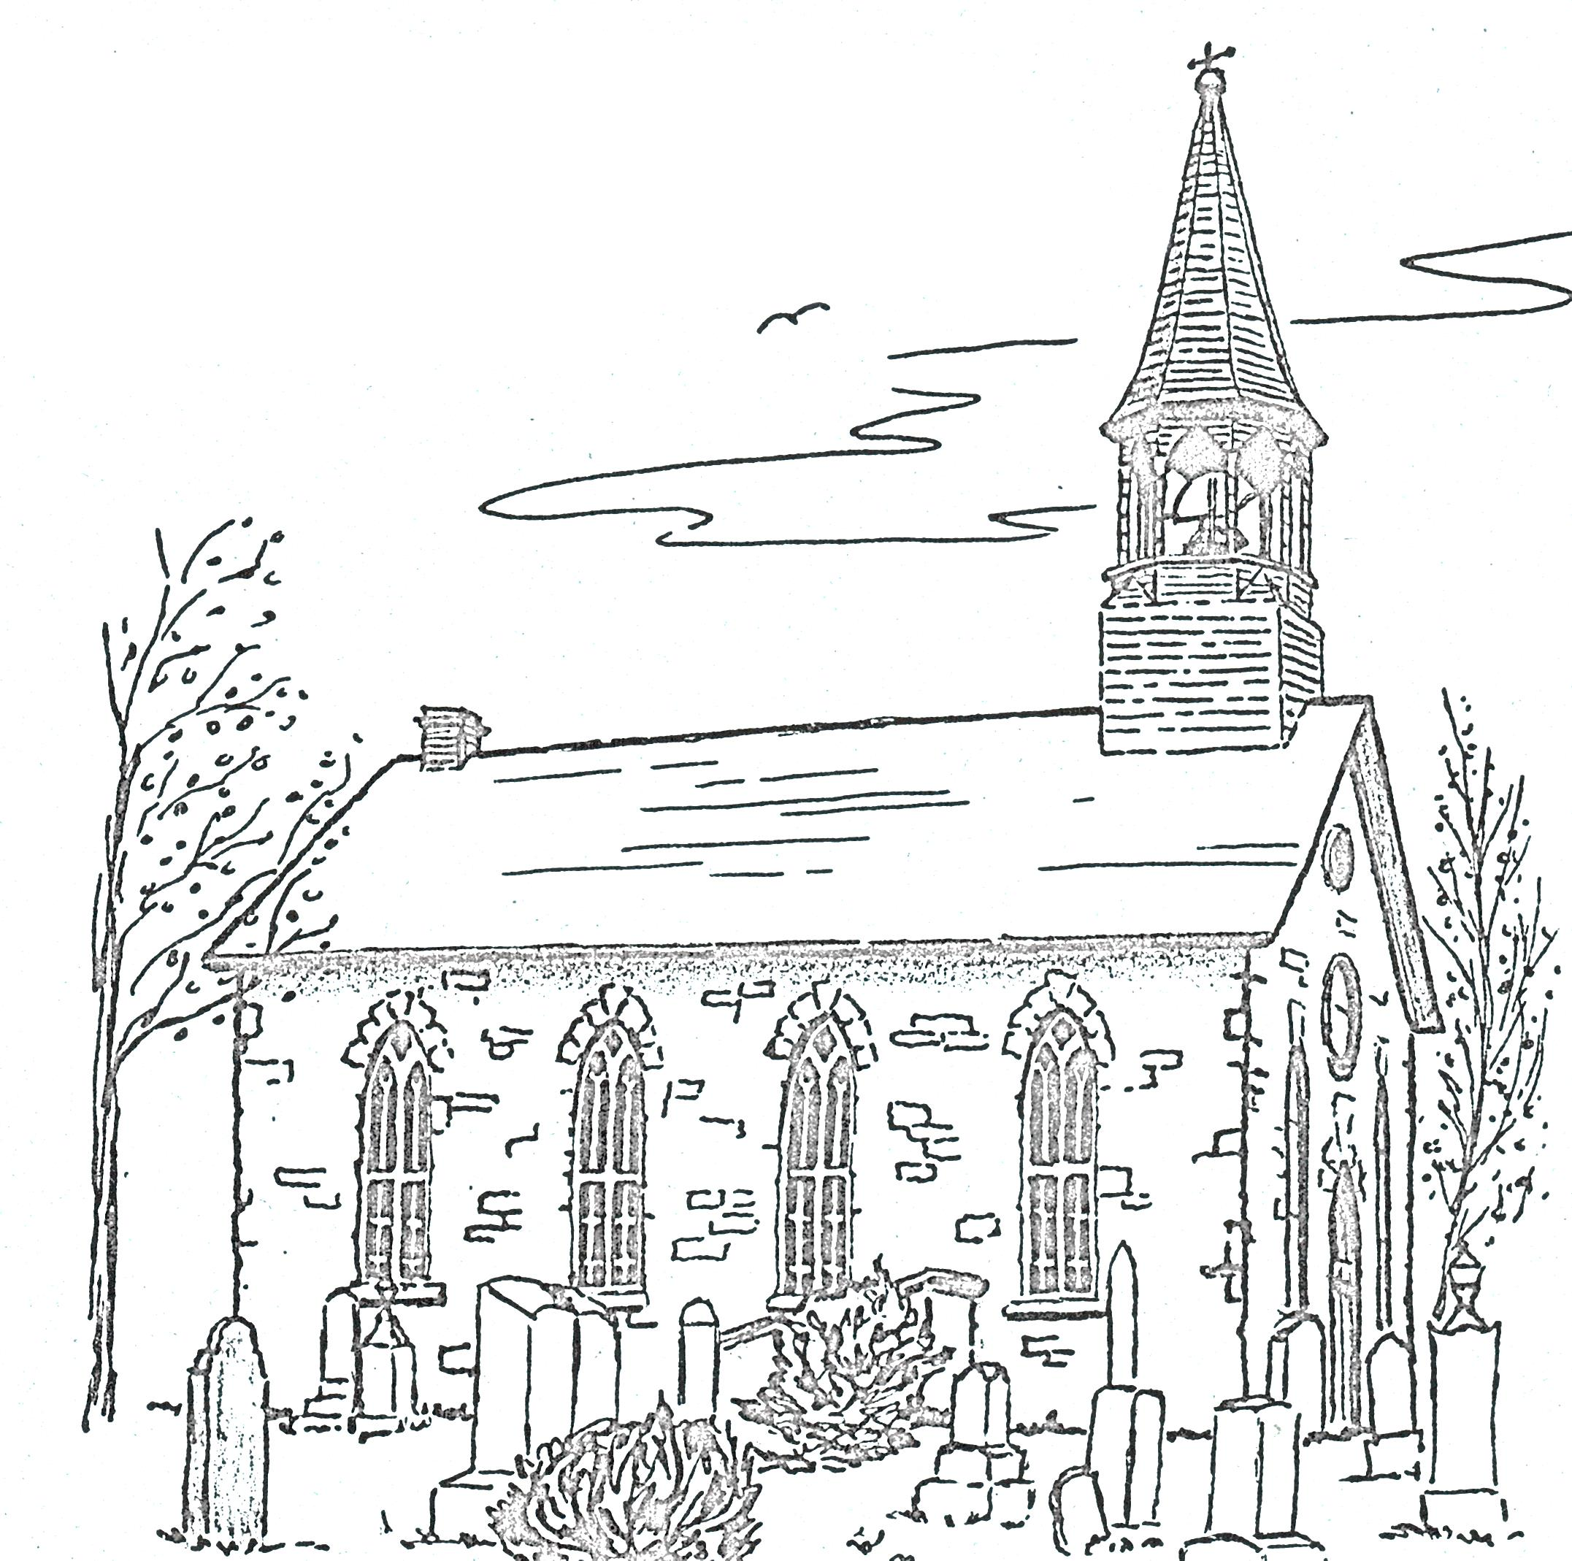
 | sketch by unknown artist -1978 Annual Report
Lloyd MacCrimmon | Allistair &Eileen Campbell
Myrna Ladouceur | Myrna Ladouceur
Annabelle & DJ Hartrick  Ewan & Donna Hartrick  Rev. William J. Baxter  Shirley Smith | Eileen Urquhart  Andre & Grace Jean-Louis  Katie Barnes  Ian & Kathryn Jean-Louis  Murray & Thelma MacQueen  Allan & Sandy Blaney
John 11:25-26
Jesus said, “I am the resurrection and the life. The one who believes in me will live, even though they die; and whoever lives by believing in me will never die.

Memorial Donations – Kenyon Presbyterian Church Cemetery – 2023

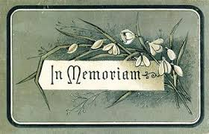
Danny John & Annabelle Hartrick  Janice & J. Thomas Corkal | Jens & Ingeborg Jensen  Karen McClellan
Chris Nutt  Bonnie MacLeod Cameron  Marvel MacLeod | Donald & Ivy Stewart  Nellie & Alec Stewart  Myrtle & Ross Nimmo  Margaret Stewart
Frank McDonell Family | Leonard & Phyllis Hutton
John & Donna Loewen | Dr. Linda Hutton
Allistair & Eileen Campbell  Richard & Pat Campbell | John Keith MacLeod  Marvel MacLeod  Bonnie MacLeod Cameron
Sander Stewart  Elizabeth Stewart | Margery & Munroe McCaskill  Heather McCaskill
Donald Ian MacLeod  Donald Clark  Weldon MacIntosh  Myrna Ladouceur | Evelyn MacQueen  Donald Clark  Betty Campbell  Stanley & Mildred Campbell

Thank you to our Donors – 2023

Adams, Robert | Hutton, Dr. Linda | Massia, Lorna
Addison, Dona | Jean-Louis, Andre & Grace | McCaskill, Heather
Alexander, Amanda | Jean-Louis, Ian & Kathryn | McClellan, Karen
Arkinstall, Andrew & Laurie | Johnston, Isabelle | McCormick, Barbara
Arkinstall, Doug | Ladouceur, Ann & Roger | McIlveen, Donna
Arkinstall, Gwenneth | Ladouceur, Myrna | McIntosh, Evan & Heather
Barnes, Katie | Little, Kim & Eric | McLean, Alastair
Barret, Darlene M. & James | Loewen, John & Donna | McRae, Chad & Ashley
Barton, Ken | MacCrimmon, Janet | McRae, David Proudfoot & Doris
Beaumont, Verna | MacCrimmon, Margaret | McRae, Glen & Mary-Anne
Bickerstaff, Janet | MacCuaig, Marlene | McSorley, Michel & Gudrun
Bishop, Ronald & Sharon | MacDonell, Bernard & Mona | Morris, Inger
Blaney, Sandy & Allan | MacDonell, Ronald & Debra | Munroe, Ruth & Dean
Bracken, Gordon & Elizabeth | MacEwen, Allan | Nixon, Donna Jean
Buchan, Grant & Heather | MacGillivray, Emerson | Nixon, Glen & Penny
Cameron, Francine | MacGillivray, Lynn | Nixon, Marylyn
Campbell, Betty | MacGillivray, Royce | Nutt, Elizabeth
Campbell, Brian & Karen | MacInnes, Brent | Peckett, Heather
Campbell, Bruce & Louise | MacInnes, Glenda | Prevost, Sandra MacPherson & James
Campbell, Jean | MacInnes, Rhonda | Ritchie, Shirley
Campbell, Richard & Pat | MacIntosh, Doris | Rupp, Margarita
Chatterson, Rosemary | MacKinnon, Leslie & Joyce | Ruttle, Clarence
Cherry, Richard & Eileen | MacLean, Donald & Martha | Shannon, Greg & Allison
Chisholm, Elizabeth | MacLeod Cameron, Bonnie | Shields, Helen
Clark, Donald | MacLeod, Elsie | Smith, Shirley
Clark, Donalda | MacLeod, Gladys | Stevens,Estate of Percy
Clark, Douglas A. | MacLeod, Isabel Clark & Donaldson | Stewart, Elizabeth
Corkal, Janice M. & J. Thomas | MacLeod, Jean | Stewart, Margaret
Ferrier, Jim & Olga | MacLeod, Ken & Annette | Urquhart, Evelyn
Fletcher, James | MacLeod, Kevin | Urquhart, Keith
Fraser, Alastair | MacLeod, Margaret | Walker, Allan
Fraser, Gordon | MacLeod, Marvel | Waugh, Audrey
Fraser, Jack & Linda | MacLeod, Roberta J. | Zsadany, Ron & Faye
Fraser, Mark & Jade | MacLeod, Wendy
Fraser, Matthew | MacMaster, Brenda
Gauthier, Catherine | MacMillan, Lorna
Hartrick, Ewan & Donna | MacNaughton, Lois
Hartrick, Ian & Michelle | MacQueen, Audrey
Hollis, Moira & Murray | MacQueen, Evelyn

