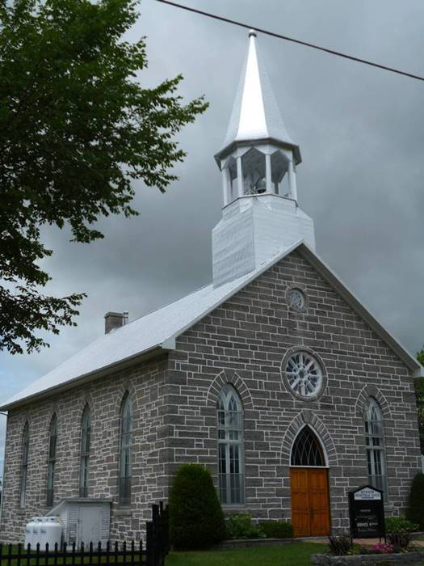
Kenyon Presbyterian Church
Annual Report
2024



Table of Contents

Mission, Vision, Values and Motto 2
Interim-Moderator’s Message 3
Committees and General Notices for 2025 4
Minutes of the 2023 Annual Meeting held March 24, 2024 5
Kirk Session Report 2024 7
Membership 8
Weddings 8
Baptisms 8
In Memorium 9
Cradle Roll 2024 9
Search Committee Report 2024 10
Cemetery Committee Report 2024 11
Board of Manager’s Report 2024 12
Trustee Investment Committee Report 2024 14
Memorial Donations – Kenyon Presbyterian Church – 2024 15
Memorial Donations – Kenyon Presbyterian Church Cemetery – 2024 16
Thank you to our Donors – 2024 17

Mission, Vision, Values and Motto

MISSION STATEMENT
Provide a safe space where the community can freely gather to worship and praise God to grow in Christian faith.

VISION STATEMENT
On our journey forward we will:
- Live as a caring congregation seeking to share, show and speak about the love and joy of knowing God
- Adapt to changes and take risks to live by our values by hearing and teaching His word through the gospel of Jesus Christ
- Promote stewardship of accumulated resources
- Foster communication between session, committees and the congregation
- Invite the participation of all in our church programs and activities
- Support the world-wide mission of The Presbyterian Church in Canada

VALUE STATEMENT
We value:
- The involvement of members, adherents and children
- Interdependency and caring for one another
- Trust and integrity
- The power of prayer
- The use of our spiritual gifts in Christ’s service

MOTTO
With God we find a way



Interim-Moderator’s Message

Have you read Kenyon Church's Mission Statement and Motto lately? These are a part of your congregation's "Mission, Vision, Values", and your Motto. As with any Mission Statement and Motto, each of these in succinct terms tells us and proclaims to others what Kenyon Presbyterian Church is about. And of course, that's what they are intended to do.
The Kenyon Church’s overall Statement was the result of careful and prayerful reflection and discussion by your Session to develop a "Mission, Vision, Values" and your Motto for Kenyon Church. The Session brought the statement to Kenyon's Annual Meeting in February of 2022, where it was adopted by everyone in attendance. You'll find these just inside your collection of Annual Reports. As well, it is posted prominently on the back wall of the church. If you haven't read or reviewed it, I would encourage you to do so, and take some time to reflect on it.
The wording of your overall Mission, Vision, Values Statement and Motto - and especially your Mission statement and Motto, reminds me of a portion of the Letter of James. It's found in the Letters portion of the New Testament - following the Gospels, and is one of the shorter of the letters in this section.
James' letter speaks of the "intersection" of Faith and Works. In a sense it is a handbook for putting our Christian Faith into action. Another term to describe it would be "Practical Christianity". The letter itself is a short and at times startling read. The writer of James' letter is making the case that Faith alone needs to have "works", otherwise Faith is only words. I'd recommend it to you for reading and reflection.
I like the way that the late William Barclay - a Scottish theologian and pastor, describes the relationship between Faith and Works. He describes it like this: "The fact is that no person can be saved by works; but equally no person can be saved without producing works". Mr. Barclay continues, "We are not saved by deeds; we are saved for deeds"...in fact faith and works do not contradict each other, but complement each other...the message of both is essential to the Christian faith in its fullest form." To put this another way, our Faith needs 'Works', just as our 'Works' come from our Faith.
Over the course of my time as your Interim Moderator, I've had the privilege to see these two statements put into action and lived out in your life as a congregation. I am certain that you will continue showing your faith in your actions and letting your actions be guided by your faith. At the same time I would encourage you to be open to new ways of living out your faith.
As I have in previous Minister's Messages, I continue to be grateful for your prayers and support over the course of this past year. It is truly a blessing.
May God's every blessing continue with each of you and your congregation.
Rev. Jim Ferrier, Interim Moderator

*The Daily Study Bible, The Letters of James and Peter; page 75. William Barclay

Committees and General Notices for 2025
Website: kenyondunvegan.ca Facebook: Kenyon Presbyterian Church
Worship Service Times: |  |  | January to April – 09:30 a.m. (Mar & Apr at 11:00 am)  May to August – 11:00 a.m.
 |  |  | September to December – 09:30 a.m.
Kenyon Session Meetings: |  |  | Every other month except June and July
Board of Managers Meetings: |  |  | Third Sunday of every other month except July and August
The Kirk Session
Jack Fraser | Gwen Arkinstall |  | Wendy MacLeod | Ashley MacLeod-McRae
Bobbi Jo MacLeod | James Prevost |  | Heather McIntosh-Clerk
The Deacon’s Court
Donald MacLean | Jack Fraser |  | Leslie McKinnon | Ian Hartrick
Board of Managers
Until Mar 2025 | Until Mar 2026 |  | Until Mar 2027 | Until Mar 2028
Laurie Arkinstall | Matthew Fraser |  | Janet MacCrimmon | Lynn MacGillivray
Lynn MacGillivray | Chad McRae |  | Elizabeth Anne Nutt | Audrey MacQueen
 | Jack Fraser |  | James Prevost
Nominating Committee
Until Mar 2025 | Until Mar 2026 |  | Until Mar 2027
Audrey MacQueen | Linda Fraser |  | James Prevost
Board of Trustees
Laurie Arkinstall (2025) | James Prevost (2026) |  | Heather McIntosh (2027)
Investment Committee
Jack Fraser (Church Member) | Elizabeth-Anne Nutt-Treasurer
Laurie Arkinstall (Trustee) | Heather McIntosh (Trustee) |  | James Prevost (Trustee)
Auditors for 2025-2028 | Myrna Ladouceur |  | James Prevost
Cemetery Committee
Matthew Fraser (2027) | Myrna Ladouceur (2027) |  | Eric Nixon (2027) | Audrey MacQueen (2027)
Wendy MacLeod (2027) | Janet MacCrimmon (2027) |  | Ian Hartrick (2027)
Church Treasurer: |  |  | Cemetery Supervisor:
Elizabeth Anne Nutt  Kenyon Presbyterian Church |  |  | Audrey MacQueen Email: audreymacqueen@gmail.com  Kenyon Presbyterian Church
1630 County Road 30 |  |  | 1630 County Road 30
Dunvegan, ON K0C 1J0 |  |  | Dunvegan, ON K0C 1J0
Email: treasurerKPC@gmail.com |  |  | 613-527-1655 Email: cemeteryKPC@gmail.com
Hall Rental | Custodian |  | Proof Readers
James Prevost (2026) | Annette MacLeod |  | Laurie Arkinstall
 |  |  | Wendy MacLeod
Ushers
Heather McIntosh | Jack Fraser |  | Doris MacIntosh | Jean MacLeod
Linda Fraser

Minutes of the 2023 Annual Meeting held March 24, 2024
March 24, 2024, after the service and a delicious lunch in the hall, the Annual General Meeting was held at 1 PM.
In attendance: Rev. Jim Ferrier, James Prevost, Sandra MacPherson, Jack and Linda Fraser, Gwen Arkinstall, Dona Addison, Myrna Ladouceur, Doris MacIntosh, Gordon and Betty Bracken, Isabelle Johnston, Catherine Gauthier, Janet MacCrimmon, Janet Bickerstaff, Heather MacIntosh, Bettianne Nutt, as well as Laurie Arkinstall remotely on cellphone.
Copies of the Annual reports had been distributed two weeks previous to this date. Everyone agreed that they were familiar with the content, eliminating the need to read each page at the meeting.
Rev. Jim opened with a welcome prayer. He called for nominations for the positions of chairman and secretary of the meeting. Jack nominated James for chairman, Gwen seconded that motion. All were in favour. Dona nominated Janet MacCrimmon as secretary, Betty seconded that motion. All were in favour.
Gwen moved that the Minutes of the 2022 Annual General Meeting be accepted as printed. Linda seconded that motion. All were in favour.
Jack moved that all of the written and financial reports be received. Heather seconded that motion. All were in favour.
James explained the item of the Cryptkeeper software for cemetery records since constant progress is being made to update the information. Currently 2500 burials are recorded. Access to these records is user friendly on the church website. He has noticed that many people are searching the data, offering edits and asking to add more family details. The software is quite affordable at $75.00 for an annual subscription. Bettianne moved that all reports be accepted. Linda seconded that motion. All were in favour.
Laurie clarified the Financial Reports on pages 14 and 15. Heather moved that the financial reports be accepted as written. Linda seconded that motion. All were in favour. It was moved by Jack that an overpayment to Presbyterian Sharing be left as noted, not adjusted in next year’s donations. Doris seconded that motion. All were in favour.
Laurie pointed out that the Balance Sheet on page 16 shows how Investment Dividends cover any cash deficits. Jack moved that all Financial Reports be accepted and approved. Gwen seconded that motion. All were in favour.
The opportunity to discuss the concept of forming a 4-point Pastoral Charge was part of new business. However, this is the extension of the work of the Search Committee over the last 4 years. Sessions of each of the churches, Kenyon, St Columba, Knox and St. Andrew’s, have asked for feedback on this union. Janet MacCrimmon asked the church members to think carefully on questions such as; how many Sundays in a month should a church provide a service? Would members actually travel to the other churches on different weeks to attend a service? How much should each church pay for shared services of a minister? Can our church really afford a portion of a minister’s salary, plus the cost of lay preachers when the shared minister is not attending, plus monthly, seasonal and annual operating costs, plus building and property maintenance? The members responded that they wanted to focus on our “home church”. Jack brought news from other congregations about increasing costs (ie, housing allowance) and lower attendance records, the small supply of ministers graduating and many empty pulpits, aging active ministers and the new lay preacher development workshops. Linda noted the burden of one church being held responsible for the possible future failure of the other churches was unsatisfactory. Betty asked Rev. Jim if he would be available to preach in the future. He responded that he would remain actively preaching for the foreseeable future. The challenge was to find a few local ministers and lay preachers to create a steady rotating group.
Betty moved that the congregants of Kenyon Presbyterian Church reject the proposal of a 4-point charge. Linda seconded that motion. All were in favour.
St Columba discussed this topic 2 weeks ago. They seem to be favouring the union though did not vote on this matter. St Andrew’s and Knox have not yet held their AGM.
For all of the above reasons, Janet asked for an end to the Search Committee. Rev. Jim explained that these two responses were not usual and needed to approach Sessions and Presbytery to present the rejection of the 4-point charge and an end to the Search Committee. Our next steps will be to wait for responses from the other 3 congregations, Sessions and Presbytery, take lots of time to create a plan to improve the circumstances of Kenyon, support delegates to the Lay Workshop April 20, and ask for a list of Lay Preacher expectations.
James presented the opportunity to discuss Other Business. Catherine asked if any other group or level of the Presbytery had seen the Church profile created by the Search Committee. Rev. Jim responded that it had been discussed with the congregation, then shelved by the Committee and not intended for publication. It will be updated in the future when needed.
James thanked Bettianne for accepting the role of Treasurer. Betty and Bobbi Jo were thanked for decorating the front of the church and Sunday School room. He also thanked Laurie for completing the yearend financial transactions and reports for the AGM, as well as being a vital participant in the AGM.
Linda asked if anyone from the National Presbyterian Church had responded to James’ email concerning the deteriorating appearance of St Elmo church. No one has officially acknowledged the message; however, someone repaired the missing windows. Janet mentioned that bricks are missing around some of the window frames. Donna McIlveen is also concerned and will contact someone on the issue of property maintenance.
James asked for historical photos of the Dunvegan Cheese Factory. The lane to the cemetery was called Cheese Factory Lane and James would like to have a sign and or plaque made to recognize that bit of local history. Facebook and the Glengarry Archives will be used to search for those facts.
Rev Jim led a Memorial Service for those who passed in 2023. Fourteen burials occurred this year with details listed on page 9 of the Annual report. The Scripture reading was Romans 8: verses 38-9. All members present read a prayer and reflected in silence.
Bettianne adjourned the meeting.
Rev Jim sent us off with thanks for a most productive and honest set of discussions dealing with serious matters, and a final prayer.
Submitted by Janet MacCrimmon, March 2024

Kirk Session Report 2024

Kenyon Church has continued to provide a comforting place of worship over the constantly changing and challenging months of 2024. The church provides sanctuary, support and renewal for our faithful members. Our average attendance has remained about 20-25 worshippers, where most of the group are seniors. There is an atmosphere of warmth and caring observed and experienced in the friendly chatter before and after the worship services and in the monthly coffee hours after the services. We gather together to not only learn about God’s Word and Direction but to also support and encourage our church family members as they deal with joys and challenges in their life journeys
We worshipped together with our sister church St Columba in January and February with services being held in January in Kirk Hill and February in Dunvegan
We celebrated the Holy Sacrament of Communion on February 18th [Lenten], June 16h^{th}, October 6th [World Communion] and December 1st [Advent] with an average of 20-21 participants.
A Four Sessions joint meeting was held on February 16th to gauge interest in forming a 4 point pastoral charge with St Andrew’s Maxville, Knox Moose Creek, Kenyon Dunvegan and St Columba Kirk Hill. A joint Session meeting with St Columba was held on November 21st to make decisions about certain changes or dates, circular emails were used quite often as it was often difficult to get a common date and time to meet. The results were then homologated at the next meeting.
Rev Jim Ferrier as our Interim Moderator has led us in worship for the majority of Sunday services in 2024 but did manage to take off several Sundays for a well-deserved rest and some vacation time. We know and appreciate all the other occasions and sacraments, he has to prepare and carry out duties for like funerals, burials, weddings, and baptisms- which have been many times, this year. We did appreciate and enjoy the worship services led by pulpit supply like the Rev Ian MacMillan, Guy Laberge, Alastair Fraser, and Keppel Bharath. The Co Interim Moderator Rev Robert Adams was relieved of his duties with our charge at the June Presbytery meeting as he was appointed Interim Moderator for the Finch/Gravel Hill, Avonmore pastoral charge.
We had many Special Services this year with the help of our musical talent in the congregation. On Easter Sunday March 31st, Ashley MacLeod McRae was the musical leader with her Kenyon Youth Strings including Kenzie, Shelby, Glenn and Chancy McRae, Brenna Villeneuve, Abbey MacLeod, Cadence MacIntosh and Olivia Fraser. The beautiful vocals and music of Kenzie and Shelby were well received and appreciated. On Mother’s Day/Family Day May 12th, Rosemary Chatterson was the musical leader and Brenna provided the always loved fiddle music. Rosemary was our musical leader for quite a few Sundays this year and we always appreciate her lovely vocals and piano playing. For our Memorial Sunday on Sunday September 1st, Ashley was the musical leader with her Kenyon Youth Strings performing for our enjoyment and Allan Walker providing the bagpipe lament music. For our Old Tyme Service on September 22nd the Rev Ian MacMillan led the service with Rosemary Chatterson leading the music, both dressed in period costume, along with the Reenactors. Our Thanksgiving service was cancelled due to illness. For our Remembrance Day Service, Brenna provided the fiddle music and Lynn MacGillivary played her bagpipes. For our Christmas Eve service, Rev Jim Ferrier led the worship with the help of many members of the congregation and Ashley led the music with her Kenyon Youth Strings with Paul Villeneuve lending his vocals to the musical talent. Many members of our congregation are always willing to help out with readings or prayers at our services. Thank you to all who volunteer and help.

As the Presbytery of Seaway Glengarry representative for Kenyon and St Columba I have attended all the in person and Zoom Meetings during 2024, The January and March meetings are online via Zoom so presbyters did not have to travel the long distances in winter weather. I took part in Presbytery pastoral charge visitations in April to St Lukes/Knox Finch and St Andrew’s Avonmore/St James Gravel Hill and in October to St Matthews Ingleside and Knox Morrisburg as part of a visitation team.
We consider ourselves to be very fortunate to have Rev Jim Ferrier as our Interim Moderator as he has worked tirelessly this year as usual, to provide us with the spiritual leadership and support and pastoral care to our congregations. Even though he is supposed to be retired, he is always available when needed! We hope for better health for both Jim and Olga in 2025 and maybe some down time to recover strength and health.
We are always appreciative of the hard work and dedication of our very active Board of Managers, Cemetery Committee, Investment Committee, and our Treasurer, the church and hall caretaker Annette MacLeod, church decorators like Betty Bracken. We are blessed to have so many willing hands and hearts, in our small congregation who keep our church buildings and grounds so well maintained and groomed. We are thankful to James Prevost for the time and effort in taking care of our church website and Facebook site as well as his opening and closing the church hall all year. We acknowledge with many thanks the faithful support of members, adherents and their families and the many friends of our historical church and for their financial generosity.
We pray for God’s guidance and grace as the Joint Ministry Search Committee progresses on with their difficult task to ready the Call for a Minister proposal to Presbytery.
We are God’s people, called to serve God with our many gifts. When we work together, we can accomplish so much more than we could ever accomplish on our own.
Respectfully submitted
Heather McIntosh, Clerk of Session

Membership
On Roll as of January 1, 2024 |  | 81
Added by Profession of Faith |  | 0
Added by Session - Transfer |  | 0
Removed by Certificate |  | 0
Removed by Death |  | 2
On Roll as of December 31st, 2024 |  | 79

Weddings

October 12, 2024 | Ceilidh Catherine MacRae | William Robert Brant Woodside

Baptisms
Abigail Jean Nixon Birth: August 22 2023 Baptism: June 9 2024 Parents: Megan Ewing and Kyle Nixon

In Memorium

Name | née | Date of Death | Date of Burial |  | Age
John Walter Hutton |  | December 4 2023 | May 10 2024 |  | 76
Garry Hewston |  | May 16 2024 | May 28 2024 |  | 76
Stewart James MacQueen |  | May 23 2024 | May 29 2024 |  | 66
Elizabeth Anne Stewart | McEwen | May 13 2024 | June 1 2024 |  | 91
Gerard Lucien Gauthier |  | January 1 2024 | June 9 2024 |  | 91
Kenneth Alexander MacEwen |  | February 9 2024 | June 22 2024 |  | 91
Sybil Madeleine Mulhern |  | June 10 2024 | June 27 2024 |  | 1m
Kevin Cameron McRae Diane Patricia MacDonald  Evan Andrew McIntosh Janet Catherine Williams  Barbara Joan MacDonald | MacKinnon | March 30 2024 December 18 2023  February 4 2024 February 3 2024  August 8 2024 | August 1 2024 September 18 2024  September 21 2024 September 21 2024  November 23 2024 |  | 69  69  73  94  90
Elizabeth Stewart was a past elder for many years which she served faithfully and also participated on many committees.

Cradle Roll 2024 |  |  | 
Children on Cradle Roll in 2024: |  |  | 7
Graduated from Cradle Roll in 2024: |  |  | 2
Added by Baptism in 2024: |  |  | 0
Children on Cradle Roll as of December 31st, 2024: |  |  | 5
Birthday Cards sent in 2024 |  |  | 7
Blessed are the peacemakers for they will be called Children of God.

Respectfully Submitted,
Margaret MacLeod – Cradle Roll Superintendent

Search Committee Report 2024

Kenyon Church's committee members are: Laurie Arkinstall, Lynn MacGillivray, Jack Fraser and Janet MacCrimmon. St Columba Church's committee members are Doreen Howes, Ralph MacGillivray, and Pauline Hambleton.
This committee had not met since June 2023, as the next step was in the hands of the Sessions of Kenyon, St. Columba, St. Andrew's and Knox.
On February 16, 2024, all four Sessions met to discuss forming a 4 Point Pastoral Charge. The idea was acceptable and it was recommended that individual congregations could now discuss this at their upcoming Annual Meetings. This occurred March 24, 2024 at Kenyon Presbyterian Church Hall 1:00 pm, as part of new business. A serious but productive discussion ensued. Jack and Janet led with new information on current costs, scenarios about services and sharing ministers, as well as answering questions.
- Costs to hire a minister have increased dramatically since starting the Search in 2019
- Kenyon congregants want their church open every Sunday
- The number of regularly attending people is naturally decreasing
- All costs, including pulpit coverage, utilities, maintenance, are being covered by donations and savings
-Investments continue to grow which could leave us responsible for a greater share of all expenses for the 4 churches
-If members of our congregation are willing to participate in services with pastoral support, our future would be extended
The congregation voted unanimously to reject inclusion in a 4 Part Pastoral Charge. Kenyon Church members would continue working and worshipping together with St Columba Church members, when convenient.
Additionally, Janet asked if the Search Committee could ask permission from Presbytery to dissolve the Pastoral Search Committee.
Months passed before we received acknowledgement of our decisions to stay with a 2 point charge and end the Search Committee. Rev Adams is no longer Co-Moderator. Members of the Kenyon and St Columba Congregations continue to participate in services in many different ways and gradually assume more responsibilities. ThePresbytery has managed to initiate instructional opportunities for sermon and prayer leadership.
Submitted by Janet MacCrimmon

Cemetery Committee Report 2024

Committee members: Audrey MacQueen (chair), Gordon Bracken, Myrna Ladouceur, Wendy MacLeod, Janet MacCrimmon and Eric Nixon.
The Crypt Keeper software is a valuable database of cemetery records. James Prevost continues to update names of new burials. He also has attached photos of the gravestones. Not all burials are named on the gravestones but these also need to be recorded accurately in the software. A precise system of recording, using letters and numbers, will make family burial plans and the excavations much easier.
2024 was yet another busy year at the Cemetery. We had a large number of burials. The perennial garden wintered very well and continued to flourish with bright blossoms from spring into the fall.
Raccoons invaded the cemetery lawn again in 2024, digging out grubs. Traps had to be placed by Trapper Ken and the lawn reseeded more than once by Gordon Bracken.
Gravestone repairs continued, costing $5,000.00. Work was carried out by contractor Fern Viuris and Son to straighten and replace slabs, as well as reset taller multi-level monuments.
Twelve funerals and burials were held in the church and as graveside events. The hall was also used for some catered receptions. Committee members have established a routine of sharing the work and duties for the burials. More men have also volunteered, taking turns to hand dig holes for urn burials.
Memorial Sunday was very well attended. Generous donations were given. The map of the cemetery was reprinted and was on display on the landing beside the hall. The cemetery looked particularly well-manicured and the gardens and plots displayed vibrant blooms and bouquets. Many of the worshippers commented on the scene.
The remaining large overgrown cedars along the west creek bank have been removed and new small oak and elm trees have been planted in their place. Several older weed trees were also removed along the creek bank
Wet weather in the fall prevented removal of brush, posts, wire and stones from the west fence line. This project, to open the extension to the cemetery, will continue into 2025.
Submitted by Audrey MacQueen
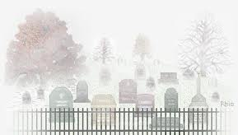

Board of Manager’s Report 2024

The Board of Managers held 5 regular meetings in 2024. Board members Janet MacCrimmon, Elizabeth Anne Nutt and James Prevost completed their 3 year terms on the Board. Janet MacCrimmon, Elizabeth Anne Nutt and James Prevost were welcomed as Board members for further 3 year terms.
The Cemetery committee continued its active participation in all Board of Managers’ meetings to work closely with the Board of Managers to review/discuss/resolve cemetery tasks and issues.

The committee was shocked and very saddened to hear of the loss of Evan McIntosh in February. We are grateful for his many contributions. Evan served as the Church treasurer and was a valued member of the Board of Managers for a number of years. Evan used many of his skills to maintain, install and fix many items and issues that needed to be addressed in the Church and the Church Hall.

Treasurer tasks were discussed. An external hard drive was purchased for the treasurer’s files. Elizabeth Anne Nutt kindly assumed the treasurer role and we were thankful that Laurie Arkinstall provided assistance in this transition.

There were 11 Church and Hall rentals in 2024. There is a new Church rental policy because of requests from non-members to rent the church for weddings and funerals. .
There is an updated process for booking and recording both Church Sanctuary and Church Hall Rentals. All bookings are now recorded on the church website under https://kenyondunvegan.ca/church-hall-bookings/ and manually listed in the Board of Manager’s black binder(Section 13) stored in the hall closet. The rules and regulations for the rentals were updated and approved by both the Board of Managers and the Session. All bookings are also listed on the calendar posted on the fridge in the Church Hall.
The committee discussed and approved a donation to the Maxville Manor Foundation in the amount of $100,000.00. The first $25,000.00 cheque was issued.

It was noted that the church’s perimeter fence was chipping and peeling. Options to fix this were considered and investigated. A small section of the fence near the gate was spray painted and the paint is adhering well. It will be reassessed in 2025 and, if it continues to adhere well, other areas needing it will be spray painted.

Other maintenance tasks completed include:

- Gravel was purchased and spread in the parking lot, cemetery lane, and cemetery.
- A new flower bed was created around the flood light at the front of the church, replacing overgrown shrubs. The floodlight will be controlled by a timer.
- The Glengarry Fire department conducted an inspection and issues were rectified including new smoke detectors and carbon monoxide detectors. Improper use of extension cords was also corrected.
- The Church and Church Hall exteriors as well as the Church attic were sprayed for flies, Japanese beetles and wasps.
- 2 thermostats were replaced in the church hall.
- Water samples were taken quarterly for testing.
- Church furnace was checked and cleaned.
- Norman MacLennan was confirmed for snow clearing of the parking lot and Norm Jeaurond was confirmed for the church and hall walkways.

The Board of Managers continues to gather information about the Dunvegan Cheese Factory and is in favour of naming the right-of-way access lane “Cheese Factory Lane.” There was continued work on cemetery map creation and updates.

The Board accepted two donations from Ina Urquhart Colbran of Fretwork pieces of art on behalf of the Urquhart family. The first piece was Noah’s Ark and the second piece was a framed Lord’s Prayer. These works of art were created by Etta Cameron Urquhart. Noah’s Ark is displayed in the glass cabinet at the front of the church and the framed Lord’s Prayer is hung on the west wall of the Church Hall. Ina’s grandparents, Hector Urquhart and Christy Macleod are buried in Kenyon Cemetery.

Thank you to Betty Bracken for her decorating skills in the Church and the Church hall. Thanks to Doris MacIntosh for her continued maintenance of the Pioneer Cemetery. Doris also assists Betty Bracken with Church decorating for special events.
Thanks to the Nominating Committee for their work in recruiting volunteers to sit on the Board of Managers and other committees.
Christmas gifts were purchased and delivered.

Thanks to our Board of Managers and Cemetery Committee members who continue to donate their time, talents and resources towards keeping the Church, the hall, and the cemetery well maintained.

Respectfully submitted by,
James Prevost, Chairperson
Lynn MacGillivray, Secretary

"Be careful not to do your 'acts of righteousness' before men, to be seen by them. If you do, you will have no reward from your Father in heaven." — Matthew 6:1



Trustee Investment Committee Report 2024

The Trustee Investment Committee held its Annual Review Meeting virtually in May 2024 with Kenyon Church’s financial advisor, Randy Douglas of Ventum Financial Corp. (formerly Echelon Wealth Partners, June 2024). Randy looks after both Kenyon’s Church and Cemetery financial accounts. Randy has throughout the year, via telephone, email and in person conversations, kept us fully informed, provided sound advice while allowing input from our committee, kept our balanced investment portfolio safe while earning income. We utilized the Statement of Investment Philosophy, Policy and Guidelines in making decisions throughout the year.

The Church’s investment portfolio with Ventum Financial Corp. earned 3.1% in interest and dividends and had an increase in Market Value of 12.4% in 2024. The earnings on investments in the Church’s Canadian account were deposited into the Church bank account monthly to help cover operational costs. The Cemetery investment portfolio earned 5.0% in interest and dividends this year and the Market Value of the account was up 12.8% at year end.

With the interest rate continuing to climb in 2024, we maintained a larger percentage holding in bonds and GIC’s again this year. Common stocks and Exchange Traded Funds were well monitored and bought and sold as necessary to tweak the portfolio. Portfolio market values continually increased throughout the year with a dip at the end of year, with a more significant drop in the US portfolio with Canadian and US economic uncertainty. Dividends remained strong and provided the church with regular income throughout the year. There was a continued focus on purchasing quality investments with good earnings potential. The portfolios include high quality GIC’s, Fixed Income, Preferred Shared, Common Stocks, Bonds, Exchange Traded Funds and Income Trusts.

The Margaret U. Stewart Memorial Trust continues to be invested in the Church’s Canadian account with Ventum Financial Corp. The original portion of the trust, $10,000.00 was designated to go towards Youth and Sunday School programs, the interest on this amount was calculated from interest and dividends earned in the Church’s Canadian Cash Account in the amount of $319.50 for the year 2024. The remainder of the Margaret U. Stewart Memorial Trust earnings go towards the general operation of the Church.

Through careful and thoughtful management of these investments and with Donors continued support, Kenyon Presbyterian Church and Cemetery will be able to continue Gods work into the future. Thank you to all our generous donors.

Respectfully submitted,
Laurie Arkinstall

Memorial Donations – Kenyon Presbyterian Church – 2024

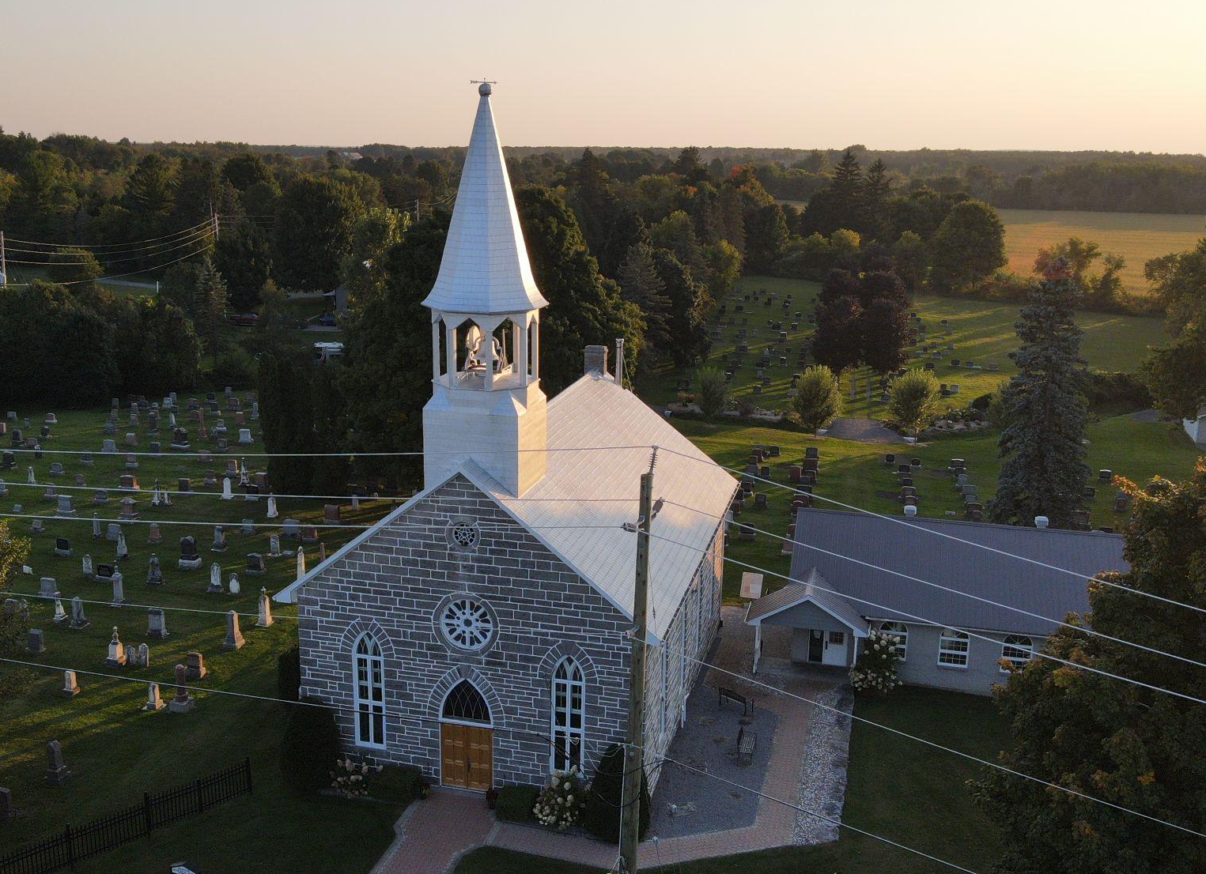

Evan McIntosh  Laurie and Andrew Arkinstall  Gerard Gauthier  Heather McIntosh  Annabelle and D.J. Hartrick  Ewan and Donna Hartrick  Alexander D and Ellen A Stewart  Margaret Stewart  Murray and Thelma MacQueen  Allan and Sandy Blaney  Stewart MacQueen  Allan and Sandy Blaney | Elizabeth Stewart  Gwen Arkinstall  Myrna Ladouceur  Wendy MacLeod  Donald and Susane Munroe  Heather McIntosh  Lois Worthren  Gary and Jean Ivens  Margaret MacLeod  Donaldson MacLeod and Isabel Clark  Donna and Freda Campbell  Leona Campbell  Lillian Campbell  Leona Campbell

John 11:25-26
Jesus said, “I am the resurrection and the life. The one who believes in me will live, even though they die; and whoever lives by believing in me will never die.

Memorial Donations – Kenyon Presbyterian Church Cemetery – 2024
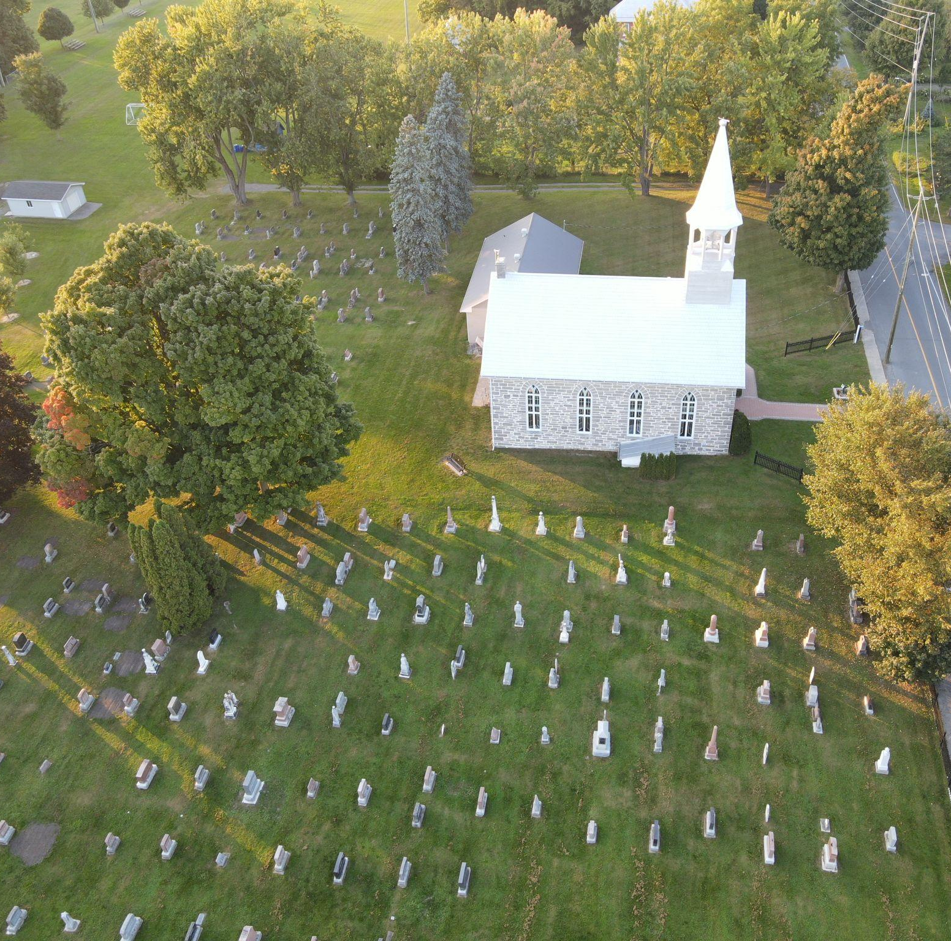

Allister and Eileen Campbell  Richard and Pat Campbell  Myrna Ladouceur  Munroe and Margery McCaskill  Heather McCaskill  Chris Nutt  Marvel MacLeod  Bonnie Cameron  Linda Dashney  Donald Clark  Forbes and Isobel Crawford  Grant and Heather Buchan  Donald and Freda Campbell  Brenda Campbell  Lillian Campbell  Brenda Campbell  Rev W.M. Baxter  Shirley Smith | Frank, Mora and Murray McDonell  John and Donna Loewen  Marlene McCuaig  Kevin McRae  Colleen Shepherd  Keith MacLeod  Marvel MacLeod  Betti Nutt  Bonnie Cameron  Annie, Stanley and Mildred Campbell  Bruce and Lois Campbell  Ruth Hollis  Moira and Murray Hollis  Mr. and Mrs Leornard MacPhee Hutton  Dr. Linda Hutton  John Walter Hutton  Dr. Linda Hutton  Elizabeth Stewart  Jean MacLeod
Alexander D and Ellen A Stewart (nee Newman)
Margaret Stewart

Thank you to our Donors – 2024

Dona Addison  Andrew and Laurie Arkinstall  Gwen Arkinstall  Katie Barnes  Darlene and James Barret  Ken Barton  Verna Beaumont  Keppel Barath  Janet Bickerstaff  Sharon and Ronald Bishop  Sandy and Allan Blaney  Gordon and Elizabeth Bracken  Grant and Heather Buchan  Francine Cameron  Betty Campbell  Brenda Campbell  Brian and Karen Campbell  Bruce and Louise Campbell  Leona Campbell  Nancy Campbell  Richard and Pat Campbell  Richard and Eileen Cherry  Donald Clark  Donalda Clark  Douglas A Clark  Janice and Thomas Corkall  Jim and Olga Ferrier  Alastair Fraser  Gordon Fraser  Jack and Linda Fraser  Catherine Gauthier  Ewan and Donna Hartrick  Ian and Michelle Hartrick  Maura and Murray Hollis | Dr. Linda Hutton  Gary and Jean Ivens  Andre and Grace Jean-Louis  Ian and Kathryn Jean-Louis  Isabel Johnston  Arnold and Anna Kuralti  Ann and Roger Ladouceur  Myrna Ladouceur  Wendy and Roy Lang  John and Donna Loewen  Janet MacCrimmon  Margaret MacCrimmon  Marlene MacCuaig  Bernard and Mona MacDonell  Allan MacEwen  Emerson MacGillivray  Lynn MacGillivray  Brent MacInnes  Rhonda MacInnes  Doris MacIntosh  Leslie and Joyce MacKinnon  Donald and Martha MacLean  Bonnie MacLeod Cameron  Elsie MacLeod  Gladys MacLeod  Ian and Karen MacLeod  Isabel Clark and Donaldson MacLeod  Jean MacLeod  Ken and Annette MacLeod  Kevin MacLeod  Margaret MacLeod  Marvel MacLeod  Roberta MacLeod  Wendy MacLeod  Brenda MacMaster | Carlyle MacMillan  Lorna MacMillan  Lois MacNaughton  Audrey MacQueen  Lorna Massia  Heather McCaskill  Barbara McCormick  Heather McIntosh  Alastair McLean  David Proudfoot and Doris McRae  Glen and Mary-Anne McRae  Donald and Susan Munroe  Ruth and Dean Munroe  Donna Jean Nixon  Glen and Penny Nixon  Elizabeth Nutt  Heather Peckett  Sandra MacPherson and James Prevost  Margarita Rupp  Clarence Ruttle  Colleen Shepherd  Helen Shields  Shirley Smith  Margaret Stewart  Keith Urquhart  Violet Urquhart  Allan Walker  Audrey Waugh  Lois Worthren

