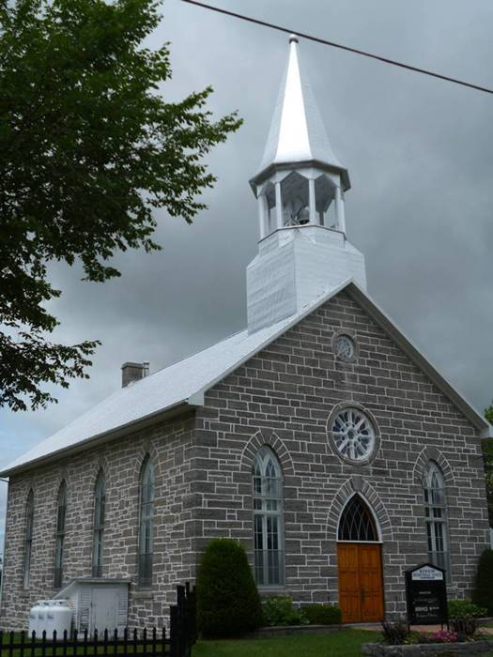
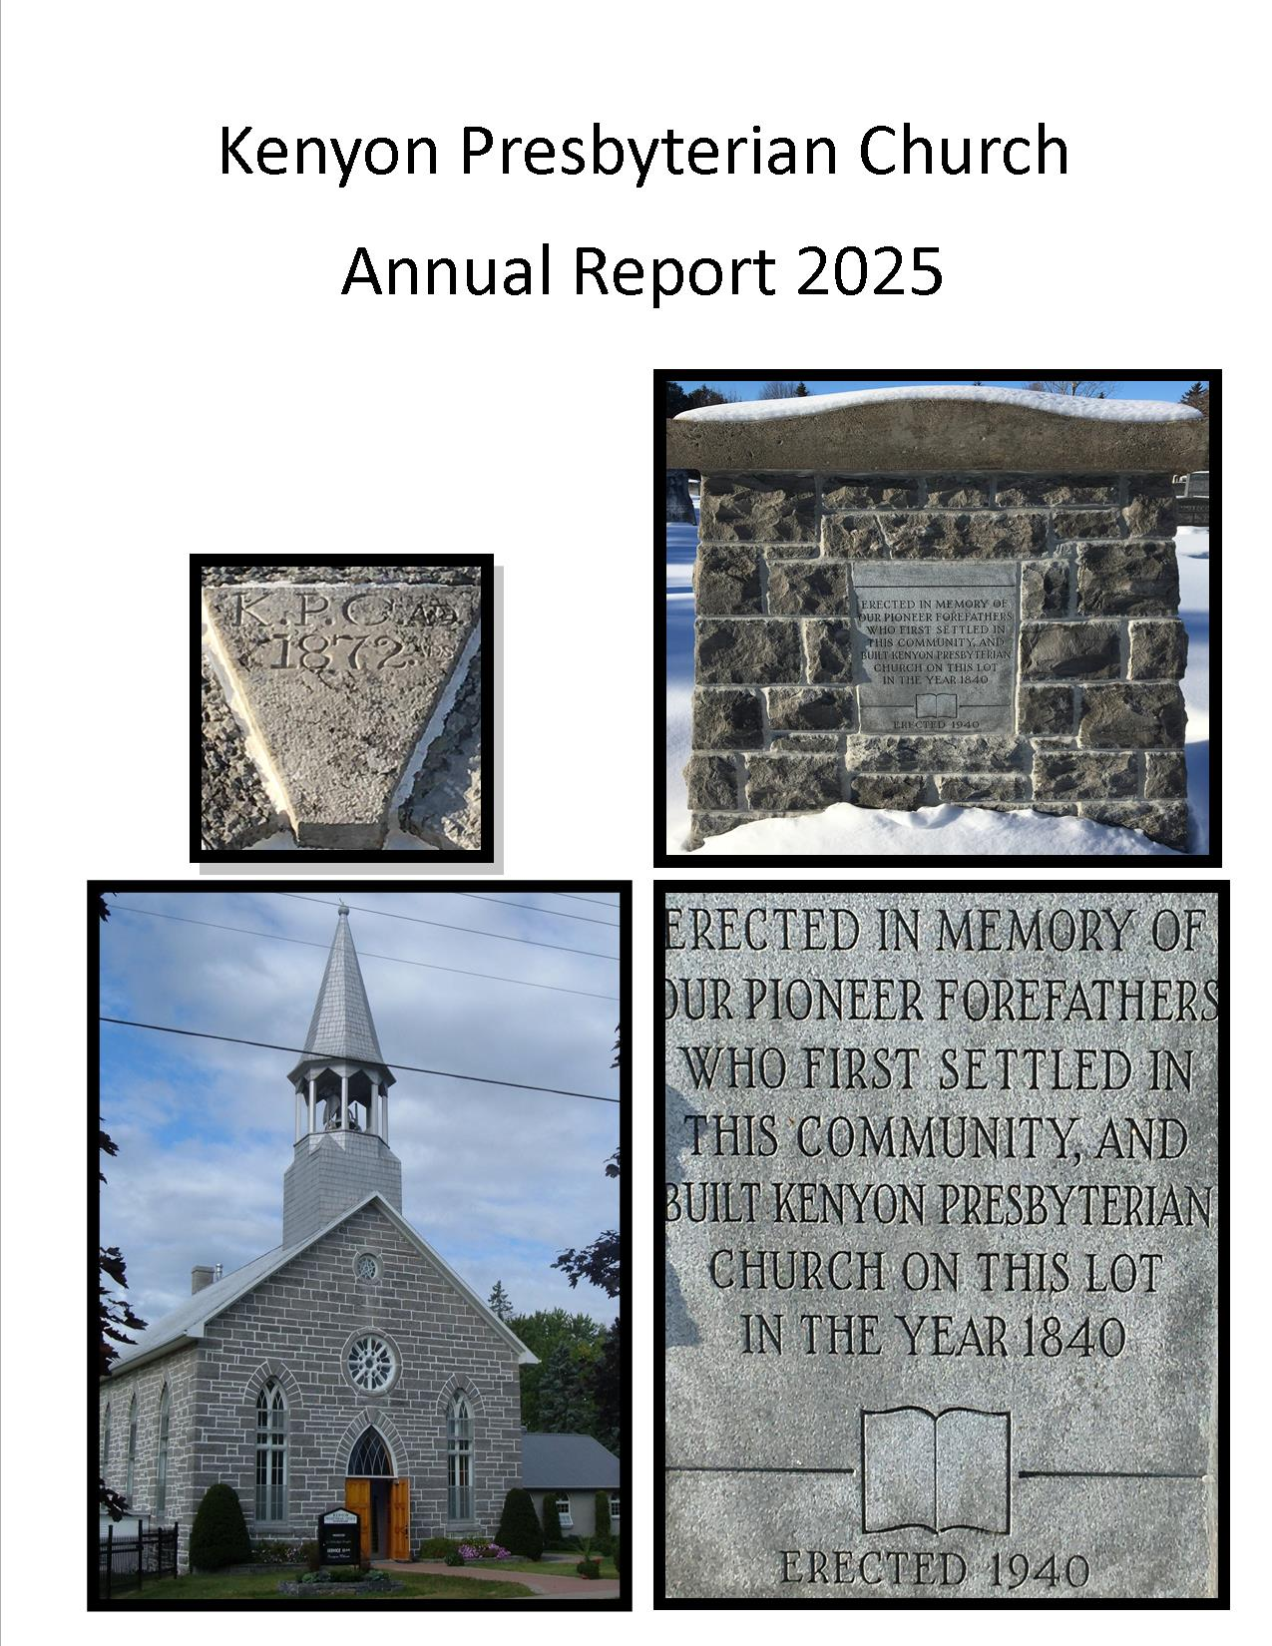

Table of Contents

Mission, Vision, Values and Motto 2
Interim-Moderator’s Message 3
Committees and General Notices for 2026 4
Minutes of the 2024 Annual Meeting held March 23, 2025 5
Search Committee Report 2025 6
Kirk Session Report 2025 7
Membership 9
Weddings 9
Baptisms 9
In Memorium 9
The Pioneer Cairn – Kenyon Presbyterian Church – 185th Anniversary 10
Cemetery Committee Report 2025 11
Board of Manager’s Report 2025 12
Trustee Investment Committee Report 2025 14
Memorial Donations – Kenyon Presbyterian Church – 2025 15
Memorial Donations – Kenyon Presbyterian Church Cemetery – 2025 16
Thank you to our Donors – 2025 17

Mission, Vision, Values and Motto

MISSION STATEMENT
Provide a safe space where the community can freely gather to worship and praise God to grow in Christian faith.

VISION STATEMENT
On our journey forward we will:
- Live as a caring congregation seeking to share, show and speak about the love and joy of knowing God
- Adapt to changes and take risks to live by our values by hearing and teaching His word through the gospel of Jesus Christ
- Promote stewardship of accumulated resources
- Foster communication between session, committees and the congregation
- Invite the participation of all in our church programs and activities
- Support the world-wide mission of The Presbyterian Church in Canada

VALUE STATEMENT
We value:
- The involvement of members, adherents and children
- Interdependency and caring for one another
- Trust and integrity
- The power of prayer
- The use of our spiritual gifts in Christ’s service

MOTTO
With God we find a way



Interim-Moderator’s Message

The heading for this year’s Minister’s Message is actually the title of a hymn I came across while looking on Google (where else) for a New Year’s hymn. It seemed to me that the title - “Another Year Completed”, to be an apt theme for this year’s message.
First though, an observation about this hymn’s title and how it can be understood in a couple of ways. One way is along the lines of “Whew!!! We crawled through that year!” - as if to say that there was some doubt that you would. Another way to view it is to consider what has been accomplished as Christ’s Church. Personally, my pick would be the second of these views.
In the course of this past “year completed”, Kenyon Church has held a number of special Sunday worship services: Memorial Sunday, Remembrance Sunday, Christmas Eve, Easter and of course - the celebrating of Holy Communion. These services have been staples in Kenyon’s life and witness - not only within your congregation, also to the surrounding area. And we cannot overlook your support for various outreaches in the wider area, for example; Gracefield Camp, the Canadian Bible Society, Samaritans’ Purse, Canadian Foodgrains Bank. Also, we cannot forget your support for local initiatives, for example the St. Vincent de Paul Food Bank during Advent, as well as donations to Youth Unlimited, Maxville and Laggan Schools and Maxville Manor. As in past years, you responded generously.
I highlight these services and initiatives - not to “raise them above” your continuing support of Kenyon Church. Your continuing and faithful support of your church is a testament to how much your faith in God and in Christ Jesus are a part of your lives and the life of your church.
On a more personal note, I have experienced your support in a quite unexpected fashion. As you know, toward the end of Olga’s and my summer vacation last year, I had an accident that resulted in wounding my left leg. Part of the healing process was to keep off my feet and to keep that leg elevated to enhance blood flow. In turn this made conducting worship services a challenge, as I would be standing for most of the service. Very quickly you swung into action and made accommodation in order that I could be seated - leg elevated, for worship. I am grateful for your support. And although this was done on my behalf, I know that you have made accommodation for others with special needs - whether short-term or chronic.
Before signing off, a few words about the hymn - “Another Year Completed” - this in contrast to the first of the above views, beginning with “Whew!!!....” . The lyrics have been around for a long time, first penned mid-5th century. It is attributed to St. Paulinus of Nola (Spain). It has undergone several translations, the most recent being by John Athelstan Riley in the mid-1800s.
What follows is the first verse, and I commend it to your reflection:
Another year completed,
The day comes round once more
Which with our patron’s radiance
Is bright as heretofore.
Now, strong in hope, united
His festival we greet;
He will present our troubles
Before the mercy-seat.
Grace and peace for you in this year and beyond.
Rev. Jim Ferrier, Interim Moderator

Committees and General Notices for 2026
Website: kenyondunvegan.ca Facebook: Kenyon Presbyterian Church
Worship Service Times: |  |  | January to April – 11:00 a.m.  May to August – 11:00 a.m.
 |  |  | September to December – 09:30 a.m.
Kenyon Session Meetings: |  |  | Every other month except June and July and August
Board of Managers Meetings: |  |  | Third Sunday of every other month except July and August
The Kirk Session
Jack Fraser | Gwen Arkinstall |  | Wendy MacLeod | Ashley MacLeod-McRae
Bobbi Jo MacLeod | James Prevost |  | Heather McIntosh-Clerk
The Deacon’s Court
Donald MacLean | Jack Fraser |  | Leslie McKinnon | Ian Hartrick
Board of Managers
Until Mar 2026 | Until Mar 2027 |  | Until Mar 2028 | Until Mar 2029
Matthew Fraser | Janet MacCrimmon |  | Lynn MacGillivray | Jack Fraser
Chad McRae | Elizabeth Anne Nutt |  | Audrey MacQueen | Glenna Van Drunen
Jack Fraser
Nominating Committee
Until Mar 2025 | Until Mar 2027 |  | Until Mar 2028
Audrey MacQueen | James Prevost |  | Audrey MacQueen
Board of Trustees
Laurie Arkinstall (2028) | James Prevost (2029) |  | Heather McIntosh (2027)
Investment Committee
Jack Fraser (Church Member) | Elizabeth-Anne Nutt-Treasurer
Laurie Arkinstall (Trustee) | Heather McIntosh (Trustee) |  | James Prevost (Trustee)
Auditors for 2025-2028 | Myrna Ladouceur |  | James Prevost
Cemetery Committee
Matthew Fraser (2027) | Myrna Ladouceur (2027) |  | Eric Nixon (2027) | Audrey MacQueen (2027)
Wendy MacLeod (2027) | Janet MacCrimmon (2027) |  | Ian Hartrick (2027)
Church Treasurer: |  |  | Cemetery Supervisor:
Elizabeth Anne Nutt  Kenyon Presbyterian Church |  |  | Audrey MacQueen Email: audreymacqueen@gmail.com  Kenyon Presbyterian Church
1630 County Road 30 |  |  | 1630 County Road 30
Dunvegan, ON K0C 1J0 |  |  | Dunvegan, ON K0C 1J0
Email: treasurerKPC@gmail.com |  |  | 613-527-1655 Email: cemeteryKPC@gmail.com
Hall Rental | Custodian |  | Proof Readers
James Prevost (2027) | Annette MacLeod |  | Laurie Arkinstall
 |  |  | Wendy MacLeod
Ushers
Heather McIntosh | Jack Fraser |  | Doris MacIntosh | Jean MacLeod
Linda Fraser

Minutes of the 2024 Annual Meeting held March 23, 2025
Sunday, March 23, 2025, the Annual General Meeting of Kenyon Presbyterian Church was held in the Church Hall following the morning service and a lunch. The meeting began at 1:10 p.m. with 15 members present; Rev Jim Ferrier, James Prevost, Sandra MacPherson, Janet Bickerstaff, Janet MacCrimmon, Linda and Jack Fraser, Jean MacLeod, Isabelle Johnstone, Elizabeth Nutt, Catherine A. Gauthier, Gwen Arkinstall, Myrna Ladouceur, Heather McIntosh, Betty Bracken and Laurie Arkinstall sent regrets. Chairman of the Board of Managers, James Prevost, handed out the printed and bound copies of the 2024 Annual Report to everyone. Janet MacCrimmon accepted the task of Recording Secretary.
It was moved by Betty and seconded by Jean to accept the Annual Reports. All in favour. Rev Jim welcomed all and focused them with prayer.
Business arising from the reading of the 2023 AGM minutes, dealt with the Kenyon Presbyterian Church Search Committee decision to extend a proposal for a four point charge, with Knox Presbyterian Church, Moose Creek, St Andrew's Presbyterian Church, Maxville, and St Columba Presbyterian Church, Kirk Hill. The following ideas were voiced at a Joint Sessions meeting December 2023.
(1) Knox Presbyterian Church representative stated that their savings had been used trying to mitigate basement mold. They are no longer viable financially, nor do they have a healthy building, so would not be part of a four point charge.
(2) St Andrew's Presbyterian Church and St Columba Presbyterian Church representatives stated they were not interested in working towards a four point charge.
Rev Jim explained that this failure to create a four point charge should be presented again to the Joint Sessions October 2025 meeting. Next steps will need to be discussed, advising Kenyon Presbyterian Church on their desire to suspend the Search Committee.
Elizabeth Nutt moved that the Search Committee would wait for feedback from Presbytery, seconded by Gwen. All in favour.
Gwen moved to accept all Written and Financial Reports, seconded by Linda. All in favour.
Linda moved to approve all Written Reports, seconded by Myrna. All in favour. In the future, the In Memorium Report will not include the column identifying Urn/Coffin. It is more significant to continue the column containing maiden names to identify family relatives.
Financial Reports were discussed in-depth, line by line, out of interest and to understand vocabulary, categories and content. The Echelon Wealth Management Advisor stated that with such a positive balance, our annual commitment of $25,000.00 to the Maxville Manor Redevelopment Fund should be paid with annual cash funds, no need to break successful investments. Let the funds grow. Heather moved to approve all Financial Reports, seconded by Jack. All were in favour. Much appreciation was expressed to Elizabeth Nutt for efforts to understand and capably manage the detailed and unique accounting habits required for Church Financial records.

New Business: A list of maintenance jobs was created
1) Weatherproof and refinish the front door
2) Clean furnace grates in the aisles
3) Survey both congregations to discuss more seasonal joint services. Note that the cost of a service will increase to $250.00 plus travel allowance
The Church members who attended were thanked for their attentiveness in discussing all Reports, striving for clarity and proper procedure.
The Memorial Service followed from the pre-scripted sheet of readings, reflections and prayers, to honour members who passed away in 2024.
Gwen Arkinstall adjourned the meeting at 2:30.

Search Committee Report 2025

The Search Committee did not meet in 2025. However, when representatives from Presbytery met with Kenyon congregation members for a review on Oct 30, 2025, they strongly encouraged the Kenyon Church and St Columba Church Search Committees to continue to seek a fulltime minister. A congregational meeting will be scheduled and held in 2026 to discuss this recommendation.
Current committee members are Laurie Arkinstall, Jack Fraser, Lynn MacGillivray and Janet MacCrimmon
Submitted by Janet MacCrimmon

Kirk Session Report 2025

Kenyon Church has been able to provide a comfortable space for Sunday worship for our faithful congregational members and their families, old friends and neighbours who visit when they are in the area, interested passing strangers and past church members. We try to provide a welcoming atmosphere to everyone who enters into our beautiful sanctuary and help them to feel connected to the words and music of the worship services. We continue to have an average attendance of 20-25 worshippers, who are mostly seniors but we do have all ages present for special occasions. We continue to gather together to not only hear and learn about God’s word and the teachings of Jesus, but to also support each other as we deal with life joys and challenges.

We worshipped together with our sister church St Columba for the winter and early spring months. For January and March, combined worship was held in Kenyon Church and for February and April, we met in St Columba. Then in May, we resumed our two worship times of 09:30 am and 11:00 am, with times switching every 4 months in the churches.

We celebrated the Holy Sacrament of Communion on March 16th [Lenten] June 15th, October 5th [World Communion] and November 30th [Advent].
We held one joint Sessions meeting in October plus a short joint Sessions meeting after church in November. Earlier in the year, circular emails were used to make decisions as it was often difficult to get a common time and date to meet. The decisions were homologated at the joint meetings.

Rev Jim Ferrier, as our Interim Moderator has lead us in worship for a good number of the services, but he did take time for a well-deserved rest periodically. We did appreciate the opportunity to hear quite a variety of worship services being led by pulpit supply speakers like the Rev Ian MacMillan, Guy Laberge, Alastair Fraser, Keppel Bharath, Rev Karen Hincke and Rev Susan Clarke.

We held a good number of special services this year, with the help of all the musical talent in our congregation. On May 11th, Mother’s Day, Ashley MacLeod MacRae was our musical leader as she directed the Kenyon Youth Strings Fiddlers through several wonderful tunes. These talented young musicians are Kenzie, Shelby, Glenn and Chancey MacRae, Brenna Villeneuve, Olivia Fraser, Cadence MacIntosh and Abbey MacLeod. The Youth Strings also played for the Kenyon Memorial Service on August 31st. Kenzie and Shelby also treated us to some harmonious vocals with Shelby playing her guitar as well. Lynn MacGillivary played her bagpipes for the Memorial Service and for our combined Remembrance Day Service on Nov 9th at St Columba.

For our Christmas Eve service on Dec 24, Ashley was the musical leader and she was joined by her young fiddlers and singers. Paul Villeneuve treated us to some beautiful Christmas vocals. Bobbi-Jo MacLeod was the Session leader for this service. We are blessed to have this wonderful musical talent in our midst. Rosemary Chatterson has been quite willing to be our pianist and musical leader for many Sundays worship services. With her wonderful soprano voice, the hymns have so much more resonance.

As the Kenyon/St Columba representative to the Seaway Glengarry Presbytery, I have attended all their meetings in 2025. The January and March meetings are via ZOOM and the other 6 are in person. I am a member of the Congregational Life committee and have been appointed to the Visioning Committee. The Presbytery has initiated a Visioning Committee to address the major issue of having so many vacant congregational charges with many interim moderators who primarily are retired ministers like Rev Jim Ferrier. We did have a Presbytery Visitation on Thursday Oct 30th in the afternoon, and then the team went on to St Columba for the evening meetings. Visitation is one of the responsibilities of the Congregational Life Committee whose mandate is to visit each charge every two years. The Visitation Report has not been received yet from the team.

We would like to welcome, at this time, four new members to our congregation, who have transferred their membership from another church to our church. They are Paul and Joyce Kane, and Casey and Glenna Van Drunen. We are so happy to have you join us.

We consider ourselves as very fortunate to have Rev Jim Ferrier as our Interim Moderator as he has given so tirelessly of his time and talents. He has provided us with the spiritual leadership and support and pastoral care needed to help our congregation. We sincerely hope for better health for him and Olga as this has been a negative health year with Jim’s leg injury and respiratory issues for both of them. We pray for better health in this next year and maybe more down time for both to recover strength and health. Our Session, like many other Sessions is considering doing more Session lead services to decrease the stress on our interim moderator.

We are always appreciative of the hard work and dedication of our very active Board of Managers, Cemetery Committee, Investment Committee, Treasurer and church decorators like Betty Bracken. We are blessed to have so many willing hands and hearts in our small congregation who keep our church buildings and grounds so immaculately maintained. We are thankful to James Prevost for taking care of our church website and Facebook page and also for bringing in the internet services to our church and hall. We acknowledge with many thanks, the faithful support of members, adherents and their families and the many friends of our historical church for their financial generosity.

We are God’s people, called to serve God with our many gifts. When we work together, we can accomplish so much more than we could on our own.

Respectfully submitted
Heather McIntosh - Clerk of Session

Trust in the Lord with all your heart and lean not on your own understanding; in all your ways acknowledge him, and he will make your paths straight. — Proverbs 3:5-6

Membership

On Roll as of January 1, 2024 |  | 79
Added by Profession of Faith |  | 0
Added by Session - Transfer |  | 4
Removed by Certificate |  | 0
Removed by Death |  | 2
On Roll as of December 31st, 2024 |  | 81

“But grow in the grace and knowledge of our Lord and Savior Jesus Christ. To him be glory both now and forever! Amen” – 2 Peter 3:18

Weddings

July 12, 2025  July 19, 2025  . | Kathrin Haerle  Sarah Rita Ida Padbury | Ryan Andrew Arkinstall  Matthew John Fraser
|”And above all these put on love, which binds everything together in perfect harmony” – Collossians 3:14

Baptisms
Addilyn Marie Blanchette Birth: August 12 2024 Baptism: May 11, 2025 Parents: Ashley Nixon & Stephane Blanchette
“For all of you who were baptized into Christ have clothed yourselves with Christ.” – Galatians 3:27

In Memorium

Name | née | Date of Death | Date of Burial |  | Age
Rene Trottier |  | October 23, 2024 | June 22, 2025 |  | 90
Juanita Cinquina | Golden | July 23, 2024 | July 31, 2025 |  | 95
Donald Malcolm Clark |  | August 27, 2025 | September 3, 2025 |  | 78
Gladys Isabel MacLeod |  | October 17, 2025 | October 23, 2025 |  | 106

“Then shall the dust return to the earth as it was: and the spirit shall return unto God who gave it”. Ecclesiastes 12:7

The Pioneer Cairn – Kenyon Presbyterian Church – 185th Anniversary

Captain Norman MacLeod generously donated Lot 25, Concession 9 and thus began Kenyon Presbyterian Church, a large log structure open for services in 1840. Reverend Daniel Clark led fifty families at the time. The strength of faith and family kept the Kenyon settlers together to build the old log church, the Manse and the new Stone Church.
In the early summer of 1871 a building committee was formed to build a new stone church as the log church was too small to hold the entire congregation. The little booklet in which was entered the minutes of the meetings that were held from time to time was carefully preserved for many years in the home of Miss Finney MacCuaig.
During the summer, excavation for the foundation (60 X 40 feet) was completed. By September they were ready to lay the cornerstone. The following quotation is from the minutes: It was agreed by the committee that the corner stone of Kenyon Free Presbyterian Church be laid and inscriptions be written by Rev. A. F. MacQueen (minister at the time), lectures given by Rev. Mr. Mclean and Rev. Mr. Ross on the Friday the 26th day of September, 1871. It was the custom to place some articles in the wall and according to reports, inscriptions and coins were put in a glass container and placed in the north east cornerstone of the church.
The limestone and cedar plank building materials were sourced on nearby farms, cut and hauled by hand, horse and oxen. It was officially opened November 1880, not yet completed inside, nor out of debt. It was deemed quite acceptable for winter services despite most of the floor planks missing.
The congregation and community of Kenyon Presbyterian Church continued to grow into the 20th century, through harsh environmental conditions, political setbacks of two World Wars and the Great Depression. There was much to celebrate, so by 1938, members of the Cemetery Committee voted to begin organizing a centennial celebration. By then, the Young Peoples' Society had more than 100 members, with well over 200 adults recorded as donating every Sunday service. Reverend Donald N MacMillan served this congregation during its most formative years, 1935 to 1959.
The bulk of the Centennial celebration centred on creation of a limestone block Cairn on the sight of the Old Log Church. Once again, a glass container holding coins from 1940, letters from local ministers, copies of The Presbyterian record and the Glengarry News were sealed inside. The Cairn was inscribed "In memory of the pioneer settlers and building the first church". Large white gravestones are still visible around that very cairn. A Gaelic Centenary Service led by Rev Malcolm N. McDonald was held September 15, 1940, to unveil the Cairn. Rev Malcolm A Campbell from Montreal led two Sunday services morning and evening Sept 22, and Monday Sept 23, a final Anniversary service and supper. All services were held outside in the cemetery with huge numbers in attendance. Rev Donald N. MacMillan was absent, but serving as an RCAF chaplain.
More details and many photographs of the Pioneer Cairn can be found in the Glengarry News archives and Annual Reports stored in the Church Hall, along with Rev Dr. Donald N MacMillan's publications.
Note: Excerpts taken from Dr. Macmillan’s publications and from a sermon he gave at an anniversary service held in September of 1971.
Submitted by Janet MacCrimmon and James Prevost

Cemetery Committee Report 2025

Four burials were conducted this year. The Church Hall was also used for receptions and other family gatherings.
More small signs for lots and concessions have been made. The mailbox beside the hall holds an alphabetic list for all burials. The map was enlarged. It is getting easier to navigate the graveyards.
WiFi was installed in the spring in the Church and Hall. A new laptop, dedicated to the cemetery records, can be used in the Hall, for your search online.
Annual gravestone repairs, budgeted at $5000.00, were completed by Vivarais Backhoe Services from Avonmore. Soil was added, levelled and seeded continually throughout the cemetery. Regular landscaping has been completed.
The Pioneer Cairn in the South Cemetery required replacement of special mortar, more suited to limestone. Built in 1940, it is now stable, thanks to the work of Kennedy Historical, at a cost of $3000.00. A more detailed article on the history of the Cairn follows.
Your Church Cemetery Committee members are Audrey MacQueen chair person, Myrna Ladouceur, Gordon Bracken, Ian Hartrick, Janet MacCrimmon, Eric Nixon.
Gravesite Opening/Closing: Chad McRae, Steven MacIntosh, Mark and Matthew Fraser
Additional volunteers are our Junior Groundskeeper crew: the McRae children Kenzie, Shelby, Glenn and Chancey, as well as Cadence MacIntosh
Many hands make light work. It is a pleasure to work with the next generation who have shown pride and interest in the family legacies in our care.

Submitted by Janet MacCrimmon
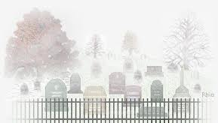

Board of Manager’s Report 2025

The Board of Managers held 3 regular meetings in 2025. Board members are: James Prevost (Chairman), Elizabeth Anne Nutt (Treasurer), Lynn MacGillivray (Secretary), Audrey MacQueen (Cemetery committee), Jack Fraser, Janet MacCrimmon, Matthew Fraser, and Chad McRae.

The Cemetery committee continued its active participation in all Board of Managers’ meetings to work closely with the Board of Managers to review/discuss/resolve cemetery tasks and issues.

There were four Church Hall rentals in 2025.

Internet connection was purchased for the church and hall. It is also accessible at the cemetery. The internet is used during church and hall rentals and during Memorial Weekend and periodically for access to the Cemetery records online. An external keyboard was purchased for the laptop in the hall which is now permanently available to use as it is installed in the closet.
Maxville Manor requested rental of the church hall for Outreach use during the Manor construction and submitted a written proposal to the church. The consensus was to agree to the Manor Outreach use of the hall with the rental fee covering the heating and hydro expenses. The Manor did not rent the hall as other arrangements were made to maintain the activities at the Manor.
The second $25,000.00 cheque (of the total $100,000 donation) was issued to the Maxville Manor Foundation.
Maintenance tasks completed include:
* Furnace inspection and cleaning
* Heating grates cleaned
* Fire permit obtained
* Water samples were taken quarterly to Ottawa for testing
* Fire Extinguisher inspections
* Replacement of the UV light and filter in the hall well
* Replacement of the cap seal on the well
* Repaired and updated the exterior church sign
* Placement of the hall smoke detector 6 inches from the ceiling
* Scraping and painting of approximately half of the perimeter fence
* Repairs to hall doors, inside church foyer doors, and church entrance doors.
* Repair of the flashing above the church entrance doors and restraining of the doors
* Replacement of the sensor in the floodlight in front of the church
* Toiletry supplies purchased for hall bathrooms
* Removal of nonfunctioning coffee makers in the hall with replacements purchased (as well as a new kettle).
* The Church and Church Hall exteriors and the Church attic were sprayed for flies, Japanese beetles and wasps
* Rodents were trapped in the Church

Norman MacLennan was confirmed for snow clearing of the parking lot and Norm Jeaurond was confirmed for the church and hall walkways.

Upcoming projects:
- Repairs/replacement of large church basement door where the furnace is installed
- Replacement/repair of the mortar on the cracked, stone windowsills on the stone exterior of the south side of the church
- Completion of scraping and painting the perimeter fence
- Painting of the inside foyer doors in the church
- Re-stain the church entrance doors

Thank you to Betty Bracken for her decorating skills in the Church and the Church hall.

Christmas gifts were purchased and delivered.

Thanks to our Board of Managers and Cemetery Committee members who continue to donate their time, talents and resources towards keeping the Church, the hall, and the cemetery well maintained.

Respectfully submitted by,
James Prevost, Chairperson
Lynn MacGillivray, Secretary

"Be careful not to do your 'acts of righteousness' before men, to be seen by them. If you do, you will have no reward from your Father in heaven." — Matthew 6:1



Trustee Investment Committee Report 2025

Kenyon Church’s financial advisor, Randy Douglas of Highgate Group Inc. (formerly Ventum Financial Corp. June 2025) looked after both Kenyon’s Church and Cemetery financial accounts. Randy has throughout the year, via telephone, MS Teams meetings, and email and in person conversations, kept us fully informed, provided sound advice while allowing input from our committee. We utilized the Statement of Investment Philosophy, Policy and Guidelines in making decisions throughout the year keeping the investment portfolio safe while earning income.

The Church’s investment portfolio with Highgate Group Inc. earned 4.0% in interest and dividends and had an increase in Market Value of 21% in 2025. The earnings on investments in the Church’s Canadian account were deposited into the Church bank account monthly to help cover operational costs. The Cemetery investment portfolio earned 5.2% in interest and dividends this year and the Market Value of the account was up 5.7% at year end.

In 2025 a large percentage of the portfolio was held in Bonds, Preferred Shares and GIC’s. Common stocks and Exchange Traded Funds were well monitored and bought and sold as necessary to balance and support the portfolio. Interest and dividends from the investments remained strong and provided the church with regular income throughout the year. There was a continued focus on purchasing quality investments with good earnings potential. The portfolios include high quality GIC’s, Fixed Income, Preferred Shared, Common Stocks, Bonds, Exchange Traded Funds and Income Trusts.

The Margaret U. Stewart Memorial Trust continues to be invested in the Church’s Canadian investment account. The original portion of the trust, $10,000.00 was designated to go towards Youth and Sunday School programs, the interest and earnings on this amount was $413.69 for the year 2025. The remainder of the Margaret U. Stewart Memorial Trust earnings goes towards the general operation of the Church.

Through thoughtful and prayerful management of these investments and with Donors continued support, Kenyon Presbyterian Church and Cemetery will be able to continue Gods work into the future. Thank you to all our generous donors.

Respectfully submitted,
Laurie Arkinstall

Memorial Donations – Kenyon Presbyterian Church – 2025

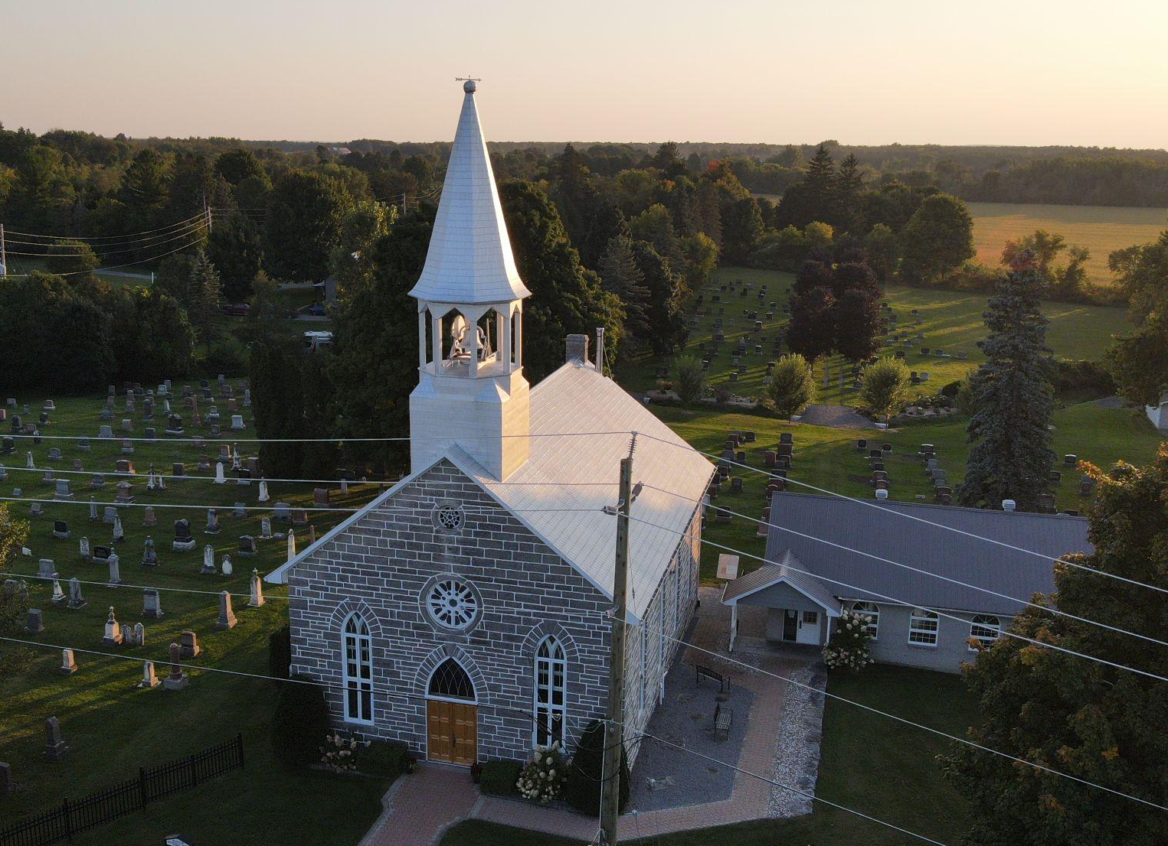

Annabelle and D.J. Hartrick  Ewan and Donna Hartrick  Murray and Thelma MacQueen  Allan and Sandy Blaney  Stewart MacQueen  Allan and Sandy Blaney  Rev. W.J. Baxter  Shirley Smith | Donald Clark  J & D Loewan  Giselle Telewiak  Ron & William Jelley  St. Lawrence Seniors Club  Gladys MacLeod  Monique Roleau  Barry & Elaine Perkins
John 11:25-26
Jesus said, “I am the resurrection and the life. The one who believes in me will live, even though they die; and whoever lives by believing in me will never die.

Memorial Donations – Kenyon Presbyterian Church Cemetery – 2025
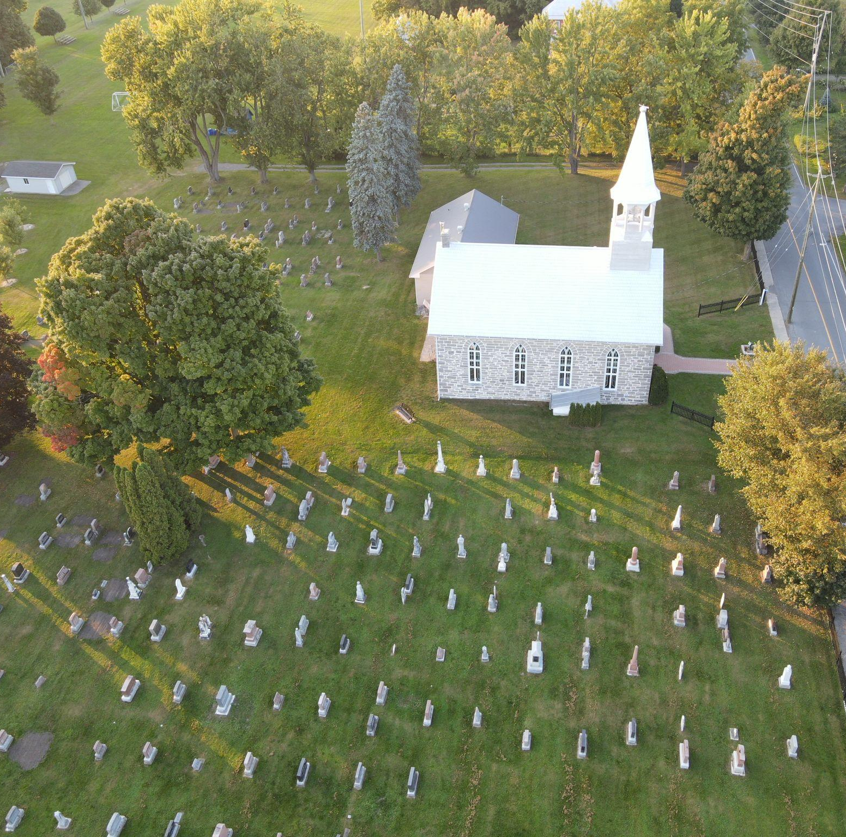

Annie, Stanley and Mildred Campbell  Bruce and Louise Campbell | Evan McIntosh  Heather McIntosh
Allister & Eileen Campbell  Richard and Pat Campbell  Myrna Ladouceur  Lorna Massia | Keith MacLeod  Bonnie Cameron  Marvel MacLeod  Betti Nutt
Chris Nutt  Marvel MacLeod  Betti Nutt | Donald Clark  Gordon & Betty Bracken  Richard & Eileen Cherry  Donalda Clark  Bernadine Duval  Jean MacLeod  Wendy MacLeod  Barbara McCormick
Dorothy, Dougald and Robert MacMillan
Evelyn Newton
Ivy (Stewart) & Donald Stewart  Myrtle (Stewart) & Ross Nimmo  Nellie (Newman) & Alex D Stewart  Margaret Stewart | Leonard MacPhee Hutton  Phyllis Hutton  John Walter Hutton  Dr. Linda Hutton
Donald, Freda & Lillian Campbell  Leona Campbell | Kenzie MacLeod  Elsie MacLeod
Munroe and Margery McCaskill
Heather McCaskill

“Brothers and sisters, we do not want you to be uninformed about those who sleep in death, so that you do not grieve like the rest of mankind, who have no hope. For we believe that Jesus died and rose again, and so we believe that God will bring with Jesus those who have fallen asleep in him.” – 1 Thessalonians 4:13-14

Thank you to our Donors – 2025

Dona Addison  Amanda Alexander  Andrew & Laurie Arkinstall  Doug Arkinstall  Gwenneth Arkinstall  Katie Barnes  Darlene & James Barret  Ken Barton  Verna Beaumont  Keppel Bharath  Janet Bickerstaff  Allan & Sandy Blaney  Gordon & Elizabeth Bracken  Francine Cameron  Betty Campbell  Brian & Karen Campbell  Bruce & Louise Campbell  Leona Campbell  Richard & Pat Campbell  Richard & Eileen Cherry  Donalda Clark  Douglas A Clark  Susan Clark  Janice & J. Thomas Corkal  Bernadine Duval  Jim & Olga Ferrier  James Fletcher  Alastair Fraser  Gordon Fraser  Jack & Linda Fraser  Catherine Gauthier  Dr. Linda Grace  Ewan & Donna Hartrick  Ian & Michelle Hartrick  Andre & Grace Jean-Louis | Ian & Katherine Jean-Louis  Ron & Wilma Jelley  Isabelle Johnston  Arnold & Anna Kuralti  Roger & Ann Ladouceur  Myrna Ladouceur  Roy & Wendy Lang  John & Donna Loewen  Ewen & Audrey MacDonald  Allan MacEwen  Emerson MacGillivray  Lynn MacGillivray  Brent MacInnes  Glenda MacInnes  Rhonda MacInnes  Doris MacIntosh  Leslie & Joyce MacKinnon  Donald & Martha MacLean  Gordon MacLean  Elsie MacLeod  Ian & Karen MacLeod  Jean MacLeod  Ken & Annette MacLeod  Kevin MacLeod  Margaret MacLeod  Marvel MacLeod  Nancy MacLeod  Roberta MacLeod  Wendy MacLeod  Brenda MacMaster  Kyle & Carol MacMillan  Lorna MacMillan  Lois McNaughton | Audrey MacQueen  Lorna Massia  Heather McCaskill  Bernard & Mona McDonell  Heather McIntosh  Alastair McLean  Doris McRae & David Proudfoot  Glen & Mary-Anne McRae  Inger Morris  Donald H & Susan Munroe  Ruth & Dean Munroe  Evelyn Newton  Donna Jean Nixon  Glen & Penny Nixon  Elizabeth Nutt  Judy C Ouderkirk  Heather Peckett  Barry & Elaine Perkins  James Prevost & Sandra MacPherson  Peter Reid & Wendy Reid  Monique Rouleau  Margarita Rupp  Clarence Ruttle  Helen Shields  Shirley Smith  St Lawrence Seniors Club  Margaret Stewart  Giselle Telewiak  Evelyn Urquhart  Keith Urquhart  Casey & Glenna Van Drunen  Audrey Waugh  Ron & Faye Zsadany

